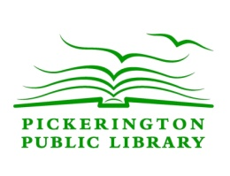
Pickerington Public Library
Confidentiality of Patron Records Policy

The Board of Trustees of the Pickerington Public Library recognizes that library records and patron information are confidential. According to Ohio Revised Code 149.432 library records are defined as a record in any form that is maintained by the library and that contains any of the following types of information:

- Information an individual is required to provide in order to be eligible to use library services or borrow materials
- Information that identifies an individual as having requested or obtained specific materials or materials on a specific subject
- Information that is provided by an individual to assist a staff member to answer a specific question or provide information on a particular subject

Under Ohio law, a patron’s library records or information shall not be made available to any agency of federal, state or local government, or to any spouse or other individual other than the individual who is the subject of the record or information, except as follows:

- For the records or patron information pertaining to minor children when requested by parents, guardians or custodians
- In accordance with a subpoena, search warrant or other court order, or to a law enforcement officer who is investigating a matter involving public safety in exigent circumstances
- Upon request or with the consent of the individual who is the subject of the record or information
- For library administrative purposes as defined by Ohio Revised Code 149.432

Information that does not identify an individual and that is retained for studying or evaluating the use of the library is not considered confidential and is not subject to this policy.

Adopted:
May 9, 2011

