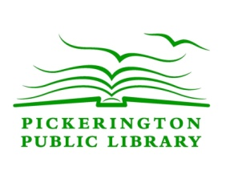

Pickerington Public Library

Exam Proctoring Policy

Proctoring is available for students in accredited degree or certificate granting programs. Students are required to pay a $20.00 fee for each paper exam and each login session for online exams. This payment must be made to the library at the time of the scheduled exam. The student should discuss with the Reference Department Staff the conditions for proctoring and the arrangements for taking an exam. The library may not be able to meet the proctoring requirements for all institutions.

Approved:
11/8/2011
Revised:
02/11/2013

