PICKERINGTON PUBLIC LIBRARY BOARD OF TRUSTEES MEETING
March 19, 2018
The Board of Trustees of the Pickerington Public Library met in regular session on Monday, March 19 at 7:21 p.m. at the Sycamore Plaza Library, 7861 Refugee Road. Members present were Cristie Hammond, Mary Herron, Cheryl Rickett, and Michelle Shirer. Staff members present: Tony Howard, Library Director, Brenda Oliver, Fiscal Officer and Colleen Bauman, Community Relations Coordinator.
Public in attendance: Kathy Bowden, President of the Friends
Call to Order
Cristie called the meeting to order.
Roll Call
Excused: Todd Stanley, Berneice Ritter, Mike Jones
Secretary’s Report
Cristie asked for approval for the regularly scheduled Board meeting and FAB Committee minutes from February 19, 2018.

Approval of Minutes
03-01-18 Motion to approve the Regular Board and FAB Committee Meeting Minutes for February 19, 2018
Mary Herron made a motion to approve the Regular Board and FAB Committee meeting minutes for February 19, 2018. Cheryl Ricketts seconded. Minutes were approved with no changes. Motion passed.
Public Participation
Friends of the Library Report - none
Finance Committee
Fiscal Officer’s Report
Brenda asked if there were any questions from the financial reports. There were none.
She shared what was discussed in the FAB meeting.
Other Committee Reports
Library Fund and Fundraising Meeting April 12 at 5:30pm; reminder to be sent out.
Director’s Report
Current Projects: Wood line clean up progressing well. Ash trees being removed, vines removed. Tech Services carpet project finished. Conference room furniture is set up. Security camera project complete; software will be added to staff computers to monitor. LED lighting project is almost complete for this year. Tony said comparisons will be made to usage over the last 3 years to see the savings from LED bulb replacement. Roof leak issues by DVD area; has been addressed and bid process has begun. It will be determined if that area will need to be closed when beams are being replaced.
Staffing – 3 positions open. Assistant director position interviews are scheduled. Custodian position is still open and there is a Patron Services position open.
Tony shared a Gale Analytics report to show the Board how staff will use it to make better decisions on marketing, programs and services.
Old Business
2018 Strategic Plan
Tony and the Board reviewed the updated 2018 Strategic Plan with suggested changes; this will be put on the website and in the libraries for the public. Detailed strategies were shared to show the desired outcome of the strategic plan.
03-02-2018 Resolution to approve the 2018 Strategic Plan with suggested changes
Cheryl Ricketts made a motion to approve the 2018 Strategic Plan with suggested changes. Mary Herron seconded the motion. Motion passed.
Roll Call: Cristie Hammond-yes, Mary Herron-yes, Michelle Shirer-yes, Cheryl Ricketts-yes.
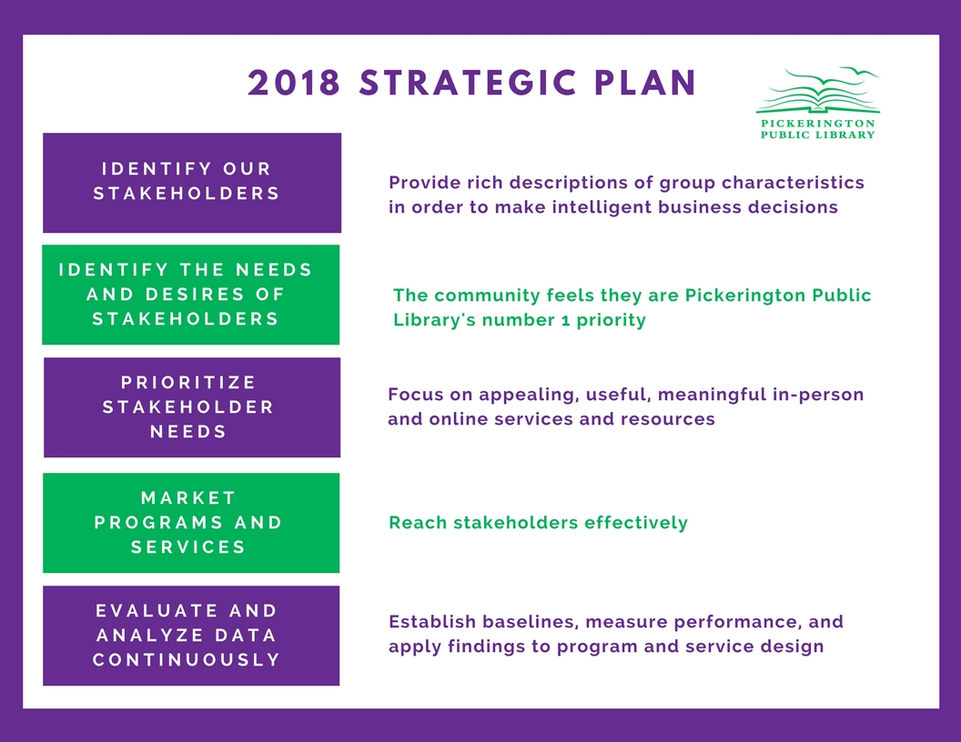
New Business
Donations
Public Participation at Board Meetings Policy
Last update was in 2006. The changes made to this policy bring the policy in line with the Board Bylaws.
03-03-2018 Resolution to approve changes to the Public Participation at Board Meetings Policy
Cheryl Ricketts made a motion to approve changes to the Public Participation at Board Meetings Policy. Michelle Shirer seconded. Motion passed.
Roll Call: Cheryl Ricketts-yes, Mary Herron-yes, Michelle Shirer-yes, Cristie Hammond-yes.

Open Public Meetings Policy
This policy was last updated in January 2004. Changes to this policy include the separation of the Board Policy from the Administrative Procedure and bring the policy in line with the current Board Bylaws.
03-04-2018 Resolution to approve the Open Public Meetings Policy
Cheryl Ricketts made a motion to approve the update to the Open Public Meeting Policy. Mary Herron seconded. Motion passed.
Roll Call: Mary Herron-yes, Cheryl Ricketts-yes, Cristie Hammond-yes, Michelle Shirer-yes.

Records Retention Policy
Many additions to this policy as it was last updated in March 2012. As with other policy updates, SHRM resource and several other public library policies were used when working on this update. The Board policy was separated from the Administrative procedure. The Ohio Revised Code requires the libraries to have a Records Commission and review the schedule every 12 months. This was added to the policy. The schedule was reorganized to mirror what we are required to submit to the state. Records were added that were not included in the previous policy.
03-05-2018 Resolution to approve the changes to the Records Retention Policy
Michelle Shirer made a motion to approve the Records Retention Policy with the discussed revisions. Cheryl Ricketts seconded. Motion passed.
Roll Call: Cristie Hammond-yes, Michelle Shirer-yes, Cheryl Ricketts-yes, Mary Herron-yes.

Pickerington Public Library

RECORDS RETENTION POLICY
Board Policy Date Approved: 3/19/2018
Effective Date: 3/19/2018
Replacing Policy Effective: 3/12/2012

The Pickerington Public Library, like other public entities in the State of Ohio, must retain certain records from year to year. It is the Policy of the Library to comply with all applicable laws for the proper retention of public records.

Although the Ohio Revised Code does not set guidelines for public libraries, the Pickerington Public Library Records Commission sets and approves the record retention schedule. The Pickerington Public Library Records Commission is comprised of all Board Members, the Fiscal Officer and the Library Director. The Commission will meet at least once every twelve months to review schedules of records retention and disposition.
Administrative Procedures Date Approved: 3/19/2018
Effective Date: 3/19/2018
Replacing Schedule Approved: 3/12/2012

Retention of records may be any commercially viable media that provides an accurate reproduction of the record. The following list show the retention period of specific records, which is compiled from recommendations from the Auditor of State’s Office and the Ohio Historical Society:

Schedule Number | Record Title/Description | Retention Period
ADMINISTRATION
A-01 | Accident/Incident Report | 6 years providing no pending action
A-02 | Administrative Policy/Procedure File | 1 year after superseded
A-03 | ADA grievance files | 6 years
A-04 | Annual Reports to the Community | 4 years
A-05 | Annual Reports to the State Library of Ohio | Permanent
A-06 | Board Agendas | 1 year
A-07 | Building Fire Inspections | 7 years
A-08 | Building Project Records – Unsuccessful | 3 years
A-09 | Building Project Records - Successful | Retain as long as PPL owns or leases the property
A-10 | Building Specifications and Plans | Retain as long as PPL owns or leases the property
A-11 | CCTV Surveillance Videos | 20 days (unless as part of a criminal investigation, court proceeding, or security incident report)
A-12 | Circulation Records | Retained until Item is returned
A-13 | Committee Reports | 1 year
A-14 | Computer Booking Logs | Daily
A-15 | Consultant Report | 4 years
A-16 | Correspondence – Informative – does not attempt to influence library policy | 2 years
A-17 | E-Mail | Retain according to content
A-18 | Formal Legal Opinions | Permanent
A-19 | General Correspondence | 2 years
A-20 | Historical Information | Permanent
A-21 | Library Board of Trustees’ Minutes | Permanent
A-22 | Library Card Application - Adult | 1 year
A-23 | Library Card Application - Juvenile | Until Juvenile reaches 18
A-24 | Library Material Request for Review Form | 2 Years
A-25 | Library News Releases | 4 Years
A-26 | Library Publications | 2 Years
A-27 | Litigation Records | 5 years after case closed and appeals exhausted
A-28 | Meeting Room Applications | 1 year
A-29 | Monthly Statistical Reports | Until incorporated into year-end report
A-30 | Open Meeting Notifications | 3 years
A-31 | Operating Procedures/Guidelines | Retained until Superseded
A-32 | Overdue Circulation Records | 6 years
A-33 | Patron Information | Permanent or 3 years after inactive
A-34 | Postal Records (e.g. registered /certified/ insured or receipts/postal meter documents | 2 years
A-35 | Public Programming documentation | 4 years
A-36 | Record Requests and responses | 2 years
A-37 | Recordings of Board Meetings (Audio) | Until written minutes approved
A-38 | Records Commission/ Records Disposal Documents | 10 years
A-39 | Software | Retain until software is no longer in use
A-40 | Survey Results | Permanent
A-41 | Technology Plans | Until superseded
A-42 | Training Manuals | Until superseded
A-43 | Transient Material (all informal and/or temporary messages and notes, including e-mail and voice mail message, and all drafts used in the production of public records) | Discretionary; retain until no longer of administrative value
A-44 | Vehicle Title | Retain as long as PPL owns the vehicle
FINANCE
F-01 | Accounting Records not specified | 5 years provided audited
F-02 | Accounts Payable Ledger | 5 years provided audited
F-03 | Amended Official Certificates | 5 years provided audited
F-04 | Annual Budget Resolutions | 5 years provided audited
F-05 | Annual Certificate of Estimated Resources | 5 years provided audited
F-06 | Annual Financial Reports to the Auditor of State | Permanent
F-07 | Appropriation Ledger | 5 years provided audited
F-08 | Audit of Library’s Financial Records | Permanent
F-09 | Bank Deposit Receipts | Until audited
F-10 | Bank Statements | 4 years provided audited
F-11 | Bids – Successful | 15 years after completion of project
F-12 | Bids – Unsuccessful | 4 years after Letting of Contract provided audited
F-13 | Budgets – Annual (filed with the County Budget Commission) | 10 years
F-14 | Canceled Checks | 4 years provided audited
F-15 | Cash Journals | 4 years provided audited
F-16 | Cash Register Tapes | Until audited
F-17 | Certificates of Total Amount from Sources Available for Expenditures | 4 years provided audited
F-18 | Check Registers | 4 years provided audited
F-19 | Construction Contracts | Retain as long as PPL owns or leases the building/property
F-20 | Contracts | 6 years after expiration
F-21 | Depository Agreements | 4 years provided audited
F-22 | Donor Correspondence | 2 years (unless gift requires a commitment from PPL that extends beyond 2 years)
F-23 | Encumbrance and Expenditure Journal | 5 years provided audited
F-24 | Expense Records | 5 years
F-25 | Financial Year End Backups | 4 years
F-26 | Gift Donor Forms | 3 years
F-27 | Grant Files | 5 years provided all state or federal audits conducted and audit reports released and audit findings resolved
F-28 | Insurance Policies/Bonds | 12 years after expiration provided all claims have been settled
F-29 | Inventories, except library materials | Until superseded
F-30 | Investment Records | 4 years provided audited
F-31 | Leases - Equipment | 4 years after expiration
F-32 | Leases – Real Estate | 5 years after expiration, provided audited
F-33 | Levy Campaigns and Work Papers | Life of Levy plus 5 years
F-34 | Levy Official Files | Life of Levy plus 5 years
F-35 | Monthly financial reports, including investment report to the Library’s Board of Trustees | 3 years (provided that the audit report was released
F-36 | Prevailing Wages Records | 4 years provided audited
F-37 | Purchase Orders | 2 years provided audited
F-38 | Purchased Services and Maintenance Contracts | 7 Years after expiration, unless part of litigation
F-39 | Receipt Books | Until audited
F-40 | Receipt Journals | 5 years provided audited
F-41 | Voucher with Invoices | 5 years provided audited
PAYROLL
P-01 | Annual Employee Absence Summary | 5 years provided audited
P-02 | Annual Payroll Summaries | Permanent
P-03 | Applications for Employment, resumes, interview notes and all other related employment documents | Retain with personnel records if applicant employed, others 1 years
P-04 | Benefits Enrollment | 2 years
P-05 | Benefits Summary Plan Documents | 7 years
P-06 | Court Orders for Payroll Deductions | Permanent
P-07 | Deduction Authorizations | Permanent
P-08 | Deferred Compensation Deduction Reports | 5 years provided audited
P-09 | Employment Handbook | 2 years provided audited
P-10 | Employment Request for Leave Forms | Until audited
P-11 | Employee Schedules | 4 years provided audited
P-12 | Employee Withholding Requests | Until replaced or revoked by employee
P-13 | Employer Quarterly Federal Tax Return | Permanent
P-14 | I-9 Immigration Verification Forms (retained separately from personnel files) | The later of 3 years from date of hire or 1 year following termination
P-15 | Job Descriptions | Until Superseded
P-16 | Job Postings/Advertisement of Job Openings, Promotions, Training Programs | 1 years if no action pending
P-17 | OPERS Records and Reports | Permanent
P-18 | Payroll Tax Records | Permanent
P-19 | Personnel Records | Permanent
P-20 | Time Sheets | 4 years provided audited
P-21 | Unemployment Compensation Claims | 4 years provided audited
P-22 | W-2 Forms | Permanent
P-23 | W-4 Forms | Until superseded
P-24 | Worker’s Compensation Claims | 10 years after date of final payment
Technical Services
T-01 | Material Inventories | Maintained online; until superseded
T-02 | Collection Guidelines | Retain until superseded
T-03 | Collection Management – Ordering (Selections) | Keep until no longer administratively necessary
T-04 | Collection Management - Acquisitions | 2 years
T-05 | Collections – Holdings (Items in Library Catalog | As long as viable item exists in the library collection
T-06 | ILL Records | 30 days, unless financial obligation

Regardless of format, computer back-ups of any of the above-referenced records shall follow the same retention period as paper records.

For all above records, if a paper record has been scanned into electronic format, then the paper copy of the record can be destroyed after the audit.

“Until Audited” and “Provided Audited” are defined as the Auditor of State (or other contracted auditors) having audited the fiscal years encompassed and the audit report has been duly released.

2018 Permanent Appropriations
Proposed 2018 Permanent Appropriations for the General, Homework Help Center and the Capital Fund are included. The proposed General Fund appropriations are $2,209.120, Homework Help Center is $2,300 and the Capital Fund is $240,000.
03-06-2018 Resolution to approve the proposed 2018 permanent appropriations; General Fund Appropriations $2,209,120, Homework Help Center $2,300, Capital Fund $240,000
Mary Herron made a motion to approve the 2018 permanent appropriations as proposed. Michelle Shirer seconded.
Roll Call: Cheryl Rickets-yes, Cristie Hammond-yes, Mary Herron-yes, Michelle Shirer-yes. Resolution passed.
Staffing Changes
Last year the Board approved a plan to bring acquisitions and cataloging in house. As part of that plan, Joan Underwood was promoted to Cataloger. She has gone through most of her training and has taken on more of the cataloging workload. It has been decided to increase her rate of pay to 3% pay increase to $15.03 per hour effective March 4, 2018. Debbie Madison was promoted to Technical Services Staff II in order to fill the vacancy Joan left when she was promoted to Cataloger. Her new rate of pay is $12.46 per hour effective March 18, 2018.
03-07-2018 Resolution to approve the new rates of pay for Joan Underwood and Debbie Madison
Cheryl Ricketts made a motion to approve the new rates of pay for Joan Underwood and Debbie Madison. Mary Herron seconded. Motion passed.
Roll Call: Michelle Shirer-yes, Cristie Hammond-yes, Cheryl Ricketts-yes, Mary Herron-yes.
Transfer funds between Appropriation Accounts, as needed, up to $25,000 per transfer.
03-08-2018 Resolution authorizing the Fiscal Officer and Library Director to transfer funds between appropriation accounts, as needed, up to $25,000 per transfer.
Mary Herron made a motion to approve the resolution to authorize the Fiscal Officer and Library Director to transfer funds between appropriation accounts, as needed, up to $25,000 per transfer.
Roll Call: Cristie Hammond-yes, Mary Herron-yes, Michelle Shirer-yes, Cheryl Ricketts-yes. Resolution passed.
For the good of the order
Adjournment
Next Board Meeting:
FAB Committee Meeting
April 16, 2018 @ 6:30 p.m. (Meeting room B)
Regular Board Meeting
April 16, 2018 @ 6:30 p.m. (Meeting room A)
Important Dates:
OLC Legislative Day @ Ohio Statehouse
April 11, 2018 – all day
Library Fund and Fundraising Meeting
April 12, 2018 @ 5:30 p.m.

_______________________________
Cristie Hammond
Library Board President

_______________________________
Mary Herron
Library Board Secretary

