PICKERINGTON PUBLIC LIBRARY BOARD OF TRUSTEES MEETING  
September 21, 2020

The Board of Trustees of the Pickerington Public Library met in regular session on September 21, 2020 at 7:02 p.m. via a Zoom Virtual Meeting, Pickerington, OH 43147. Members present were Cristie Hammond, Mike Jones, Mary Herron, Jennifer Hess, Michelle Shirer, Todd Stanley and Berneice Ritter. Staff members present: Tony Howard, Library Director, Brenda Oliver, Fiscal Officer, Colleen Bauman, Community Engagement Manager and Norma Lockney, Deputy Fiscal Officer. Also in attendance: Jennifer Hrusch and Mikel Coulter.

Call to Order

Meeting called to order by Cristie Hammond.

Roll Call

Secretary’s Report

Consent Agenda

* + - 1. August 17, 2020 Regular Board Meeting minutes
      2. August 29, 2020 Special Board Meeting minutes

**09-01-20 Motion to approve the Consent Agenda**

Mary Herron made a motion to approve the Consent Agenda items. Todd Stanley seconded.

Roll Call: Mike Jones-yes, Mary Herron-yes, Cristie Hammond-yes, Todd Stanley-yes, Berneice Ritter-yes, Jennifer Hess-yes. Motion passed with no changes.

Public Participation

Friends of the Library Report

Michelle Shirer joined the meeting.

Finance Committee

Fiscal Officer’s Report

Brenda shared the August financials:

Checking balance - $1,674,344.54

General Fund Investments - $2,339,600.35

Capital Fund Investments – Star Ohio - $543,186.06

August General Fund Revenue - $847,319.99

Revenue Highlights:

Property Tax - $675,725.56

PLF - $118,335.60

Property Tax Allocation (Rollback) - $51,888.64

Customer Fines - $72.68

Interest - $483.00

Misc. Revenue - $235.95 (Kroger Rewards)

Capital Projects Interest Income - $134.51

Special Revenue - $53,000.00 (Coronavirus Relief Fund - $3,000, $50,000 OBM-PLA Coronavirus Relief Fund)

Expenditure Highlights:

Main Personnel - $75,687

Branch Personnel - $13,371

Main Operations - $23,053

Branch Operations - $8,802

Collection - $19,043

Equipment and Furniture - $29

August General Fund Expenditures - $139,985

Financial Updates:

Revenues:

- Property tax levy revenue – Fairfield County taxes have been collected and the 2nd half received was $675,725.56 in August, which is $39,488.59 over the budget. Franklin County’s portion will be received soon.

- Public Library Fund – State Revenues – The August PLF based on July receipts was 36.78% higher than estimated due to delayed income taxes. The amount to be received for September PLF is $109,676.34.



Star Ohio’s daily interest rate – 0.23%

Star Ohio Plus daily interest rate – 0.25%

Other Items:

- Grants –

* Guiding Ohio Online Grant – The library has been approved for a $17,649 federal grant for 2020-2021. The local requirement for this grant is $5,883.
* IMLS CARES Act Grant – The library should be notified in September about this $373,537 grant for a lending kiosk.
* Ohio’s Office of Budget and Management Grant – The library has received $50,000 for this grant to be used at either location for increased sanitation costs, maintaining social distancing, purchasing personal protective equipment and other necessary costs to comply with public health orders, local health department recommendations and best practices. This grant can be applied toward expenses already incurred and expenses through 12/30/20.

- Extra Spending Due to Pandemic – The library has been spending an extra $1,300 a month on average due to the pandemic for PPE, social distancing, increased sanitation costs, curbside services, quarantining materials and unemployment costs. The library also paid an additional $10,000 for increased Overdrive access for customers for 2020. These amounts will be reimbursed from OBM-PLA Coronavirus Grant from Ohio’s Office of Budget and Management.

- August 26th Power Outage/Surge – The library had some damage to the computer firewall and HVAC system due to the power surges on August 26th. The total damage was $13,641.13 and the library’s deductible is $1,000. The library is expecting an insurance claim check for $12,641.13.

Other Committee Reports

Director’s Report

Fall Strategic Focus – Connect Community

Facilities:

Current projects:

- Main Library Structural roofing issue - The State of Ohio Board of Building Appeals has scheduled the library’s variance hearing for 9:00 a.m. on October 13, 2020. Mikel Coulter from CTL engineering will be presenting the case. Tony will be there to provide historical information about the building if needed. Mikel shared information about the variance.

- Storing furniture - With extended quarantine causing space issues, staff are finding ways to be more creative in storing furniture. Both storage units are filled close to capacity. Additionally, Main library’s quiet study room has been filled. This is expected to last through the pandemic. Tony shared some pictures.

- Annual Boiler inspection and biannual preventative maintenance - The library passed the annual boiler inspection. General Temperature conducted the Biannual Preventative maintenance on the HVAC systems at both locations.

- Repairs to the HVAC System - Three air-handling units had damage to their transformers after power surges from recent storms. Insurance covered the cost of the damage and all air handlers are now repaired. The library had to pay out the $1000 deductible.

- Leaking roof at Sycamore Plaza - Frank is investigating a possible roof leak at Sycamore Plaza Library. Ceiling tiles have been removed in preparation for the next rain to determine where the leak is located. These repairs will be the responsibility of the property owner.

Miscellaneous:

Project work:

- Down with Dewey - Project is on track and moving forward swiftly! Planning phase is complete. All supplies purchased in order to make changes (labels, tape, stickers, etc.). Communications plan has been created and is being implemented. Timeline:

|  |  |  |  |  |  |  |  |  |  |  |  |  |  |  |  |
| --- | --- | --- | --- | --- | --- | --- | --- | --- | --- | --- | --- | --- | --- | --- | --- |
| ***Deliverables*** | ***End Date*** | **Finance** | **HR** | **Marketing** | **Facilities** | **Patron Services** | **IT** | **Children Services** | **Reference Services** | **Tech Services** | **ELT** | **Community Relations** | **BOARD** | **PPLF** | **FOPPL** |
| Research & Recommend Categories | 9/1/2020 |  |  |  |  |  |  | X | X | X | X |  |  |  |  |
| Finalize Categories & Select call numbers | 9/15/2020 |  |  |  |  |  |  |  |  | X | X |  |  |  |  |
| Create Marketing Plan | 9/7/2020 |  |  | x |  |  |  |  |  |  | x |  |  |  |  |
| Convert Graphic Novel & Manga | 9/15/2020 |  |  |  |  |  |  | X | X | X | x |  |  |  |  |
| Convert Picture Books, Easy Reader, & Blue Label nonfiction | 10/31/2020 |  |  | X | X | X |  | X | X | X | X | X |  |  |  |
| Identify and relabel Adult Thriller/Horror & remove from general fiction | 10/31/2020 |  |  | X | x | x |  | x | x | x | x | x |  |  |  |
| Convert J fiction | 11/18/2020 |  |  | X | x | x |  | x | x | x | x | x |  |  |  |
| Convert J non-fiction book and all J AV | 12/18/2020 |  |  | X | X | X |  | X | X | X | X | X |  |  |  |
| Convert Adult Audiobook, Adult DVD | 12/18/2020 |  |  | XX | X | X |  | X | X | X | X | X |  |  |  |
| Convert Adult Nonfiction | 2/26/2020 |  |  | X | X | X |  | X | X | X | X | X |  |  |  |
| Convert Teen Fiction | 4/15/2020 |  |  | X | X | X |  | X | X | X | X | X |  |  |  |
| Survey the Public - Follow-up to changes | 6/14/2020 |  |  | X |  |  |  |  |  |  | X | x |  |  |  |

Kudos to Joan Underwood, Grace Walker & Laura Hanby for helping keep this project organized and moving along.

HHC:

The library began in person homework help on September 8. With limited seating and strict safety protocols, we have only had mild success. There were 10 students at Main Library and 4 students at Sycamore Plaza.

Virtual HHC – The library has an agreement with PLSD to use their system to provide virtual help. The bugs are still being worked out.

Summer Reading:

Registration & Reading Logs

|  |  |  |  |
| --- | --- | --- | --- |
|  | 2020 | 2019 | 2018 |
| Registration | Total: 832*  Baby: 26 (3.1%)  Children: 250 (42.1%)  Teen: 74 (8.9%)  Adult: 270 (32.4%) | Total: 3000  Baby: 116 (3.9%)  Pre-Reader: 615 (20.5%)  Reader: 912 (30.4%)  Tween: 529 (17.6%)  Teen: 172 (5.7%)  Adult: 656 (21.9%) | Total: 2163  Pre-Reader: 505 (23.3%)  Reader: 964 (44.6%)  Teen: 280 (12.9%)  Adult: 414 (19.1%) |
| Registration / Logging Format | Online registration & logging via READsquared  Paper logging with online tracking of prize redemption  Online: 677 (81.3%)*  Paper: 155 (18.7%)* | Online registration & prize redemption via Google Forms  Paper Logging | Paper only |
| Age/Grade Breakdown of Pre-K/ School-Age Participants | Unspecified: 6 (0.8%)  Under 1: 9 (1.2%)  Age 1: 16 (2.2%)  Age 2: 26 (3.6%)  Age 3: 22 (3.1%)  Age 4: 41 (5.7%)  Age 5: 36 (5%)  Age 6: 45 (6.2%)  Age 7: 50 (7.0%)  Age 8: 33 (4.6%)  Age 9: 42 (5.8%)  Age 10: 30 (4.2%)  Age 11: 23 (3.2%)  Age 12: 25 (3.5%)  Age 13: 15 (2.1%)  Age 14: 12 (1.7%)  Age 15: 9 (1.3%)  Age 16: 5 (0.7%)  Age 17: 8 (1.2%) | * Preschool: 269 (13.3%) * Kindergarten: 186 (9.2%) * 1st: 223 (11%) * 2nd: 246 (12.1%) * 3rd: 229 (11.3%) * 4th:199 (9.8%) * 5th: 171 (8.4%) * 6th: 150 (7.4%) * 7th: 112 (5.5%) * 8th: 85 (4.2%) * 9th: 58 (2.9%) * 10th: 36 (1.8%) * 11th: 28 (1.4%) * 12th: 36 (1.8%) | * (No data for Preschool-6th grade) * 7th: 114 (40.7%) * 8th: 60 (21.4%) * 9th: 36 (12.9%) * 10th: 25 (8.9%) * 11th: 28 (10%) * 12th: 17 (6%) |

*\*43 paper participants redeemed prizes for a total of 720 online registrants. The numbers above track unique participants.*

Incentives & Completion

|  |  |  |  |
| --- | --- | --- | --- |
|  | 2020 | 2019 | 2018 |
| Treasure Chest / Coupon Prizes | 845  *Combination of Levels 1 & 2 | 2539  Level 1: 1367  Level 2: 1172 | 2976  Level 1: 1226  Level 2: 1086  Level 3: 664 |
| Completion / Book Prize | 246 (29.5%)  *15 hours of reading | 1048 (34.9%)  *15 hours of reading | 580 (30.0%)  *20 hours of reading |
| Bonus logs | Y: Every 100 minutes/points = 1 raffle ticket, including after completion | Y: Every 300 minutes after completion = 1 raffle ticket | N |
| Total number of reading hours logged | 6,435 | 24,015 | Unknown |

READsquared:

89 book reviews written

278 missions achieved by completing more than 1,390 literacy activities

684 literacy games played

Volunteers:

7 volunteers completed “virtual volunteering” projects including book reviews and cards for homebound residents.

2020 Director Action Items:

- Better Communication early on with Managers and Staff regarding changes

* + Holding regular meetings with Managers during the Pandemic. Continuing with an all staff zoom update meeting every week. These meetings are to ensure all staff have the information they need to help them through the transitions occurring during the pandemic.
  + The Dewey project has been a focus in communications lately. With all of the changes, extra efforts have been made to speak with managers in person to ensure they understand and are able to communicate the changes to their teams.
  + Met with a couple managers when there was major change regarding the oversight of the virtual programming process.

- Better Communication with the Board – Tony was out a couple weeks this month and there were not any pressing changes that needed communicated outside of the Board Meeting. Tony shared the newest Gale Analytics information with the Board at the last meeting to provide a current snapshot of the community.

- Continue to expand community outreach to be reflective of the community – With the updated Gale Analytics information, the library has been incorporating that information into projects and programming decisions.

- Find better ways to manage the afterschool crowds – The current COVID-19 safety protocols have been a major factor in low turnout of the afterschool crowds.

Community Engagement Report

- Attended first FACFC virtual meeting since March. Message from PPL: We are open! Reserve a Service available for reserving tables, business center is open as well.

- Grace Fellowship book bundles – Remote Learning Center has 64 total students visiting throughout the week. K-8 level. Mix of picture, easy readers, chapter books.

- Autograph request:  
Ramsey received a Violet coloring book, sticker and a note from Violet with her stamp.

Service/Resource changes:  
- OverDrive consolidated collections on Libby  
(E-books, audiobooks all in one place to browse, read and listen)

- Reserve a service rolled out

- Reserve a table, computer or business center.

EVENTS: 16 Total events

* 9 hosted interactive (live) events
* 7 recorded YouTube videos  
  *Not including grab n’ go and 1-2 events missing from after/forms.

Most attended hosted interactive events:

* Virtual Family Fun w/ Grace
* First Draft Book Club
* Brown Bag Book Club
* On demand stories & songs w/ Brienne
* On demand stories & songs w/ Grace

Most watched recorded videos:

* Family Fun Early Literacy w/ Miss Ali (July 31, 2020: 36 views)
* Cup Shooters: Summer Reading Grab & Go (Aug. 3, 2020: 21 views)
* Sensory Stories w/ Miss Grace (Aug. 1, 2020: 17 views)
* Science in 60 Seconds: Capillary Action (2014: 16 views)
* No-Sew Heating Pads (2017: 16 views)

Mobile App:

Events – How do they work on the app? Colleen demonstrated the app.

Colleen gave an update about the Labor Day parade.

Old Business

COVID-19 Update

Library Stats: Aug. 1 – Aug. 31, 2020  
- Curbside: 2,188  
- Door Count: 2,978 (subtracting curbside employee activity)   
- Computer Use: 106 (75 were reservations)\

- Circulation: 23,328 (checkouts and renewals)   
- Wifi Use: 383 unique users

- Copy/Fax/Scan reservations: 39 (does not include walk in)   
- Table reservations: 41 (does not include walk in)

*Reserve a service rolled out this month.

July Comparison: July 1 – July 31, 2020  
- Curbside: 2,588  
- Door Count: 4,496 (subtracting curbside employee activity)   
- Computer Use (to July 27): 379 people   
- Circulation: 34,583 (checkouts and renewals)   
- Wifi Use: 573 unique users

Quarantine - REALM Test 4 **results show that after six days of quarantine the SARS-CoV-2 virus was still detected on all five materials tested. When compared to Test 1, which resulted in nondetectable virus after three days on an unstacked hardcover book, softcover book, plastic protective cover, and DVD case, the results of Test 4 highlight the effect of stacking and its ability to prolong the survivability of the SARS-CoV-2 virus.**

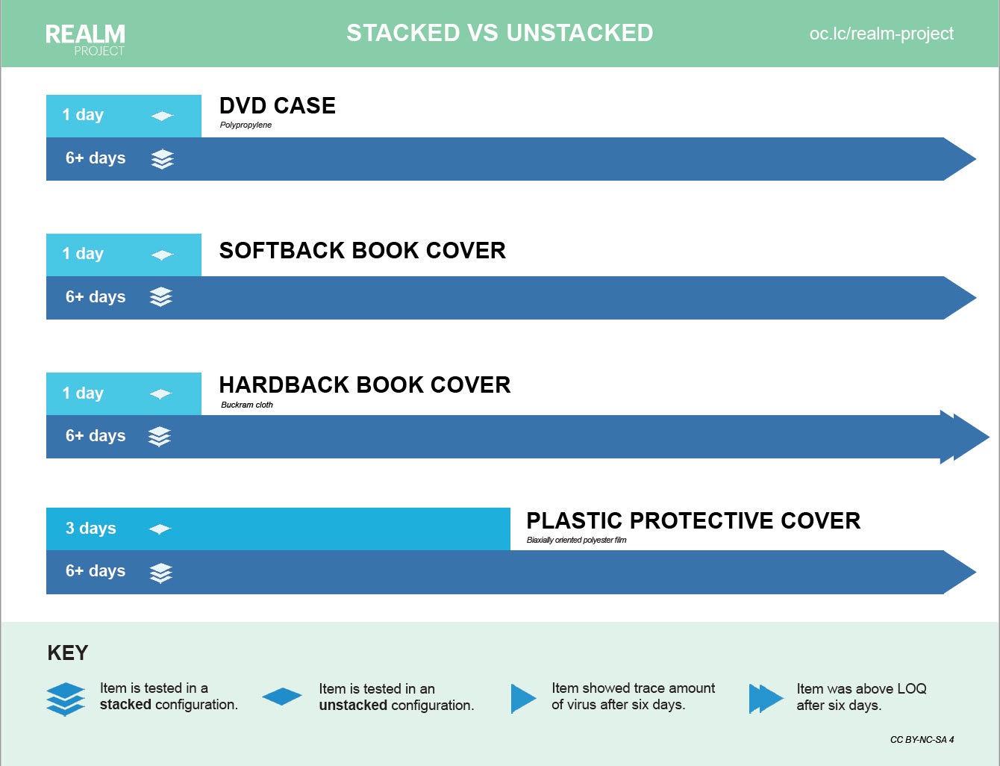

As a direct result of these findings, the library has extended the quarantine of items stacked in bookdrop bins to 9 days. When taking a deeper dive into the findings, the library felt a longer approach is in the best interest of our customers and community. Additionally, staff is looking into ways to reduce the length of the quarantine time by “Unboxing” or spreading returns out on tables. Tony shared some pictures.

A couple of CLC libraries have increased their quarantine time to one week (6 to 7 days). Most stayed with the 96-hour quarantine. To accommodate all the CLC libraries with different quarantine lengths, CLC has adjusted the protocol for the quarantine process. Beginning last week, the library began putting dates on the bin so the receiving location knows when the last time those materials were touched.

Mike asked if any adjustments need to be made to the operational plan. Tony felt that the current plan is working.

New Business

Drive Up Window

While considering long term options for serving the public during and beyond the current pandemic, the library is looking at all areas of operations. One area for opportunity is the curbside service at Main library. The new curbside service is working well and popular with customers. This service does not come without challenges. At both locations, it is difficult to serve customers at curbside during inclement weather. Sycamore Plaza has an overhang, providing staff with some protection from bad weather. At Main library, all pickup spots are out in the open. Thus requiring staff to work in unfriendly environments or temporarily halting the service. There is simply no way to locate these spots in a semi covered area. Therefore, in order to improve this service and ensure staff safety during inclement weather, staff has determined adding a drive up window at Main library is the best option.

With COVID-19 funding provided by the State of Ohio, the library has an opportunity to pay for these changes to the facility.

The Library’s Facilities Manager has been working on quoting out the project. Currently, the library has two quotes and are expecting one to two more over the next week.

Quote one - Varone Construction $10,175

Quote two - Handyman Matters $12,000

The library will need to follow up on both current quotes to add an overhang to the drive up window, which could add at least a couple thousand dollars to the project.

Main library has a sizable drive up book drop room that would easily accommodate a drive up window as well as maintain current materials return space.

**09-02-20 Resolution to authorize the Director and Fiscal Officer to accept the lowest responsible bid not to exceed $20,000 in order to move forward with adding a drive up bookdrop window at Pickerington Main library**

Mary Herron made a motion to authorize the Director and Fiscal Officer to accept the lowest responsible bid not to exceed $20,000 in order to move forward with adding a drive up bookdrop window at Pickerington Main library. Berneice Ritter seconded.

Roll Call: Berneice Ritter-yes, Todd Stanley-yes, Cristie Hammond-yes, Michelle Shirer-yes, Mike Jones-yes, Jennifer Hess-yes, Mary Herron-yes. Resolution passed.

OBM-PLA Coronavirus Grant Fund

The library has received $50,000 for the OBM-PLA Coronavirus Relief Fund. This grant is for COVID-19 related costs from March 1, 2020 through December 30, 2020. This grant reimburses the library for expenses that were spent out of the General Fund that were not originally included in the budgeted amounts as well as additional expenses until December 30, 2020. Examples of items these funds pay for are PPE, sanitation, plexiglass, signage for curbside, unemployment costs, paid sick leave due to the FFCRA Act, additional electronic resources due to COVID-19 and more. These are Federal Funds provided through the CARES Act. The library also received the amended Certificate of Estimated Resources from the county showing the available grant funds of $50,000 available for appropriation. The library was approved for $50,000 for COVID-19 Relief from the Ohio Office of Budget and Management for Public Library Assistance. The library set-up the OBM-PLA Coronavirus Relief Fund at the August 29, 2020 special board meeting.

**09-03-20 Resolution to appropriate OBM-PLA Coronavirus Grant Fund of 2802 for $50,000**

Mike Jones made a motion to appropriate OBM-PLA Coronavirus Grant Fund of 2802 for $50,000. Todd Stanley seconded.

Roll Call: Todd Stanley-yes, Mike Jones-yes, Cristie Hammond-yes, Michelle Shirer-yes, Berneice Ritter-yes, Mary Herron-yes, Jennifer Hess-yes. Resolution passed.

**09-04-20 Resolution to authorize the Fiscal Officer and Library Director to add additional account codes and to transfer between appropriation accounts, as needed in the OBM-PLA Coronavirus Relief Fund**

Mary Herron made a motion to authorize the Fiscal Officer and Library Director to add additional account codes and to transfer between appropriation accounts, as needed in the OBM-PLA Coronavirus Relief Fund. Berneice Ritter seconded.

Roll Call: Mary Herron-yes, Mike Jones-yes, Todd Stanley-yes, Jennifer Hess-yes, Cristie Hammond-yes, Michelle Shirer-yes, Berneice Ritter-yes. Resolution passed.

Patron Purge

Currently, the library has 2673 cardholders with three or more years of inactivity. These cardholders owe a combined $28670.90 in fines and fees.

Out of these 2673 inactive cardholders, 824 owe the library money.

66 owe between $100 and $784 totaling $13698.26

244 owe between $25.01 and $99.99 totaling $11386.34

514 owe between $.01 and $25.00 totaling $3586.30

1849 inactive cardholders have a zero balance on their accounts.

With current CLC membership costs, the library is paying $2779.92 annually to hold these inactive customers. By purging these customers, the library will save $27799.20 over the next 10 years.

Staff would like to do this purge now in order to clean up server space and to maintain a more accurate customer count.

Annually, the library purges customers with three or more years of inactivity. In January of 2019, the Board of Trustees decided to purge all customers regardless of what they owed to the library. Before that decision, the library only purged customers with fines and fees less than $25.00.

The library conducts these annual purges to free up file storage space on the computer system, and to reduce consortium costs. There is a cost of $1.04 associated with each cardholder. This cost is realized as part of the Central Library Consortium (CLC) membership dues.

Three years is determined as the purge timeframe due to historical trends and industry standards.

The Library’s last customer purge was January 2019 when 2712 customers were purged with a total of $238,741.57 in fines and fees.

Normally this purge is conducted in October; however, CLC has requested it be complete by October 5.

**09-05-20 Resolution to approve a purge of inactive customers (3 years or more) regardless of the amount of fees:  2673 inactive customers, total fines & fees $28670.90**

Todd Stanley made a motion to approve a purge of inactive customers (3 years or more) regardless of the amount of fees:  2673 inactive customers, total fines & fees $28670.90. Mary Herron seconded.

Roll call: Jennifer Hess-yes, Berneice Ritter-yes, Todd Stanley-yes, Cristie Hammond-yes, Michelle Shirer-yes, Mike Jones-yes, Mary Herron-yes. Resolution passed.

Board Retreat

Cristie Hammond proposed a Board Retreat that is socially distanced in person, with Tony and Brenda attending, for a Saturday or Sunday in October for 4 hours. Topics to be covered are the Bylaw updates, role of the Trustee, industry trends, and strategic planning.

For the good of the order

Adjournment

Cristie adjourned the meeting at 8:16 p.m.

Next Board Meeting:

Regular Board Meeting  
October 19, 2020 @ 7:00 p.m. will be a hybrid meeting at Main Library in person and Zoom for virtual attendees, including the public

____________________________________________

Cristie Hammond

President

____________________________________________

Mary Herron

Secretary