PICKERINGTON PUBLIC LIBRARY BOARD OF TRUSTEES MEETING  
December 21, 2020

The Board of Trustees of the Pickerington Public Library met in regular session on December 21, 2020 at 7:01 p.m. via a Zoom Virtual Meeting, Pickerington, OH 43147. Members present were Cristie Hammond, Mike Jones, Mary Herron, Michelle Shirer, Todd Stanley and Berneice Ritter. Staff members present: Tony Howard, Library Director, Brenda Oliver, Fiscal Officer, Colleen Bauman, Community Engagement Manager and Norma Lockney, Deputy Fiscal Officer. Also in attendance: Jennifer Hrusch and Grace Walker.

Call to Order

Meeting called to order by Cristie Hammond.

Roll Call

Excused Absence: Jennifer Hess

Secretary’s Report

Consent Agenda

1. November 16, 2020 Regular Board Meeting minutes
2. New release books donated on a monthly basis by Joyce Vaughn valued at $930.87
3. Minimum Wage Increase
   1. Lorna Reine – Effective January 1, 2021 – Increase to $8.80 an hour
4. New Staff
   1. Kimberly Boggs – Started 12/8 as the Custodian at $10.25 an hour
   2. Danielle Carey – Starting 12/29 as a Customer Service Assistant at Sycamore Plaza Library - $10.25 an hour
5. Changes to the Administrative Procedures of the Cardholder Policy

**12-01-20 Motion to approve the Consent Agenda**

Mary Herron made a motion to approve the Consent Agenda items. Todd Stanley seconded.

Roll Call: Mike Jones-yes, Michelle Shirer-yes, Mary Herron-yes, Cristie Hammond-yes, Todd Stanley-yes, Berneice Ritter-yes. Motion passed with no changes.

Public Participation

Friends of the Library Report

Tony reported that the library requested $1,000 from the FOPPL for winter reading materials, and they are voting online.

Finance Committee

Fiscal Officer’s Report

Brenda shared the November financials:

November 2020 financials

Checking balance - $1,572,183.94

General Fund Investments - $2,340,729.65

Capital Fund Investments – Star Ohio - $543,418.15

November General Fund Revenue - $102,246.05

Revenue Highlights:

PLF - $99,113.21

Customer Fines - $103.92

Coin Op - $403.15

Interest - $315.63

Refunds & Reimbursements - $2,069.70 ($2,008.52 BWC 2019 Premium refund, $31.18 Franklin County Auditor Refund on fees, $30 OLC refund)

Misc. Revenue - $222.90 (Kroger)

Capital Projects Interest Income - $60.74

Special Revenue Income - $0

Expenditure Highlights:

Main Personnel - $73,709

Branch Personnel - $13,768

Main Operations - $15,030

Branch Operations - $8,185

Collection - $14,026

Equipment and Furniture - $27

November General Fund Expenditures - $124,746

Total Expenditures through 11/30/20 - $1,732,990

Financial Updates:

- Public Library Fund – State Revenues – The November PLF based on October receipts was 3.75% higher than originally estimated. The amount to be received for December PLF is $101,475.02 which is 0.14% higher than the estimate. Total PLF is $1,148,336.98 which is 1.16% short of the original estimate.



Star Ohio’s daily interest rate – 0.13%

Star Ohio Plus daily interest rate –0.15%

Other Items:

- BWC Dividend – The BWC has sent the library a check for $5,740.93 and paid the 2020 premium that was due in December. This is part of BWC’s $5 billion dividend which is approximately 372% of the library’s premium for the 2019 policy year.

- 2021 Temporary Budget –

2021 Estimated Revenue - $2,720,765

2021 Temporary Budget - $2,135,559

- Personnel – Hours and exempt pay restored; health insurance costs may be adjusted for the permanent budget once the renewal is received.

- Operations – Difference in consortium fees due to the delivery being cancelled at Sycamore.

- Collections – Reduced to the same as the 2021 Budget Request.

- Equipment and Furniture – An increase mostly due to public and staff computer replacement needs.

- Capital Projects – $50,000 for possible roof replacement change requests and $50,000 for the parking lot.

The 2021 Temporary Budget request is 13% less than the 2020 Permanent Budget.

Other Committee Reports

Berneice reported that the Advisory Committee to the PPL Fund of the Fairfield County Foundation and Fundraising received $280.41 in donations during the 31-Hour Give with matching funds of $42.50 for a total added of $322.91. On 1/1/20, the balance was $293,472.42 and the balance on 12/21/20 is $325.485.72.

Mike reported that the Personnel Committee is meeting on 12/22/20.

Mike reported that the Political Action Committee is starting to put together the annual report.

Director’s Report

Fall Strategic Focus – Connect Community

Facilities:

Current projects:

- Main Library Structural roofing issue – There were communication issues between the Construction Company and CTL Engineering. That has now been resolved and construction should begin in January (weather dependent).

- Drive up service window – Construction of the space is complete. Tony shared some pictures. There are a couple of things that need completed before the library goes live with the window service next week. The configuration of the room has required a rethink a built in countertop. Instead, a mobile workstation will be purchased for more flexibility. Cyril will install ring doorbell service.

- Touchless fixtures – The library still needs to install the sink faucets, but once that is complete this project will be finished.

Miscellaneous:

- Down With Dewey – The youth services collection is finished. The Adult staff are working on genre fiction. In January, work will begin on the adult nonfiction collection.

- 2021 Tactical Plan – Tony presented the draft. The focus will be on Retain, Regain and Recover.

2020 Action Items:

- Full report submitted with self-assessment.

Community Engagement Report

E-newsletter stats and comparisons:  
November Newsletter: 40 percent open rate, 284 opens, sent to 718 people  
October Newsletter: 33 percent open rate, 240 opens, sent to 720 people  
September Newsletter: 37 percent open rate, 268 opens, sent to 722 people

(According to Mailchimp, Average email marketing campaign stats of Mailchimp customers by industry: Education: 23.42% Government: 28.77% Nonprofit: 25.17%)

November Events: roughly 20 total events:

Most attended hosted interactive events:

* Family Fun Facebook Live! (9 & 8)
* Brown Bag Book Club (7)

What’s trending on PPL YouTube:

* No Sew Fleece Scarf Demo (58)
* No Sew Heating Pad (14)
* Rhyme time w/ Shakers and Sticks (11)
* Using Rhymes Across the Midline (10)

Violet’s Holiday Special:  
<https://www.youtube.com/watch?v=nbXgf-H1InU>

Fairfield County Virtual Community:  
Take a tour of [#PPLibrary](https://www.facebook.com/hashtag/pplibrary?__eep__=6&__tn__=*NK*F) and its resources with Director Tony Howard and Community Engagement Manager Colleen Bauman - [https://bit.ly/39UK4uG](https://bit.ly/39UK4uG?fbclid=IwAR1H20-b12LMQcqRPJCFWRDQhHGZ2MraqMdU4EzyIuygaMzkvb9puth0M-I)

Columbus Parent: The library was featured the November Columbus Parent with Dana Folkerts discussing technology and libraries.

Columbus Monthly: Watch for us in February!

Winter Reading Program:

- A snowy day is a perfect excuse to curl up inside with a good book. Get rewarded for it through [#PPLibrary](https://www.facebook.com/hashtag/pplibrary?__eep__=6&__tn__=*NK*F)'s Winter Reading program. Sign up online or pick up a paper log at either library location. Get more information on [pickeringtonlibrary.org](http://pickeringtonlibrary.org/?fbclid=IwAR22fKS9_oq5vV0RWkCI9XCOyySnbhPcJsaEIIfQp1S0avckfarQQeQQrSo)

- We have 69 "officially" signed up through READsquared, but many, many more people have the paper logs! All 240 grab & go holiday bags had reading logs in them, and they are also being handed out at the greeter desk.

- Colleen shared a picture of the Grab & Go. There were 240 holiday Grab & Go handed out. Teen Grab & Go was the lizard key chain. 43 out of 50 of those have been given out.

Coming Soon: Drive-up window at Pickerington Main. Colleen shared a picture.  
You won't get fries, but we've got books, and movies, and games, and music, and ...

Old Business

COVID-19 and Operational Plan Review

During the last Board meeting, The Library Board of Trustees authorized Tony to make the most appropriate decisions regarding limiting access at the library and proper placement of safety protocols. On December 3, 2020, Fairfield County was placed on the health advisory watch list. After discussions with ELT and Public Service Managers, Tony decided to reduce occupancy of both facilities down to zero. The following week, the county was removed from the watch list and moved back to red status only. On December 14, 2020, Tony increased occupancy to 25 customers at Main library and 8 at Sycamore Plaza. He allowed access to browsing the collections. He also required all customers to use hand sanitizer or wash hands upon entry into the facility. Furthermore, the ability to use tables and conference rooms was eliminated. Finally, the library left 15 minute computers available for customers.

The plan is to keep building occupancy at these levels at least through mid-January with hopes to get through the current surge.

Library Usage:

November 1 - 30:

Curbside: 1342  
Computer reservations: 292

Copy/Fax/Scan reservations: 64

Table Reservations: 684

Door Count: 4,266 (combined, removing curbside/staff)

Total circulation: 34,698  
Wifi use: 1,086

Computer lab use: 326

October 1 - 31:   
Curbside: 460  
Computer reservations: 221

Copy/Fax/Scan reservations: 43

Table Reservations: 696

Door Count: 6,968 (combined, removing curbside/staff)

Total circulation: 41,510  
Wifi use: 1,334

Computer lab use: 428

Current COVID information:

* 5 Categories met, 2 not met

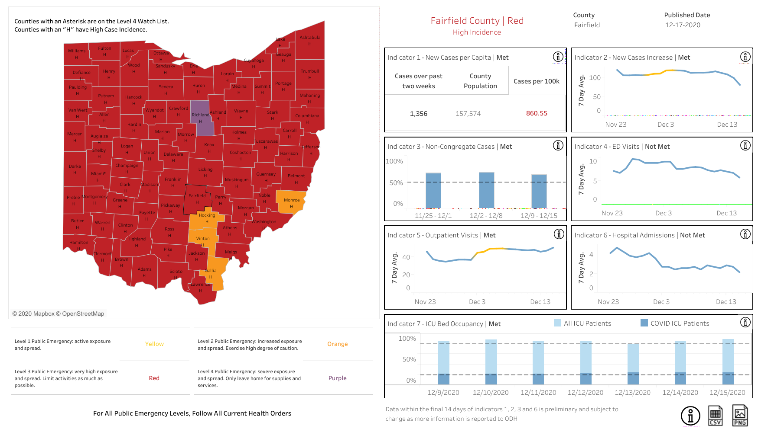

New Business

Tax Advances

**12-02-20 Resolution to direct the Fiscal Officer to request the county Auditor to provide tax advances in the 2021 year as they are received**

Mary Herron made a motion to approve the resolution to direct the Fiscal Officer to request the county Auditor to provide tax advances in the 2021 year as they are received. Mike Jones seconded.

Roll Call: Berneice Ritter-yes, Todd Stanley-yes, Cristie Hammond-yes, Michelle Shirer-yes, Mike Jones-yes, Mary Herron-yes. Resolution passed.

Temporary Appropriations

**12-03-20 Resolution to approve the 2021 Temporary Appropriations as follows: $2,135,559 General Fund, $100,000 Capital Fund, $200 Homework Help Center and $6,000 Guiding Ohio Online Grant Fund**

Mike Jones made a motion to approve the 2021 Temporary Appropriationsas follows: $2,135,559 General Fund, $100,000 Capital Fund, $200 Homework Help Center and $6,000 Guiding Ohio Online Grant Fund. Mary Herron seconded.

Roll Call: Todd Stanley-yes, Mike Jones-yes, Cristie Hammond-yes, Michelle Shirer-yes, Berneice Ritter-yes, Mary Herron-yes. Resolution passed.

Board Meeting Schedule

The meetings are currently on the 3rd Monday of each month at 7:00 p.m. The Board members wanted to keep the same schedule.

**12-04-20 Motion to approve the 2021 Board meeting schedule**

Todd Stanley made a motion to approve the 2021 Board meeting schedule. Mary Herron seconded.

Roll Call: Mary Herron-yes, Mike Jones-yes, Todd Stanley-yes, Cristie Hammond-yes, Michelle Shirer-yes, Berneice Ritter-yes. Motion passed.

Bylaws Update

Second reading of the bylaws. Discussion was held about the time limits for public participation. Tony also asked the Board members to think about the categories listed for Board meetings.

Executive Session

**12-05-20 Motion to go into Executive Session – Compensation of Public Employees (ORC 121.22 (G)(1))**

Cristie Hammond made a motion to go into Executive Session – Compensation of Public Employees (ORC 121.22 (G)(1)). Mary Herron seconded.

Roll call: Berneice Ritter-yes, Todd Stanley-yes, Cristie Hammond-yes, Michelle Shirer-yes, Mike Jones-yes, Mary Herron-yes. Motion passed.

Entered into Executive Session at 8:21 p.m.

**12-06-20 Motion to come out of Executive Session – Compensation of Public Employees (ORC 121.22 (G)(1))**

Cristie Hammond made a motion to come out of Executive Session – Compensation of Public Employees (ORC 121.22 (G)(1)). Mike Jones seconded.

Roll call: Mary Herron-yes, Todd Stanley-yes, Cristie Hammond-yes, Michelle Shirer-yes, Mike Jones-yes, Berneice Ritter-yes. Motion passed.

Came out of Executive Session at 8:38 p.m.

Library Closure and Staff Compensation

**12-07-20 Motion to approve the library closure and compensate staff as presented**

Mike Jones made a motion to approve the library closure and compensate staff as presented. Todd Stanley seconded.

Roll call: Michelle Shirer-yes, Mike Jones-yes, Cristie Hammond-yes, Berneice Ritter-yes, Mary Herron-yes, Todd Stanley-yes. Motion passed.

Approval to close the Library on December 26, December 27, January 2 and January 3.

Approval to compensate staff by giving them floating holiday hours to be used by the end of the 2nd quarter of 2021 (June 30, 2021).

* Full-time staff (36+ hours) would receive 8 hours for each of the two Saturdays and 4 hours for each of the two Sundays, for a total of 24 floating holiday hours.
* Part-time staff (27.5-35.5 hours) would receive 6 hours for each of the two Saturdays and 4 hours for each of the two Sundays, for a total of 20 floating holiday hours.
* Part-time staff (22.5-27 hours) would receive 5 hours for each of the two Saturdays and 4 hours for each of the two Sundays, for a total of 18 floating holiday hours.
* Part-time staff (15-22 hours) would receive 4 hours for each of the two Saturdays and 4 hours for each of the two Sundays, for a total of 16 floating holiday hours.

Employee’s terminating employment with the organization will forfeit any unused Floating Holiday bank hours.

For the good of the order

Adjournment

Cristie adjourned the meeting at 8:41 p.m.

Next Board Meeting:

Regular Board Meeting  
January 18, 2021 @ 7:00 p.m. at via a Zoom Virtual Meeting

____________________________________________

Cristie Hammond

President

____________________________________________

Mary Herron

Secretary