PICKERINGTON PUBLIC LIBRARY BOARD OF TRUSTEES MEETING  
April 19, 2021

The Board of Trustees of the Pickerington Public Library met in regular session on April 19, 2021 at 7:00 p.m. via a Zoom Virtual Meeting, Pickerington, OH 43147. Members present were Cristie Hammond, Mike Jones, Mary Herron, Jennifer Hess, Michelle Shirer, Todd Stanley and Berneice Ritter. Staff members present: Tony Howard, Library Director, Brenda Oliver, Fiscal Officer, Colleen Bauman, Community Engagement Manager and Norma Lockney, Deputy Fiscal Officer. Also in attendance: Kathy Bowden, President of the Friends of the Pickerington Public Library and Name, FAB Community Jennifer Hrusch, Ashley Mensah, Bryan Stout and Catie White.

Call to Order

Meeting called to order by Cristie Hammond.

Roll Call

Excused Absence(s): None

Secretary’s Report

Consent Agenda

* + - 1. March 15, 2021 Regular Board Meeting minutes
      2. March 15 FAB Committee Meeting Minutes
      3. March 15 Library Fund and Fundraising Committee Meeting minutes
      4. Donations
         1. A donation of one logic keyboard XL print American English Bluetooth mini keyboard (black on yellow), designed for visually impaired or mature-aged people. Donated by a regular customer, Nancy Courtney. Donation value - $89.90
         2. 100 Cups of frozen yogurt from Culvers of Reynoldsburg for giveaways during Summer Reading. Donation value - $200.00
         3. 8 annual passes to Dawes Arboretum. These passes expire on April 30, 2024. This is a restricted donation with the expectation that the library adds them to the circulating collection. Donation value - $1440.00

**04-01-21 Motion to approve the Consent Agenda**

Mary Herron made a motion to approve the Consent Agenda items. Jennifer Hess seconded.

Roll Call: Mike Jones-yes, Mary Herron-yes, Cristie Hammond-yes, Todd Stanley-yes, Berneice Ritter-yes, Jennifer Hess-yes. Motion passed with no changes.

Michelle Shirer entered the meeting at 7:01 p.m., but was not able to communicate until technology issues were resolved.

Public Participation

Friends of the Library Report

A report was given updating the Board from the Friends of the Pickerington Public Library.

1. The Friends met on April 12, 2021. They voted to reimburse the library for $2500 worth of expenses during Summer Reading.
2. The Friends will be conducting a “one way” children’s booksale outside under the Library’s tents June 4-5.
3. Tentatively, a fall booksale is being planned during the first week of November.
4. The Friends formally requested additional bookshelf space for the daily sale of materials. A decision has yet to be made on this request, but it was the library’s intent to add shelving after the remodel of the customer service workroom.
5. As of April 12, 2021, the Friends bank account balance is $24,694.92.

Finance Committee

Fiscal Officer’s Report

March 2021 financials

Checking balance - $2,127,920.90

General Fund Investments - $2,341,489.86

Capital Fund Investments – Star Ohio - $363,574.71

March General Fund Revenue - $939,980.87

Revenue Highlights:

Property Tax - $791,262.75

Property Tax Allocation - $52,599.88

PLF - $94,462.95

Customer Fines - $390.28

Coin Op - $844.60

Interest - $144.08

Misc. Revenue - $219.48 (Kroger)

Capital Projects Interest Income - $24.90

Special Revenue Income – none

Expenditure Highlights:

Main Personnel - $79,455

Branch Personnel - $12,643

Main Operations - $33,475

Other Purchased/Contracted Services (Other) - $11,015 (annual website support, biannual preventive maintenance on HVAC, fire & boiler inspections)

Branch Operations - $9,347 (rent lower due to reallocation of CAM charges)

Collection - $20,550

Equipment and Furniture - $518

March General Fund Expenditures - $155,990

Financial Updates:

Public Library Fund - State Revenues – The amount received for March PLF is $80,653.23 which is 9.17% higher than the original estimate. The PLF is currently 37.77% higher than estimated this year.



Star Ohio’s daily interest rate – 0.08%

Star Ohio Plus daily interest rate – 0.07%

Other Items:

- Partial Roof Replacement Copper Disposal – Per the partial roof replacement contract, the library receives the copper that is removed from the roof. At this time, both sections of the roof have been removed and the library has disposed of the copper. The library has received $22,486.70 for the copper this year.

- 2019-2020 Audit – The audit is complete and there were no issues. The library received 3 Stars based on the Star Rating System for meeting Sunshine Law Requirements which is described by the auditor as “Outstanding Achievement in Open and Transparent Government: Implemented 3-4 best practices”.

- PLF Update – The substitute house bill does not include the amendment to raise the Public Library Fund to 1.7%. It also introduced a 2% personal income tax rate cut starting in tax year 2021. The estimated loss is $10 million to the PLF fund. An amendment is being submitted to maintain the percentage of the Public Library Fund at 1.7%. An additional amendment is being submitted to hold harmless the PLF fund from the proposed income tax cut.

- American Rescue Plan (ARP) – Ohio’s public libraries are not receiving $170 million dollars in federal funding through the American Rescue Plan (ARP). About $200 million will go to libraries nationwide through the federal Institute of Museum and Library Services (IMLS). Of that amount, the State Library of Ohio will receive an estimated $4.5 million to divide among university academic libraries, K-12 school libraries and public libraries. Public libraries are also not receiving the billions of dollars that other local government units will be receiving from ARP.

Other Committee Reports

Director’s Report

Spring Strategic Focus – Enrich Our World

Facilities:

Current projects:

- Main Library Structural roofing issue - The Copper Roof on the front of the building is currently under construction. There is a noticeable difference in the new roof versus the old roof. Please remember that it will take about two years for the new roof to patina.

Rough time line for this work to be complete is approximately two weeks. May 1 – estimated completion date. There was only a little damage to the wood on the front of the building, which allowed the roof contractor to move quickly. Tony shared some pictures.

- Rear Roof update - There are still negotiations going on between the manufacturer and the contractor regarding the approach to resolving the issues with the defective materials on the rear roof. CTL Engineering and the Construction Company think they may have an acceptable compromise. The completion date has been extended to mid-June, but are hopeful the project will be complete mid-May.

Miscellaneous:

- Staff Member Highlight:

1. Erica Ward – Erica has been a Customer Services Assistant for over two years. Her character makes her stand out among her peers.  She is genuinely kind, warm, and courteous to all.  Exceptionally reliable, she is a leader on her team and available to help other customer service staff when they have questions. Erica always seeks out ideas, insights, and opportunities to better serve our community.  She came up with an event for the summer to have a Bookclub about healing after a difficult time. Additionally, she speaks up for customers to ensure they receive the best service each and every time.  Whenever Erica is unclear about any information, she prides herself on learning those details to better assist customers going forward. Erica is found deserving of recognition from ELT and the Board for her dedication and service to our library.
2. Catie White – Catie has served the Library as the Branch Manager of Sycamore Plaza Library for almost 4 years. As a core member of the team responsible for opening the branch, she brought value to the organization every step of the way. Catie is an effective leader, great communicator with the ability to build a strong team. She is focused on customers first and providing exceptional service. Fearless when it comes to dealing with difficult situations, Catie is able to remain calm and diffuse tense situations. Catie recently accepted a Manager position with another library and will be moving on at the beginning of May. Catie is highlighted today because she deserves recognition from Administration and the Board for her dedication and hard work at our library.

- Legislative Week & State Budget update - Legislative week has turned into Legislative month! Officially, Legislative week was April 5 through April 9. Tony met with legislators, Representative Jeff LaRe and Senator Tim Schaffer, to share the library’s story and seek support during the State Budget process. He also attended virtual Q&A sessions with Governor Mike DeWine and First Lady Fran DeWine on Tuesday, April 6, Senate President Matt Huffman on Tuesday, April 6, House Assistant Majority Whip Cindy Abrams, and House Assistant Minority Leader Kristin Boggs on Tuesday April 6, Senator Matt Dolan, Chair of the Senate Finance Committee on Thursday, April 8, and Senate Minority Leader Kenny Yuko Friday on April 9. The results of these meetings was the libraries justifying the need for funding. Unfortunately the following week, the House Finance Committee passed HB 110, which not only kept the governor’s reduction of the PLF at 1.66%, but it didn’t hold libraries harmless, and included tax cuts. This would take additional funding from libraries ($10 Million). Throughout the past week, Tony had multiple phone and email conversations with representative LaRe as he prepared an amendment to HB110. Currently, there are two amendments that are in the works or have been submitted. Both amendments bring the PLF to 1.7% and hold libraries harmless from future cuts.

- Digital Downloads / Overdrive update - The Digital Downloads Consortium voted to allow partnerships with schools in order to link SORA with the library’s OverDrive account. OverDrive is currently working to integrate the two systems. Once that occurs, all students of PLSD will have access to the Library’s OverDrive offerings by just using their school ID.

- Swarm of Honey Bees - A swarm of honeybees relocated on one of the trees in front of Main Library. They were right next to the entrance of the construction tunnel causing customers to walk through a portion of the swarm to enter and leave the building. Frank called a wildlife expert to remove the swarm. No one was injured and the bees were relocated safely.

- Operational Structure - When the leadership structure was reorganized, Tony created a hierarchy to ensure continuity of operations in the absence of Colleen and Tony. The person assigned to lead operations and who is third overall responsible for operations has been Catie White (Branch Manager). With Catie moving on to another organization, a decision had to be made to fill this responsibility. Ashley Mensah, Customer Services Manager, has been chosen. While all managers are experienced, Tony felt Ashley is well suited to fill this role. He will be working with her over the next few months to ensure she has what she needs to take over if there is a need.

- Customer Service Guidelines - This document was part of the library’s Tactical Plan and really fits in the retain and regain goals for the year. Now that there is a set of guidelines, Ashley Mensah will be leading the team on transitioning the staff to this new model of service. Ashley Mensah gave a brief description of the document to the Board. Guidelines are at the end of the Director’s Report

- Notable Return on Investment with PLSD – Pre-pandemic: The PLSD Library Media Specialists came to the Library for an in-service training. Recently: The library Media Specialist at Sycamore Creek Elementary requested library cards for all students at that school. This request was a result of that training by library staff. The Youth Services team at Main Library is working to process 600 kids card applications to ensure all students at that school have a library card. That department will be coordinating with the school staff to provide a pop up library several times at the school during the summer. The goal is to get books into the kid’s hands and meet the customer where they are!

- Community Resource Expo - The Information and Research team is planning a Community Resource Expo this summer. The goal of this Expo is to provide a one-day event that brings together in one location, local organizations and agencies that serve individuals, families, and businesses in the community that offer free and low-cost resources.

2021 Action Items:

- Retain - With the challenges brought by the pandemic, Tony feels working to retain current customers is vital to the organization’s success. To accomplish this, Tony will work to ensure that the quality of the library’s virtual programming and services continue to meet the customer’s changing needs. Tony will do this by launching a Customer Experience campaign outlined in newly written guidelines.

* Tony met with Secretary of State Frank LaRose to discuss how the library can support his efforts in sharing information to business and Voter Registration.
* Subscription Book/DVD Bundle Service - 5 customers have signed up so far and the library will push to get the word out.
* The library is rolling out the newly created guidelines this next quarter.

- Regain - The pandemic has changed the habits of many of the library’s citizens. Additionally, with lockdowns and concerns of spreading the virus, many people have turned to other outlets in order to meet needs traditionally fulfilled by the library. Tony will work to update the library’s business model and align services to meet the new/changed needs of community members.

- Recover - For a long time Tony has talked about the library playing a strong role in supporting the health of the community. One way to continue with this role is to create partnerships and adjust the business model to expand capacity outside of the four walls of the library’s facilities. It is important to examine whom the library is currently working with regularly and determine if the library needs to create other partnerships. Additionally, the library can no longer wait for people to come to us. Once it is safe, the library has to execute the plan to reach the community where they are instead of where the library is located. This is the first step in helping the community and the organization recover from this pandemic. The library has collaborated with Violet Township to provide classes and events at their Community Gardens. Additionally, the library is planning a summer reading finale on the Wigwam Property.

CUSTOMER SERVICES DEPARTMENT

**CUSTOMER EXPERIENCE GUIDELINES**

Revised 04/21

**Mission**

Inspire Knowledge, Connect Community, Enrich our World, Read!

**Vision**

A vital involved and evolving community resource, meeting the life-long learning and enjoyment needs of our citizens.

**INTRODUCTION**

“You can design and create and build the most wonderful place on earth. But it takes **people** to make the dream a reality.” - Walt Disney

Much like the philosophy of Walt Disney, the quality of library service is not solely determined by the building or materials. We, the staff, must be dedicated to making every customer’s library experience feel like “the most wonderful place on earth.”

The **mindset** of library staff influences their **behaviors** toward the customers, which then affect the customer’s **experience:**

|  |
| --- |
| **A CUSTOMER-FOCUSED mindset**  *The staff’s motivation:*  *“I’m here for you.”*    **Behaviors that put the CUSTOMER FIRST**  *The interaction between staff and customers:*  *“I see and hear you.”*    **A positive CUSTOMER EXPERIENCE**  *The transaction or result,*  *which conveys the message:*  *“I’ll help you.”* |

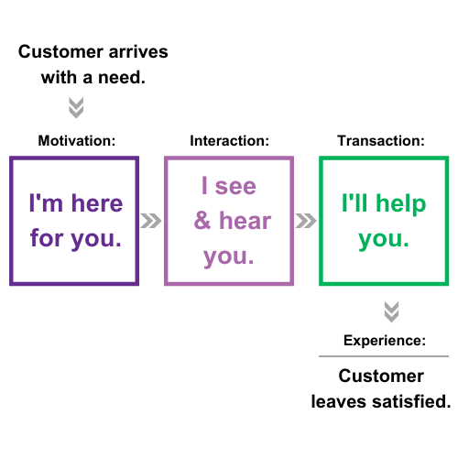

Every customer, regardless of their age or background, arrives with a need. They may be looking for entertainment, information, educational resources, the solution to a problem, or even connection within their community. Our job is to ensure the need of every customer is met and they leave satisfied with their experience.

Furthermore, customers should have a positive experience when we address their need. This is where we want to go beyond the basic, transactional “customer service” model to a more robust “customer experience” model.

**CUSTOMER-FOCUSED**

**CUSTOMER FIRST**

**CUSTOMER EXPERIENCE**

**A CUSTOMER-FOCUSED MINDSET**

***“I’m here for you.”***

Ensuring a stellar customer experience begins before the customer even walks in the door. Staff should have a **customer-focused mindset** that puts the customer first above everything else.

Consider these traits of excellent customer service:

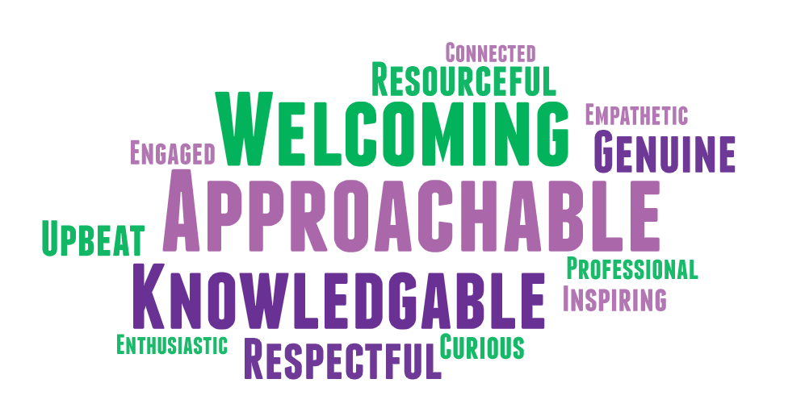

Most importantly, customers want to work with staff who are:

* **Approachable:** Customers should feel like our primary purpose is being present to help them. They should not feel like they are interrupting us from another task.
* **Knowledgeable:** As information professionals, library staff are expected by customers to be informed about resources that will help them. If we do not know the answer, we should at least know where to look or who to ask.
* **Welcoming:** Positive staff attitudes lead to pleasant customer experiences.

|  |
| --- |
| **Expectation:**    At a *minimum*, staff should be  approachable, knowledgeable, welcoming. |

The mindset of staff impacts the experience customers will (or will not) receive. In addition to the traits already discussed, staff perception of a potential issue also has an impact on how it plays out.

There are three common mindsets pertaining to how staff see an issue: **avoid it, tell someone, or take ownership.**

**SCENARIO**

A piece of trash is on the floor.

**Staff #1** sees the trash, but avoids it because she says to herself, “This is not my job.” *The issue is not resolved.*

**Staff #2** tells another staff member a piece of trash is on the floor. *The issue is not yet resolved and may not be dealt with by the colleague.*

**Staff #3** immediately picks up the trash. *The issue is quickly resolved.*

|  |  |
| --- | --- |
|  | Your Take: *How do you step up and take ownership of issues outside your department?* |

**Reflection:** If a customer sees trash on the floor and staff are working nearby yet no one picks it up, it could be interpreted that staff do not care about the appearance of the facility. Staff #1 and Staff #2 both assume that someone else will take care of it, but in that time customers may build a negative perception of their library experience.

A customer’s need and issues in general are resolved when staff take **ownership** of the matter. A collective staff mindset of ownership and customer focus impacts customer experience.

|  |
| --- |
| **Expectation:**    Staff should take immediate action and ownership when  they see something that needs to be addressed. |

**“I’m here for you”** is more than being physically present on the floor. It means understanding that your primary task is to help customers. Checking items in, working on collection development, and other projects must be the lower priority while on desk so that customers can see we are available and excited to assist them. Not all customers feel comfortable asking for help, especially if staff look busy with other tasks, so it is important to proactively offer assistance in a **welcoming** and **approachable** manner.

Consider the following scenarios, one with a staff member who stays focused on their other tasks and one with a staff member who is focused on the customer’s experience.

**SCENARIO A**

**Basic Customer Transaction:**

A customer is standing in the Large Print section. A staff member walks by pushing a shelving cart.

Ten minutes later, the customer is still standing in the same area. When the staff walks down the same row the customer is on to shelve a book, she tells the customer, “Someone can help you at the desk if you need it.”

Five minutes later, the customer exits the building empty handed.

|  |  |
| --- | --- |
|  | Your Take: *Where was the staff’s focus? Was the customer’s need met?* |

**Reflection:** The staff member was focused on her assigned task, although she did eventually check in to direct the customer toward the assistance they needed. She did not take **ownership** of the interaction, and her mindset left the customer’s library need unmet.

**SCENARIO B**

**Customer-Focused Experience:**

A customer is standing in the New Large Print section. A staff member walks by pushing a shelving cart.

**Staff:** Are you finding everything okay?

**Customer:** I’m trying to find a good biography.

**Staff:** Our new biographies are here, and we have more over here. Do you have a particular person in mind?

**Customer:** Yes. I always wanted to read about the royal family.

**Staff:** Which royal family would you like to read about – British, Japanese, Dutch, or do you have another royal family in mind?

**Customer:** British

**Staff**: Here’s a biography about the queen and more biographies are over here about the British royal family members. Also, I’ll be happy to walk you over to an Information Services staff member who can assist you further.

**Customer:** Thanks, but I’m fine.

**Staff:** [As a courtesy, the staff member notifies the Information staff for them to check in with the customer].

[Customer receives additional assistance from the second staff member and leaves satisfied, with several materials].

|  |  |
| --- | --- |
|  | Your Take: *What makes these two interactions different? What would you do differently?* |

|  |
| --- |
| **Expectation:**    Staff should approach customers to offer assistance.  Staff should be proactive, passionate,  and go above and beyond for the customer. |

**Reflection:** In this scenario, the staff member had the right **mindset** to own every customer encounter by being **proactive** and ensuring the customer received what they needed. This mindset was fueled by **motivation – the desire to fully help the customer**. Additionally, the staff member offered to walk the customer over to another staff member who could assist further and this gesture provided additional options. All staff, regardless of position, can walk a customer over to another staff member to ensure the customer receives the assistance they need.

**CUSTOMER-FIRST BEHAVIORS**

***“I see and hear you.”***

Putting customers first means behaving in ways that show you see them, hear them, and are here to meet their need.

**How do “customer-first” staff act and appear?**

* **Visible:** Be easy to find, not hiding behind a monitor or in the stacks.
* **Engaged:** Be aware of your environment. Look up from tasks to see who needs assistance.
* **Non-judgmental:** Be friendly and welcoming in helping customers find resources, regardless of your personal opinions on the topics. Customers have the right to information, and it is not the staff’s place to judge their views or interests.
* **Knowledgeable:** Educate the customer with information relevant to their needs.
* **Attentive:** Make the customer feel important, like they are our only customer and top priority.
* **Approachable body language:** Body language impacts how customers react to what you say.
  + Maintain eye contact.
  + Keep a casual, open stance.
  + Good posture = confidence.
  + Smile when appropriate.
  + Speak clearly and not too fast.
  + Be mindful of your tone of voice (e.g. friendly vs. dry/monotone)

In a customer-first model, customers can find and easily approach us, they are comfortable with asking us questions due to our approachable demeanor, and they know we will be non-judgmental. As a result, customers feel understood and heard because they have our attention.

**SCENARIO A**

**Basic Customer Transaction:**

A customer walks to the desk. No staff member is visible in the area, so the customer waits. A staff member arrives at the desk several minutes later to the now frustrated customer.

**Customer:** I lost a book and now I can’t check anything out.

**Staff:** Let me look you up...That’s $29.99 plus a $5 processing fee.

**Customer:** I guess I might as well pay it now, I don’t want to lose the hold that just came in for me.

The customer starts searching their purse and pockets for their debit card. The staff member used the time to check in materials. Finally, the customer provides the debit card to pay for the material, and the staff member must move the check-in items to make space on the counter. The hold is lifted from the customer’s account, and they can check out their held item.

|  |  |
| --- | --- |
|  | Your Take: *Did the staff member do anything wrong? What would you do differently?* |

**Reflection:** The staff member in this scenario was not within eyesight when the customer arrived, and a lack of staff presence could be frustrating for customers with limited time. We can and should move around, but it is important to stay within eyesight of customers who may need our help at the desk.

The staff member did not acknowledge the customer’s wait time, and she disengaged with the customer when she started checking in other items.

The customer’s need (paying for a lost book in order to check out other materials) was ultimately met, but the interaction was not exceptional.

**SCENARIO B**

**Customer-First Experience:**

A customer walks to the desk, where a staff member makes eye contact and smiles.

**Staff:** Hi! What can we help you find today?

**Customer:** I lost a book and now I can’t check anything out.

**Staff:** I’ll be glad to take a look at your card to see what we can do....It looks like we can renew that book to provide you extra time to look for it, and that would allow you to check out other materials today. Do you want me to renew it for you? I’m happy to do so.

**Customer:** Yes, that would be helpful. Thank you! Just in case, what’s the cost in case I cannot find it?

**Staff:** Certainly. The replacement cost is $29.99, and we charge a $5 processing fee. Keep in mind, you have the option to purchase a new copy in the same format. For instance, a hardback has to be a hardback replacement, and if you choose to replace the book you will only be left with the $5 processing fee. One more thing – we have a no-refund policy in case you decide to pay for it but find it later. I know that was a lot of information, but I wanted you to be aware of all the details. Do you have any questions?

**Customer:** No, you have been very helpful.

**Staff:** Good. We are always willing to help. By the way, I noticed the book you are looking for is about beekeeping. Did you know we have a beekeeping event in two weeks? It’s on March 27th and everyone will receive a complimentary jar of honey.

**Customer:** Beekeeping is a new hobby for me, and I had no idea you offered cool events.

**Staff:** Yes, we do. Our website and app detail all of our upcoming events, and I’ll be glad to show you how to find the events section.

**Customer:** I’m tech savvy, so I’ll take a look. I really appreciate your help.

**Staff:** Great! [smiles] What else can I help you find today?

**Customer:** That’s all. I really appreciate your help! [smiles]

**Staff:** No problem and thanks for stopping by. Have a great day!

|  |  |
| --- | --- |
|  | Your Take: *How would you feel as this customer? Did the staff member go overboard with their friendliness or were they appropriately welcoming?* |

**Reflection:** The first scenario was basic, but the second one was exceptional. The staff member communicated genuine interest in helping the customer and used warm, friendly language and tone. They met the customer’s need and provided information about additional library services the customer may enjoy.

Even though the customer may end up having to pay for the book if they do not find it, the staff member provided options like a renewal, all the details regarding a replacement/no refund, event opportunities, and overall a positive library experience.

These two examples are the difference between **transaction vs. experience.** The staff member was visible and fully engaged with the customer. Think about how this customer will feel when they exit the library. They came to the library because of a “problem,” but they received kindness and insights to support their hobby combined with a positive experience.

|  |
| --- |
| **Expectation:**    All staff should be visible, approachable, and engaged  with customers to demonstrate how they are  always our highest priority. |

|  |
| --- |
| **Expectations:**    Public Service Desks |

An important aspect of putting the customer first is the **public service desks** and the overall **environment** of the library.

Staff should always be present at the desk in order to serve customers; otherwise, customers will walk in and not see a staff member available to assist them. This could be frustrating to customers considering they may have limited time or a pressing need, which could lead to a poor customer experience before staff even interact with the customer.

**Size and Placement:**

Desks in general can serve as a barrier to customers, but large desks can seem even more overbearing and unwelcoming from a customer standpoint.

* Strategically place smaller desks with staff visible and available to offer a more inviting environment.
* When possible, staff might even stand in front of the public service desk: **“I see you.”** This allows customers to quickly identify available staff who can assist them while positioning staff to quickly respond to their need: **“I hear you.”**

**Organization:**

Messy or cluttered public service desks give off the impression that staff are disorganized, busy with other projects, and unapproachable.

* Keep items that are used sporadically in drawers or in closed cabinets.
* Be accountable for your space. If you do need to work on a task while on desk, clean up after yourself before the next person starts a desk shift.
* Put bookmarks or flyers in upright holders and tabletop signs in clear plastic holders. Keep both to a minimum.
* Avoid crowding the desks with multiple carts filled with materials. It creates the appearance of a cluttered and disorganized space, followed by the impression that staff have too much work to do to assist customers.
* Make sure any areas that customers need to access (i.e. counters) are completely clear of materials so that customers have easy access to the areas they need. Large stacks of materials make staff seem unapproachable.

**SCENARIO**

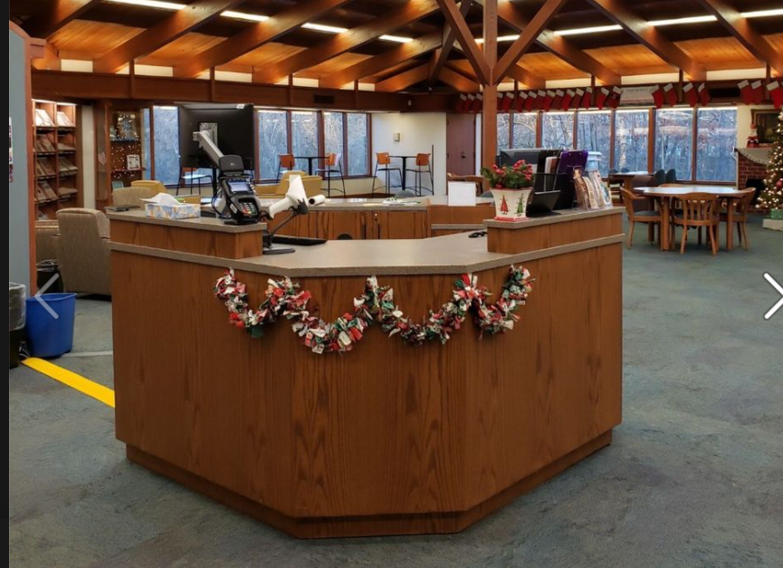

**Reflection:** This desk space is clear and uncluttered. Customers have an unobstructed view of the staff member, and there is space for the customer to place materials while they are being helped. Staff materials such as forms, schedules, and desk supplies are tucked out of sight.

|  |  |
| --- | --- |
|  | Your Take: *What does your workspace look like while you are on desk? Do your materials and tasks encourage customers to feel comfortable asking for help?* |

**SCENARIO A** **SCENARIO B**

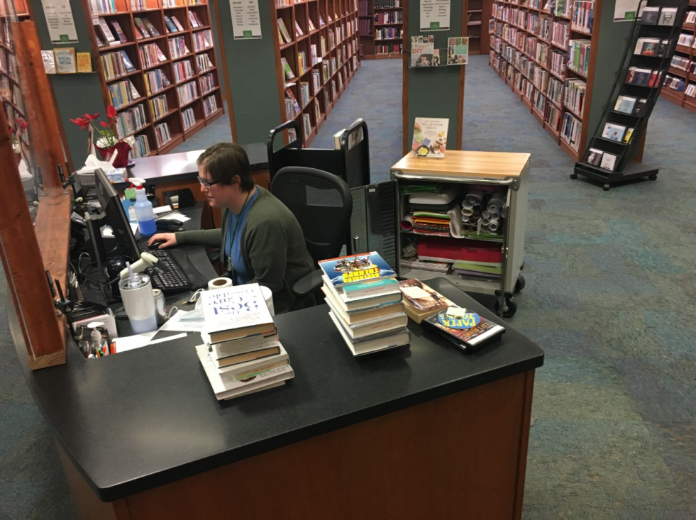 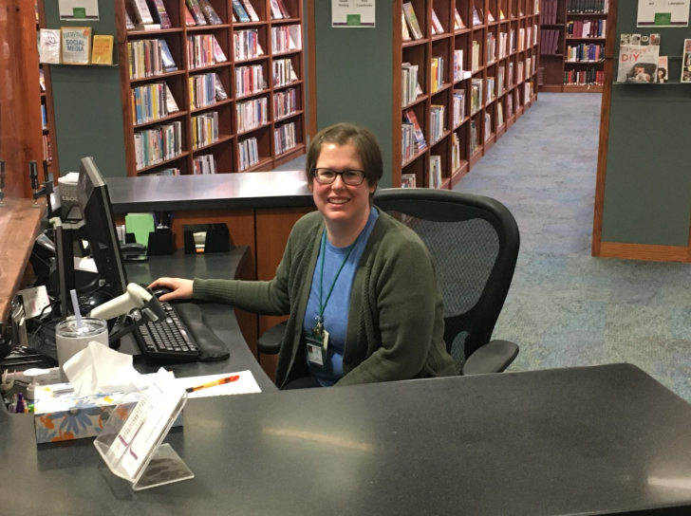

**Reflection:** Consider these two desk spaces. The desk on the left is full of unnecessary clutter around the keyboard, piles of books impeding visibility, and carts that make it clear the staff member is busy with projects. She is focused on her monitor, not acknowledging the customer, and her body posture is closed-off and uninviting.

In contrast, the desk on the right is neat and organized. Customers have an unobstructed view of the staff, and there is space for the customer to place materials while they are being helped. A few select resources are placed in the customer’s reach. The staff’s personal items, such as her water bottle and notebook, do not detract from her approachable demeanor. Her body posture and expression are welcoming.

|  |
| --- |
| **Expectations:**  Public Floor Spaces |

Just like with public service desks, public areas can become cluttered with toys, puzzles, and free publications or handouts. Maintaining clean, clear areas shows that we respect the work of both customers and staff.

**General**

* Table and computer chairs should be pushed in when not in use.
* Books found on tables or lying on shelves should be placed on re-shelving carts. Please make sure to “In-House” these items.
* Communal supplies for customer use (scrap paper, golf pencils, staplers, etc.) should be replenished regularly and the supply area kept tidy.
* Promotional or free publications on display should be current. Recycle or throw away out-of-date materials.
* Display spaces should always be filled and eye-catching. Take frequent breaks from your desk work and walk around to maintain the displays, using the opportunity to check on customers who may be hesitant to ask for help. Choose the best and the brightest of our collection and let our customers see them!

|  |  |
| --- | --- |
|  | Your Take: *How often do you fill displays you notice are empty? What can you and your department do better to ensure the displays are filled?* |

**Youth Services**

* Toys, puzzles, stuffed animals, and/or activities should be set out intentionally so that children are not overwhelmed with too many choices. We want their play time to be meaningful.
* Have a clearly identified place for toys and puzzles to live when they are not being used by customers.
* Encourage children to put items away when they are done playing.

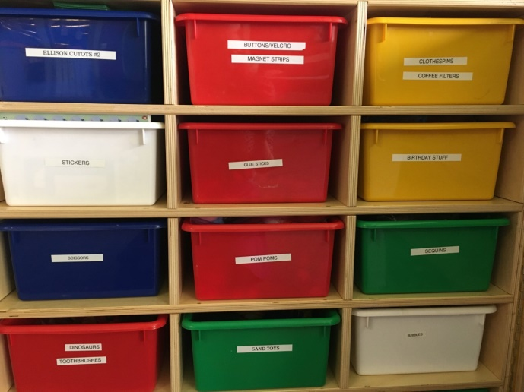

**Reflection:** These toys and craft supplies are stored in labeled bins to make it clear where they belong.

**CUSTOMER EXPERIENCE & RESULTS**

***“I’ll Help You.”***

A positive customer experience comes from finding the best solution for every customer to help them accomplish the need that led them to the library. This may mean doing the task for them, such as looking for a specific book title; guiding them through the process, such as demonstrating computer skills; or directing them to another staff member who can help.

**How do staff provide positive customer experiences?**

* Be a problem solver.
* Share our relevant knowledge.
* Offer the best solution available.
* Know what resources are available elsewhere.

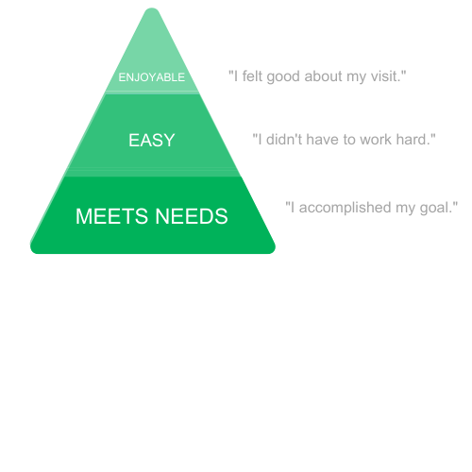

**How should customers feel about their library experience?**

A customer’s desirable experience can be looked at as a hierarchy. The most basic transactional expectation is that a customer **leaves the library with their need met.** Whenever possible, they should feel like getting that need met was **an easy experience.** The greatest mark of a positive customer experience is if the customer **enjoyed their visit** while being assisted.

**SCENARIO A**

**Basic Customer Transaction:**

A customer enters the library. A staff member is at the desk but absorbed in their monitor. After waiting a few moments, the customer approaches the desk.

**Customer:** Excuse me, I need to print. Where are the computers?

**Staff:** Down that way.

The staff member points in the direction of the computer stations and resumes their task on their monitor. The customer walks away, unclear on where exactly the staff member pointed.

|  |  |
| --- | --- |
|  | Your Take: *Have you ever been preoccupied with a task when a customer needed your help? How can you make sure you put the customer’s need first?* |

**Reflection:** The staff member did not solve the customer’s problem. Depending on how far away the computer stations are, the customer might not find them by himself.

**SCENARIO B**

**Customer Experience Interaction:**

A customer walks into the library. A staff member is standing near the desk and greets the customer warmly.

**Staff:** Hi! What can we help you with today?

**Customer:** I need to print. Where are the computers?

**Staff:** Come with me, they’re right this way. Do you have a library card to get logged in?

**Customer:** No.

**Staff:** That's okay! You can sign-up for a library card and it only takes a few minutes. Do you have something with your current address on it like your photo ID?

**Customer:** No, I recently moved and I do not have anything with me that shows my current address.

**Staff:** No problem! We can get you a guest pass today and sign you up for a library card later. Just so you know – you can use a digital address verification on your phone for a library card, but let me walk you over.

The staff member walks the customer halfway to the Information desk to introduce them to the next staff member.

**Staff:** Ms. Laura, would you mind printing a guest pass for this customer? She might also need some assistance logging in.

**Ms. Laura:** Absolutely, I’ll be glad to get her started.

**Staff:** Ms. Laura will get you all set.

**Customer:** Thank you so much.

|  |  |
| --- | --- |
|  | Your Take: *How is this scenario more welcoming and approachable?* |

**Reflection:** In this scenario, the staff member walked the customer to the department to receive assistance instead of simply pointing, which could be confusing. The staff member also checked whether the customer had their library card to use the computer and quickly introduced the solution when the customer said “No.” This prevented possible delays when the customer reached the computer and found they couldn’t log in. Later, after the customer knows their computer need is being met, Ms. Laura might offer information about signing up for a library card.

**SCENARIO A**

**Basic Customer Transaction:**

A customer approaches the Information desk.

**Customer:** Hi, I’m not sure if you can help me, but I need to find a book about the benefits of eating less carbohydrates, but not a cookbook.

The staff member leads the customer to the health section and leaves them to browse, returning to the desk.

**Staff:** Let me know if you need anything else.

The customer is overwhelmed by all the books, but not clear on where to look for their specific need. They look at a few titles, then leave without checking anything out.

|  |  |
| --- | --- |
|  | Your Take: *What was the staff member’s priority in this scenario? Was the customer’s need met, easily and enjoyably?* |

**Reflection:** Many of our collections are large like animals, history, and art. The customer in this scenario identified a specific need, but the staff member did not show them exactly where the carbohydrate books were located. Therefore, the customer’s need remained unmet and the customer probably left feeling frustrated and disappointed.

**SCENARIO B**

**Customer Experience Interaction:**

A customer approaches the Information desk.

**Customer:** Hi, I’m not sure if you can help me, but I need to find a book about the benefits of eating less carbohydrates, but not a cookbook.

**Staff:** Definitely, let me show you that section. We have many books in this section on health, but here are the books that specifically address carbs.

**Customer:** Oh, great! I wasn’t sure if I’d find anything. Thanks!

**Staff:** Also, we have some online resources about health and wellness that you might find useful. In particular, healthfinder.gov provides you with detailed information regarding a variety of topics including eating healthy. It also shares health topics with you based on your age.

**Customer:** I’ve never used these resources. Is it free? How do I find it?

**Staff:** I’ll be glad to show you how it works, and yes! It’s free!

Staff walks customer, who has gathered some titles, back to the desk and provides a brief demonstration of how to find and use healthfinder.gov.

**Customer:** I’ve been coming here for 10 years, and I didn’t know you had this available.

**Staff:** It’s pretty great, isn’t it? Also, I wasn’t sure if you noticed the heart health display near the entrance for American Heart Month since carbs can impact heart health.

**Customer:** I didn’t see it, but I’ll check it out.

**Staff:** Let us know if we can show you where it is or if you need any assistance.

**Customer:** You’ve been a great help, thanks!

**Staff:** Anytime. That’s what we are here for.

|  |  |
| --- | --- |
|  | Your Take: *How did this staff member go above and beyond in the interaction to make it easy and enjoyable?* |

**Reflection:** This scenario demonstrates how the staff member focused in on the exact need of the customer by showing her the carbohydrate books instead of just the general health section. The staff member informed the customer about additional materials on the American Heart Month display in an effort to up sale books. The customer thought this was a difficult question, but the knowledgeable, problem-solving staff member provided this customer with an exceptional experience. How will the customer feel when they exit the building? Let’s look at that chart again.

The experience was enjoyable, easy, and their need met. The customer leaves thinking, “I felt good about that, I didn’t have to work hard, and I accomplished my goal.” Unfortunately, the customer in the basic scenario will not feel the same way.

|  |
| --- |
| **Expectation**  Staff should help customers accomplish their need  by sharing their knowledge in a friendly, helpful manner. |

**Note:** If staff have to reserve materials for a customer, staff should always ask, “What other books can I get for you while you wait for those items to arrive?” to ensure customers do not leave empty handed.

**WHY CUSTOMER EXPERIENCE MATTERS**

Customers visit the library for many reasons: to explore, to discover, and to achieve their desired results. We should respond to customers by being present and approachable, actively listening to their need, and maintaining a positive attitude during the interaction. Our goal is to create an exceptional experience for customers and make them feel like they are the single most important customer every time they visit.

Customer experience drives business. No customers mean no business, while poor customer experience means poor reputation, poor reviews, reduced visits, and for libraries, reduced funding.

Conversely, great customer experience means increased revenue, satisfied customers, excellent community feedback, and repeat customers.

Focusing on the heart of the business – our customers – directly impacts community perception and satisfaction. Businesses that intentionally focus on customer experience are more successful than those who do not. The customer is the heart of all we do; therefore, they must come first and we must ensure their experiences are exceptional and memorable.

|  |
| --- |
| ***“I’m here for you.”***  ***“I see and hear you.”***  ***“I’ll help you.”*** |

Did you know Ohio has some of the best libraries in the country due in part to the state funding we receive? We have a lot to offer that many libraries would dream about and that makes us fortunate. It’s a pleasure for us to be here to serve our community by upholding our mission and vision, so let’s make every customer feel good about being here with us by showing them, **“I’m here for you, I see and hear you, and I’ll help you.”** Even though the customer may have visited one of the best-funded libraries in the country, it takes us, the staff, to make their experience exceptional; otherwise, the recognition as a great Ohio library falls flat.

|  |
| --- |
| **Expectation:**    All staff should go beyond a basic service transaction,  exhibiting a **customer-focused, customer-first**  approach to provide an exceptional  **customer experience.** |

As Walt Disney said, “You can design and create and build the most wonderful place on earth. But it takes **people** to make the dream a reality.” We must all do our part to consistently create exceptional experiences for our customers.

What will you do today to make a customer’s library experience exceptional?

**Related Documents:**

Marketing Guidelines

Visual Merchandising Guidelines

**Special Thanks:**

Ashley Mensah, Lauren Edmonds, Dana Folkerts, Jennifer Hrusch, Catie White

**References:**

Columbus Metropolitan Library. “Customer Experience (CX) for Libraries, 2016.”

Community Engagement Report

|  |  |
| --- | --- |
| March:  Curbside: 69 (just Sycamore)  Drive-up window: 441 (just Pickerington Main) Computer reservations: 140 users  Copy/Fax/Scan reservations: 11 users  Table Reservations: 654 users  Door Count: 6656 (subtracting curbside at Sycamore) Total circulation: 39,772 Wi-Fi use: 1090 users  Computer lab use: 430 users | February:  Curbside: 114 (just Sycamore)  Drive-up window: 424 (just Pickerington Main) Computer reservations: 137 users  Copy/Fax/Scan reservations: 15 users  Table Reservations: 459 users  Door Count: 3,702 (subtracting curbside at Sycamore) Total circulation: 33,487 Wi-Fi use: 710 users  Computer lab use: 302 users |

|  |  |
| --- | --- |
| March ’21 Newsletter:  31.3% open rate, 225 opens, sent to 723 people | February ’21 Newsletter:  32% open rate, 351 opens, sent to 715 people |

|  |  |
| --- | --- |
| March Events: 35 total events  Most attended hosted interactive events:  G&G Luck o’ the Irish: 22 Spring Scavenger Hunt: 30 STEAM Constellation Tubes: 50  Most watched recorded videos:  Sensory Story Time w/ Miss Grace (2020) – 52  No Sew Fleece Dem0 (Feb 2028) – 28 The Ultimate Secret Weapon: Board Books for Baby (Feb 2021) – 23 No-Sew Heating Pad Tutorial: -- 15 Help Fox find his sock! -- 14 | February Events: 17 total events  Most attended hosted interactive events:  Facebook Live chat: 161 Family Fun: 12 Draw with Violet (in person): 10 Paint Night (in person): 10  Most watched recorded videos:  No-sew Fleece Scarf Demo (2018) – 58  What happens when you give a mouse a cookie? (Feb 2021) – 18 The Ultimate Secret Weapon: Board Books for Baby (Feb 2021) – 12 Sensory Story time with Miss Grace: 11 Make Your Own Pinecone Birdfeeder: 11 |

Community Engagement Office:

Social Media Management:

- Big change this past month in Community Engagement office was making the decision to change the social media management tool. After trying out several, the decision was made to move from Hootsuite to Loomly. Hootsuite changed their free offerings from 3 platforms and 30 posts at a time to 2 platforms and 5 posts with 1 user. Loomly offers 35 platforms, unlimited posts and 16 users. Saves Communication Team time by being able to add posts directly to Loomly for review, edit and scheduling. Offers non-profit pricing.

Social campaigns:

Diaper Drive:  
<https://loom.ly/6KDbPvk>

Library Survey:   
<https://www.surveymonkey.com/r/XM6XGXT>

Other social posts:

Steam kits – ready for check out! Colleen shared a picture.

Save the Dates – May and beyond:

Early Literacy Classes:

- Sensory Stories (virtual) | Saturday, May 1 | 10:00 a.m.  
A virtual early literacy class specifically designed for children with special needs. If you’re missing Sensory Stories and Play, tune in with Miss Grace to watch our virtual version on YouTube.

- Family Fun - Pickerington Main   
Wednesdays | May 5, 12, 19 | 10:00 or 11:00 a.m.  
Fridays | May 7, 14, 21 | 10:00 or 11:00 a.m.  
Outdoor storytimes for ages 2-5. Classes will feature books, songs, and rhymes that will make imaginations run wild and prepare young ones for reading. Family Fun will be held outside, weather permitting. Please bring your own chairs or blankets. Masks are required for ages 2 and older. Registration required.

Grab & Go activities | Saturday, May 8 | Available for pick up at both locations:  
- [Feed the Bees: Grab & Go](https://pickeringtonlibrary.libnet.info/event/4869916) | Age Group: Adult

Start a wildflower garden this summer to help support local pollination and the honey bee population. Plant these seeds and feed the bees!

- [Calming Glitter Jar: Grab & Go](https://pickeringtonlibrary.libnet.info/event/4833019) | Age Group: 11-18

Melt away your troubles and decompress with your DIY calming glitter jar. Kits available at both locations while supplies last.

- [Sun Prints: Grab & Go STEAM Activity](https://pickeringtonlibrary.libnet.info/event/4865895) | Age Group: Kids

Experiment with chromatography paper to create a unique nature sun print!

[Facebook LIVE Book Chat - May the Force be with You!!](https://pickeringtonlibrary.libnet.info/event/4782602)  
Monday, May 03 | 6:00 - 6:30 p.m.

Find us on Facebook starting at 6:00 p.m. on the first Monday of every month. New books are featured at every LIVE event!

[Summer Reading Registration Kickoff](https://pickeringtonlibrary.libnet.info/event/5025199) | Monday, May 24: All Day

Stomp, hop, run, and slither during Tails and Tales: Summer Reading 2021! Kids and adults alike are invited to beat the summer slump and challenge themselves to read from May 24-August 14. Stop by the library to register for 2021 Summer Reading, and enjoy a free frozen custard cup from Culver's of Reynoldsburg! While supplies last.

Kids, June 12: “Animals We Love to Hate” with [Ohio Nature Education](https://www.ohionature.org/)

Kids, July 10: “Beekeeping” with [Bring the Farm to You](http://www.bringthefarmtoyou.com/)

Kids, July 17: “Croc Talk” with [Newport Aquarium](https://www.googleadservices.com/pagead/aclk?sa=L&ai=DChcSEwj965a7rODvAhXr_-MHHbL6CeYYABAAGgJ5bQ&ae=2&ohost=www.google.com&cid=CAASEuRoBXk8MsED_tgBZGwt_gB83Q&sig=AOD64_1z4t55U4REjE56KpAqlQdVGA7FPA&q&adurl&ved=2ahUKEwjv7o27rODvAhUIQ80KHTcrDVIQ0Qx6BAgCEAE)

All Ages, August 14:  [Jim Gill](http://jimgill.com/) Concert & Summer Finale at Wigwam Event Center

Old Business

1. Pandemic - Operational Update:

As of Friday April 16, 2021, one third of all Ohioans have had at least one dose of the vaccine. Business and organizations have been reassessing and adjusting their protocols and policies to the pandemic. On Tuesday, April 13, 2021, ELT met to discuss the library’s approach to the pandemic. ELT reviewed current CDC Guidelines, Ohio Health Department and Governor DeWine’s health orders, feedback from the Library’s Management team and current COVID-19 Data. Additionally, The CLC Governing Council and SERLS Board of Directors discussed each library’s thoughts and approach to the pandemic. As a result, the library will be making the following changes in Pandemic Procedures.

- Quarantine of Materials - Effective April 20, 2021, quarantining will end for all materials received at Pickerington Public Library. The library will continue quarantine on all materials going to CLC libraries until the CLC Governing Council votes to end that practice. There was 100% consensus among the CLC Directors to end this practice. However, the vote is being held to ensure CML transportation can work out the logistics of this change. This will be an electronic vote and is expected to happen in the next week or two.

- Masks - As long as there are restrictions imposed by the State of Ohio, the library will maintain a mask requirement. Once State mandates are removed, masks will become optional on library property. There is one caveat for masks to become optional. All staff who wish to be vaccinated must be considered fully vaccinated before this requirement is removed. Since fully vaccinated is defined as two weeks after the final dose of the vaccine, ELT is expecting this to be the end of May. Masks are required when actively involved in outdoor classes and events as long as the statewide mandate remains in effect.

- Gloves - Effective April 20, 2021, the requirement to wear gloves when handling materials will be eliminated. Gloves will still be available as an option for any employee. Gloves will be required when cleaning as outlined by the CDC.

- Cleaning - Staff will no longer be required to clean tables and computers after customers use them. Additionally, staff will no longer be required to clean their shared workstation before the next person takes over. Cleaning supplies will be available if a staff member chooses to clean the workstation when taking over the assigned station. Facilities Management will be responsible from daily cleaning of the facility unless there is an immediate need for staff to clean an area. Each facility will be fogged once per week.

- Plexiglass Barriers - All plexiglass barriers will remain in place until determined unnecessary by Library Administration.

- Staff Health Checks - Staff are required to check their temperature before coming into work or when they arrive at work. Staff should not work if they have a fever high than 100 degrees. Staff are expected to wash or sanitize their hands before the start of their work shift.

- Staff Quarantine Requirements - If staff are fully vaccinated, there will be no requirement for quarantining. If staff are not fully vaccinated and come in close contact with someone who has COVID-19, they will be required to follow CDC guidelines and quarantine for 14 days. Staff will need to take PTO or use unpaid time during this 14-day quarantine.

- Social Distancing Guidelines - The Library follows CDC guidelines on social distancing.

- Public Access:

* Restrooms – All restrooms will be made available for the public.
* Tables – A two person per table requirement remains in effect. Furniture is not allowed to be moved from the area it is located. Meaning, if two people are at a table and want to move closer together, they can do so. They are not allowed to move tables closer together, or move chairs to other tables. The requirement will end for reserving tables.
* Computers – Reservation and time limit requirements for computers are being eliminated.
* PAC stations – All Catalog Computers will be made accessible to the public.
* Meeting and small conference rooms – There will be no changes to the access to meeting and conference rooms at this time.
* Self-Serve Reserves – Self-Serve Reserves will begin at Main library. Due to collection space needs, the reserves will remain behind the desk at Sycamore Plaza.
* Self-Checkouts – All Self-Checkout stations will be brought back online and accessible to the public.

- Classes and Events:

* Indoor – All indoor classes and events follow the State of Ohio’s expectation of 25% of building capacity. The library will take this a step further and limit classes and events to 25% of room capacity.
* Outdoor – Outdoor events and classes will allow familial groups to participate with a limit of ten (10) people per group. This follows State of Ohio Health Orders. Each Familial grouping will be required to remain at least 3 feet apart and not intermingle.

- Food & Drinks – The library will not allow food or drink inside the library at this time.

Unless a date was outlined above, these changes will take effect on April 26, 2021.

Library Usage:

March:  
Curbside: 69 (just Sycamore)

Drive-up window: 441 (just Pickerington Main)  
Computer reservations: 140 users

Copy/Fax/Scan reservations: 11 users

Table Reservations: 654 users

Door Count: 6656 (subtracting curbside at Sycamore)  
Total circulation: 39,772  
Wifi use: 1090 users

Computer lab use: 430 users

February:  
Curbside: 114 (just Sycamore)

Drive-up window: 424 (just Pickerington Main)  
Computer reservations: 137 users

Copy/Fax/Scan reservations:15 users

Table Reservations: 459 users

Door Count: 3,702 (subtracting curbside at Sycamore)  
Total circulation: 33,487  
Wifi use: 710 users

Computer lab use: 302 users

January:

Curbside: 124 (just Sycamore)

Drive-up window: 632  
Computer reservations: 0

Copy/Fax/Scan reservations:0

Table Reservations: 0

Door Count: 4,271 (subtracting curbside at Sycamore)  
Total circulation: 35,338  
Wifi use: 2,768 users

Computer lab use: 322 users

Current COVID information:

* 3 Categories met, 4 not met

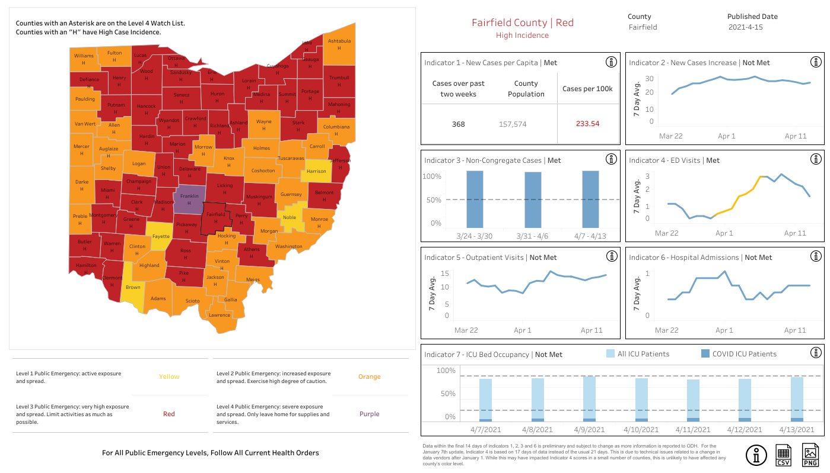

On March 8, 2021, the library began distributing at home COVID 19 tests. To date, 340 kits have been handed out from both locations.

Current Operational Plan Approved at November 2020 Board Meeting:

Level 1 (Yellow): Library Open with browseable collections, strict safety protocols, virtual service, and curbside service. Masks Required

Level 2 (Orange): Library Open with browseable collections, strict safety protocols, virtual service, and curbside service. Masks Required

Level 3 (Red): Library Open with browseable collections, strict safety protocols, virtual service, and curbside service. Masks Required. Administration will monitor traffic flow and implement controls as needed.

Level 4 (Purple): Curbside service, virtual services No access to Facilities by customers

Governor Ordered shutdown – Facilities closed

The Vaccine rollout has changed the outlook and perspective of the pandemic. All other CLC and SERLS Libraries have (or are in the process) moved away from using the State’s Health Advisory system to determine facility closure. Additionally, School districts and other nonprofit agencies are no longer looking at that system to determine closing their organization.

In a review of last year’s operations, it was discovered that following this system caused the library to close and open several times. This was confusing for customers and created a negative impact on the community.

It is the recommendation of the ELT to use the following reasons to close the library due to the current pandemic.

- Staffing issues – Illness; Leave of Absence

- Emergency Order issued by State or Federal Government

Todd Stanley raised concerns about being an extreme change. Michelle Shirer raised concerns that there are no vaccinations available for children yet.

**04-02-21 Motion to approve recommended changes to the operational plan**

Mary Herron made a motion to approve recommended changes to the operational plan. Berneice Ritter seconded.

Roll Call: Berneice Ritter-yes, Todd Stanley-no, Cristie Hammond-yes, Michelle Shirer-yes, Mike Jones-yes, Jennifer Hess-yes, Mary Herron-yes. Motion passed.

2. Board Retreat - Scheduled for Sunday May 16, 2021 from 10 a.m. to 2 p.m. This retreat will be held at the Wigwam owned by Violet Township.

New Business

Insurance Plan

The library is insured through the Ohio Plan Risk Management, Inc. for property/liability/auto/Director’s and Officer’s/umbrella/cyber/terrorism coverage. The policy is scheduled to renew on April 19, 2021. The premium has increased by $258 compared to last year’s policy. The premium for this year is $12,852. The library currently has $25,000 in Computer Fraud and Fund Transfers and Social Engineering coverage. There is an option to increase both of these to $100,000. The increase in annual cost for the increase in coverage for Computer Fraud is $19 and Social Engineering $28. The current renewal did not include any increases in building and contents coverage. To increase building and contents coverage by 1% the additional premium is $81. The current policy does not include Flood or Earthquake coverage. There is an option for $1 million in coverage with a $25,000 deductible for an additional $562 for each.

The library is currently insured through the Ohio Plan for property/liability/auto/Director’s and Officer’s/umbrella/cyber/terrorism coverage April 19, 2020 through April 19, 2021. Last April, the Board approved the insurance renewal with the Ohio Plan through April 19, 2021. The Ohio Plan Risk Management, Inc. is an Ohio self-insurance pool that falls under ORC 2744.081.

**04-03-21 Motion to approve continuing insurance coverage with the Ohio Plan Risk Management, Inc. effective April 19, 2021 thru April 19, 2022 adding additional coverage for Computer Fraud, Social Engineering and increasing building and contents values by 3%**

Mike Jones made a motion to approve continuing insurance coverage with the Ohio Plan Risk Management, Inc. effective April 19, 2021 thru April 19, 2022 adding additional coverage for Computer Fraud, Social Engineering and increasing building and contents values by 3%. Mary Herron seconded.

Roll Call: Todd Stanley-yes, Mike Jones-yes, Cristie Hammond-yes, Michelle Shirer-yes, Berneice Ritter-yes, Mary Herron-yes, Jennifer Hess-yes. Motion passed.

Appropriation of Funds

The library applied for a summer reading program grant through the State Library of Ohio and has been approved and received for $1,500. The library is going to use the grant funds to pay for summer reading program presenters. This grant is an IMLS grant and is federally funded and no matching funds are required for this grant.

Restricted Federal Grants need to be accounted for in a separate special revenue fund. The Summer Reading Grant fund was set-up in 2020.

**04-04-21 Resolution to appropriate 2011-100-390-3912 Other Purchased & Contracted Services (Info & Research) for $530 and 2011-100-390-3914 Other Purchased & Contracted Services (YS Programs) for $970**

Mike Jones made a motion to appropriate 2011-100-390-3912 Other Purchased & Contracted Services (Info & Research) for $530 and 2011-100-390-3914 Other Purchased & Contracted Services (YS Programs) for $970. Jennifer Hess seconded.

Roll Call: Mary Herron-yes, Mike Jones-yes, Todd Stanley-yes, Jennifer Hess-yes, Cristie Hammond-yes, Michelle Shirer-yes, Berneice Ritter-yes. Resolution passed.

Use of a Materials Recovery Agency

Ashley Mensah and Catie White presented the background of using a materials recovery agency.

Problem – The library is dedicated to providing the best customer service in every aspect; however, the current collection agency fees hinder this goal in several ways by negatively affecting a customer’s experience with the library. Although the collection agency fees offer some revenue for the organization, it does so at the expense of tainting the customer’s view about the library and results in a barrier to access as we focus on regaining, retaining and recovering our valued customers.  The library relies on our community and one way to build good will with customers is by consistently offering an excellent customer experience in all areas including policies and procedures.

1. Materials returned/check out still denied – When customers do not return items on time, a collection agency fee is added to their card. If not paid, this fee prevents customers from checking out physical materials regardless if the materials are returned. For example, if a customer returns an item in 2021, but they have a collection agency fee from 2018, this customer still cannot check out physical materials even though the late items may have been returned. Essentially, the library holds customers financially accountable for materials not returned years after the fact.
2. Income/ability to pay – The collection agency fee of $10 (other libraries may have a different fee such as $12) restricts customers from checking out physical materials until that fee is paid. Many customers in the community are on a fixed income, working a low income job, or suffering financially due to a spouse’s loss of household income particularly in this economy. Informing customers that they cannot check out materials can make them feel humiliated or embarrassed due to their inability to pay. This context is comparable to a customer unable to pay for groceries or other essentials. In that case, the customer walks away with no groceries. In the library’s case, the customer walks away void of physical materials to meet their educational, informational, or recreational need.
3. Misleading information – Many customers believe they will be reported to a credit agency which could hinder their ability to purchase a house, secure employment, obtain a vehicle, co-sign on a vehicle for a teenaged child, etc. Even though customers are not reported to a collection agency company like Experian, the language of “collection agency” and subsequent “collection” activity (letters and calls from Unique Management Services (UMS)) implies they will be reported. UMS recommends not informing customers that they will not be reported to a credit reporting agency leaving some customers feeling alarmed and concerned about their credit since they believe they will be reported.
4. Fee –The library is fine-free, but collection agency charges could be considered hidden fees.
5. Customer pursuance – The library mails letters to customers for overdue items 28 days after the due date. UMS mails a letter and calls customers if the items have not been returned 56 days after the due date. Each month, UMS provides a report with change of address information for library staff to update customer accounts after engaging in skip tracing activities to determine a customer’s whereabouts.

Historically speaking, many libraries have used UMS to recover materials. Pickerington Public Library started using this service in 2000 with large balance accounts (anything over $25) and added small balance in 2018 (anything under $25).

Working with the Central Library Consortium (CLC), it was determined that there is no way to view how much money the library collects from customers compared to what is collected through Unique Management. CLC was able to create a report for the library that shows how many items are overdue in a day. When these numbers are compared to how many items are submitted to UMS for collection, the numbers are fairly low.

** Please note, when collecting data 2020 was not considered due to the unique circumstances of the year.



Turnover Rate 3/4/2019 to 3/15/2020

Number of items = 570198

Circ count = 616386

Turnover rate = 1.08100

Turnover Rate 3/16/2020 to 3/4/2021

Number of items = 570203

Circ count = 349418

Turnover rate = 0.61280

Additional information:

* Since December 10, 2001, 6,460 large balance accounts have been submitted to UMS.
  + Dollars received $122,620.76
  + Materials returned $155,240.67
  + Dollars waived $50,057.29
* Since February 1, 2018, 565 small balance accounts have been submitted UMS.
  + Dollars received $4,472.20
  + Material returned $8,033.86
  + Dollars waived $2,192.96
* The library paid Unique Management Services $4,326.15 in 2019, $3,447.50 in 2018 and $2,398.60 in 2017. Prior to 2017, the average amount paid to UMS per year was roughly $2,000. Less than half of these fees paid to UMS are recovered from the customer.

Recommendation – The library recommends moving away from using the material recovery services of UMS. The cost the library recoups does not justify the negative customer experience and perception about the library. If an item is not returned in a timely manner, customers should be charged the replacement cost/processing charge without any additional fees.

Mike inquired what action the library takes in order to recover the materials.

**04-05-21 Resolution to allow Library Administrators to end the practice of using a materials recovery agency in the recovery of library materials and remove associated fines**

Mike Jones made a motion to allow Library Administrators to end the practice of using a materials recovery agency in the recovery of library materials and remove associated fines. Mary Herron seconded.

Roll call: Jennifer Hess-yes, Berneice Ritter-yes, Todd Stanley-yes, Cristie Hammond-yes, Michelle Shirer-yes, Mike Jones-yes, Mary Herron-yes. Resolution passed.

Sensory Inclusion Grant

The library applied for a Sensory Inclusion grant through the Fairfield County’s Diversity, Inclusion and Empowerment Fund and has been approved for this $750 grant. The library is going to utilize these funds to apply for a sensory inclusion certification through Kulture City for both locations.

Restricted Grants need to be accounted for in a separate special revenue fund.

**04-06-21 Resolution to establish a Sensory Inclusion Grant fund number 2013**

Todd Stanley made a motion to establish a Sensory Inclusion Grant fund number 2013. Mary Herron seconded.

Roll call: Mary Herron-yes, Todd Stanley-yes, Cristie Hammond-yes, Michelle Shirer-yes, Mike Jones-yes, Berneice Ritter-yes, Jennifer Hess-yes. Resolution passed.

**04-07-21 Resolution to establish revenue account 2013-292-0000 Restricted Other Grants-In-Aid**

Todd Stanley made a motion to establish revenue account 2013-292-0000 Restricted Other Grants-In-Aid. Berneice Ritter seconded.

Roll call: Michelle Shirer-yes, Mike Jones-yes, Cristie Hammond-yes, Jennifer Hess-yes, Berneice Ritter-yes, Mary Herron-yes, Todd Stanley-yes. Resolution passed.

**04-08-21 Resolution to appropriate 2013-100-390-3910 Other-Purchased and Contracted Services (All other) for $750**

Mary Herron made a motion to appropriate 2013-100-390-3910 Other-Purchased and Contracted Services (All other) for $750. Todd Stanley seconded.

Roll call: Todd Stanley-yes, Mike Jones-yes, Cristie Hammond-yes, Jennifer Hess-yes, Michelle Shirer-yes, Mary Herron-yes, Berneice Ritter-yes. Resolution passed.

For the good of the order

Adjournment

Cristie adjourned the meeting at 9:01 p.m.

Next Board Meeting:

Regular Board Meeting  
May 17, 2021 @ 7:00 p.m. via a Zoom Virtual Meeting or possibly in person per discussion of Trustees

____________________________________________

Cristie Hammond

President

____________________________________________

Mary Herron

Secretary