PICKERINGTON PUBLIC LIBRARY BOARD OF TRUSTEES MEETING  
May 16, 2021

The Board of Trustees of the Pickerington Public Library met in regular session on May 16, 2021 at 10:12 a.m. at the Wigwam Event Center, 10190 Blacklick-Eastern Rd NW, Pickerington, OH 43147. Members present were Cristie Hammond, Mike Jones, Mary Herron, Jennifer Hess, Michelle Shirer, Todd Stanley and Berneice Ritter. Staff members present: Tony Howard, Library Director, Brenda Oliver, Fiscal Officer, and Colleen Bauman, Community Engagement Manager.

Call to Order

Meeting called to order by Cristie Hammond.

Roll Call

Secretary’s Report

Consent Agenda

1. April 19, 2021 Regular Board Meeting minutes
2. Staff Changes
   1. Lorna Reine – Promotion to Youth Services Assistant at Sycamore - $13.87 an hour effective May 3
   2. Rebekah Lennon – Promotion to Sycamore Branch Manager - $44,824 salary (exempt) effective May 10
3. Grants
   1. The Fairfield County Diversity, Inclusion and Empowerment Fund of the Fairfield County Foundation – Gift received of $750 for the Sensory Inclusion Grant Fund

**05-01-21 Motion to approve the Consent Agenda**

Mary Herron made a motion to approve the Consent Agenda items. Todd Stanley seconded.

Roll Call: Mike Jones-yes, Mary Herron-yes, Cristie Hammond-yes, Todd Stanley-yes, Berneice Ritter-yes, Jennifer Hess-yes. Motion passed with no changes.

Public Participation

Friends of the Library Report

Tony shared that the Friends had another meeting. They have agreed to pay for seating around the Children’s Garden.

Michelle Shirer entered the meeting.

Finance Committee

Fiscal Officer’s Report

Checking balance - $1,666,113.06

General Fund Investments - $2,741,653

Capital Fund investments – Star Ohio - $363,598.04

April General Fund Revenue - $91,710.87

Revenue Highlights:

PLF - $80,653.23

Property Tax Rollback - $292.85

Customer Fines - $282.51

Coin Op - $478.85

Interest - $163.14

Other – Sale of Fixed Assets - $9,780 (Copper)

Capital Projects interest income $23.33

Special Revenue - $5,912 (Guiding Ohio Grant & Summer Reading Grant)

Expenditure Highlights:

Main Personnel - $79,537

Branch Personnel - $12,437

Main Operations - $43,723 (annual insurance, audit fees, quarterly consortium fees)

Branch Operations - $9,237

Collection - $11,836 (Lower due to transition to new book vendor)

Equipment and Furniture - $0

April General Fund Expenditures - $156,771

Financial Updates:

Public Library Fund – State Revenues –The amount to be received for April PLF is $112,042.89 which is 4.94% below the original estimate. This is due to the delay of the collection of income taxes from April to May.



Star Ohio’s daily interest rate – 0.08%

Star Ohio Plus daily interest rate – 0.07%

2022 Budget Request:

2022 Revenue Estimate – Based on the current PLF discussions of reducing PLF to 1.66% and reducing income taxes by 2% the PLF estimate has been reduced to $1,095,534. Overall revenue estimate is $2,634,084 for the General Fund and $50 for the Capital Projects Fund.

- Main Personnel – Increased to reflect an increase in operating hours starting in 2022 and provide raises for staff. The Salary ranges are due to be re-evaluated in January 2022. The amount requested of $1,208,800.

- Sycamore Personnel – Also increased to reflect an increase to full operating hours, raises and full staff coverage. Amount requested of $268,630.

- Main Operations – Increased to reflect general increases for insurance, utilities and maintenance. Programming budgets restored to pre-pandemic figures. Amount requested of $392,500.

- Branch Operations – Amount requested of $128,650.

- Collections – Increased to pre-pandemic levels and increased Overdrive budget due to increased usage. Amount requested $356,360.

- Equipment and Furniture – Increased to pre-pandemic levels to replace technology and furniture. Total requested of $79,000.

Total General Fund Budget request - $2,433,940

Homework Help Center - $300

Capital Projects Fund - $40,000 (This is the maximum available to be appropriated based on the Fund balance)

Comparison to 10 Year Forecast:

- Revenue – The 2022 estimated revenue is $82,891 below the projected revenue for 2022 due to the possible unexpected reductions to the PLF.

- Expenditures – The 2022 Budget request is $53,919 below the expected expenditures for 2022.

- Capital Fund Transfers in the Forecast – The amount projected to be transferred in 2020 was $100,000, 2021 is $150,000 and 2022 is $255,000. The $100,000 in 2020 was not transferred.

Other Committee Reports

Director’s Report

Spring Strategic Focus – Enrich Our World

Facilities:

Current projects:

- Main Library Structural Roofing Issue - The copper roof on the front of the building is complete on the outside! Tony shared some photos. The inside of the roof still needs sanded down and refinished. Expected completion is the end of the week.

- Rear Roof Update - There are still negotiations going on between the manufacturer and the contractor regarding the approach to resolving the issues with the defective materials on the rear roof. Materials are expected to be delivered next week. Pending final approval work will restart on May 24. There are three weeks of work to complete the construction of the rear roof.

Miscellaneous:

Staff Member Highlight:

- Rhonda Adams “AKA Violet”– Rhonda has been employed at the library for almost 8 years. Her current role is Customer Services Associate. Rhonda is responsible for processing incoming materials, completing monthly customer service reports and shelving. Rhonda voluntarily performs the duties as the library’s mascot, Violet the Cow. She takes this role seriously and performs the duty of a mascot with pride. Rhonda has made positive contributions to her colleagues’ morale. She created a staff driven recognition program called the “Gratitude Jar”. Staff anonymously submit notes stating why they are grateful of specific colleagues.

State Budget Update:

- The Ohio House did not include a provision in Amended Substitute House Bill 110 to maintain the Public Library Fund (PLF) for Ohio’s libraries at 1.7% of the General Revenue Fund (GRF). Based on what is included in the House Budget, libraries are being negatively impacted in several different ways:

* + - * The PLF percentage is being cut from 1.7% to 1.66%.
      * The base of the GRF will be negatively impacted by the 2% income tax cut.
      * Libraries will automatically see a $5 million deduction each fiscal year for the Ohio Public Library Information Network and the Library for the Blind.

- Libraries are not receiving any of the American Rescue Plan (ARP) Act stimulus money for local governments directly from the federal government.

- Of the $200 million devoted to libraries from the ARP stimulus money, Ohio will receive $4.5 million. The State Library of Ohio controls the distribution of those funds and they have decided to grant that money to Academic and Special Libraries.

PLF Negotiations:

- Discussions begin next week regarding the County PLF Agreement. Directors are meeting to have an initial discussion.

- Because the US Census data has yet to be released, we are hopeful the other two libraries will be willing to extend the current agreement one more year.

Benches and tables

2021 Action Item:

- Retain - With the challenges brought by the pandemic, Tony feels working to retain our current customers is vital to our organization’s success. To accomplish this, he will work to ensure that the quality of the virtual programming and services continue to meet the customer’s changing needs. Tony will do this by launching a Customer Experience campaign outlined in newly written guidelines.

* Met with Secretary of State Frank LaRose to discuss how we can support his efforts in sharing information to business and Voter Registration.
* Subscription Book/DVD Bundle Service - 5 customers have signed up so far and we plan to push to get the word out.
* We are rolling out the newly created guidelines this next quarter.

- Regain - The pandemic has changed the habits of many citizens. Additionally, with lockdowns and concerns of spreading the virus, many people have turned to other outlets in order to meet needs traditionally fulfilled by the library. Tony will work to update the library’s business model and align services to meet the new/changed needs of community members.

- Recover - For a long time, Tony has talked about the library playing a strong role in supporting the health of the community. One way the library can continue with this role is to continue to create partnerships and adjust the business model to expand capacity outside of the four walls of the facility. It is important to examine whom the library is currently working with regularly and determine if other partnerships need to be created. Additionally, the library can no longer be a library that waits for people to come to the library. Once it is safe, the library needs to have and execute the plan to reach the community where they are instead of where the library is located. This is the first step in helping the community and the library recover from this pandemic.

* + The library has collaborated with Violet Township to provide classes and events at their Community Gardens. Additionally, a summer reading finale is being planned on the Wigwam Property.

Community Engagement Report

Building stats comparison:

|  |  |  |
| --- | --- | --- |
| February Curbside: 114 (just Sycamore)  Drive-up window: 424 (just Main)  Computer reserv: 137 users  Copy/Fax/Scan reserv: 15 users  Table Reservations: 459 users  Door Count: 3,702  (subtracting curbside at Sycamore) Total circulation: 33,487 Wifi use: 710 users  Computer lab use: 302 users | March Curbside: 69 (just Sycamore)  Drive-up window: 441 (just Main) Computer reserv: 140 users  Copy/Fax/Scan reserv: 11 users  Table Reservations: 654 users  Door Count: 6,656  (subtracting curbside at Sycamore) Total circulation: 39,772 Wifi use: 1090 users  Computer lab use: 430 users COVID tests handed out: 543 *\*At-home COVID tests became available on Monday, March 8.* | April Curbside: 58 (just Sycamore)  Drive-up window: 442 (just Main) Computer reserv: 44 users  Copy/Fax/Scan reserv: 7 users  Table Reservations: 348 users  Door Count: 6,120  (subtracting curbside at Sycamore) Total circulation: 51,221 Wifi use: 1,174 users  Computer lab use: 359 COVID tests handed out: 256 (total all-time 799)  *\*Last month for reservation statistics. Stopped reservations system on April 20, after April 18 BOT.* |

Social Media:

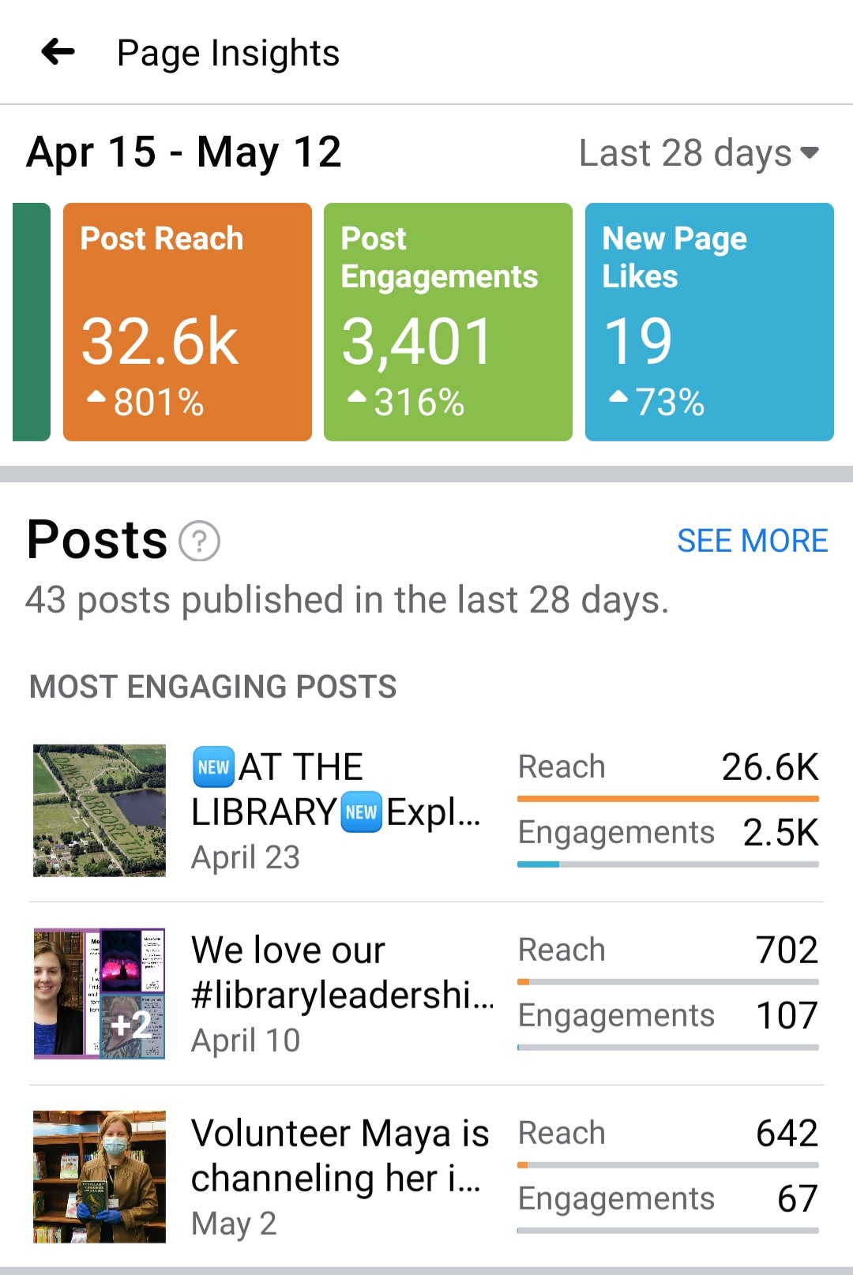

- 90 website visitors directed from Facebook, Instagram (9), Twitter (3)

Most watched recorded videos on YouTube:   
In April, people watched our videos 328 times

Colleen shared several pictures.

- [Sensory Story time with Miss Grace](https://studio.youtube.com/video/8zzamzbBcYY/analytics/tab-overview/period-default)

[Posted Oct 5, 2020 - watched 54 times in April](https://studio.youtube.com/video/8zzamzbBcYY/analytics/tab-overview/period-default)

180 total views with 26.4 hours

[- Sensory Stories: It looked like spilt milk, but it wasn't!](https://studio.youtube.com/video/ZsbTr43atbk/analytics/tab-overview/period-default)

[Posted Apr 3, 2021 – watched 24 times in April](https://studio.youtube.com/video/ZsbTr43atbk/analytics/tab-overview/period-default)

36 total views with 4.2 hours

[- Sensory Story time with Ms. Grace](https://studio.youtube.com/video/QFacdgST3I0/analytics/tab-overview/period-default)

[Posted Jun 9, 2020 – watched 18 times in April](https://studio.youtube.com/video/QFacdgST3I0/analytics/tab-overview/period-default)

81 total views with 6.2 hours

Website:

Tactical SCOPE is under way for website updates.

Community:  
Library staff is gearing up for summer outreach visits!  
Sycamore Creek Elementary monthly  
Tussing Elementary for summer feeding each Friday in June  
Farmer’s Market – held Thursdays, 4-7pm

April Events: 31 total events

Most attended hosted interactive events:   
ACT crash course: 32  
Beyond Abilities Book Club: 22 and 20  
STEAM Break: Kaleidoscope at Home Take 2: 13

Upcoming events/classes:

It’s all about Summer Reading!   
Registration kickoff – May 24 – free cup of Culver’s frozen custard (while supplies last)  
Pick up prizes through August 14  
Finale - @ Wigwam (Jim Gill, Bring the Farm to You, Dunk Tank, Touch a Truck)

Community Resources Expo  
Animals we love to hate with Ohio Nature Education  
Croc Talk with Newport Aquarium  
Summer Yoga with Jerry L. Garver YMCA  
Beekeeping with Bring the Farm to You

Kids: Dissect Owl Pellets, Kindness Trail art project display with Parks & Rec, Insect Investigation at Coyote Run  
Tweens: Live action Among Us, Balloon splatter painting  
Teens: Live Action Battleship, Trivia games, Photo editing, College Hacks: 1 - Campus Living, 2 – Scheduling & Management, Teen Lock-In  
Adults: Spark Joy! Webinar, Music & Wellness (4-part), Grow your own Succulent Garden with Orchids & Ivy,

Marketing:   
April ’21 Newsletter: 30.6% open rate, 220 opens, sent to 720 people  
March ’21 Newsletter: 31.3% open rate, 225 opens, sent to 723 people

Old Business

Pandemic Operational Update:

This past week, Governor DeWine announced that he has asked the Ohio Department of Health to remove most pandemic health orders on June 2nd.

* The timeline is intended to allow any Ohioan who has not yet received a COVID-19 vaccine to obtain one to protect themselves and others before the lifting of coronavirus mitigation protocols.
* Measures being removed will include facial covering protocols, social distancing guidelines, and capacity restrictions for indoor and outdoor events.
* Governor DeWine announced that any pandemic health orders that would remain solely relate to nursing homes and assisted living facilities.

Library Administrators understand the Governor’s decision to rescind the health orders: However, we recognize that this isn’t the end of the pandemic. Furthermore, it is our opinion that we are still facing changed customer habits and financial fallout due to the pandemic.

Below is an outline of the adjustments we are making to our operations during this phase of the pandemic. These adjustments will take effect on June 2, 2021

Quarantine of Materials:

Effective April 20, 2021, quarantining ended for all materials received at Pickerington Public Library. The CLC Governing Council voted to end the practice of quarantining materials beginning May 23, 2021. The library will continue quarantine on all materials going to CLC libraries until that date.

Masks:

With State mandated face covering requirements being lifted, the library is taking the stance that wearing masks on library property is optional for staff and customers.

The Library will end the practice of providing disposable face masks for staff and the public. This is because all staff have received 6 cloth masks provided by the BWC over the past 9 months.

Gloves:

Effective April 20, 2021, the library eliminated the requirement to wear gloves when handling materials. Gloves are still available as an option for any employee. Gloves will be required when cleaning as outlined by the CDC.

Cleaning:

Staff are no longer required to clean tables and computers after customers use them. Additionally, staff no longer are required to clean shared workstations before the next person takes over. Cleaning supplies are available if a staff member chooses to clean the workstation when taking over the assigned station.

Facilities Management staff are responsible for daily cleaning of the facility unless there is an immediate need for staff to clean an area.

Each facility will be fogged once per week.

Plexiglass Barriers:

All plexiglass barriers will remain in place until determined unnecessary by Library Administration.

Staff Health Checks:

Staff will no longer be required to take their temperature before coming into work or when they arrive at work. However, Staff are expected not to come in if they have a fever or known contagious illness.

Staff are expected to wash or sanitize their hands before the start of their work shift.

Staff Quarantine Requirements:

If staff are fully vaccinated, there will be no requirement for quarantining.

If staff are not fully vaccinated and come in close contact with someone who has COVID 19, they will be required to follow CDC guidelines and quarantine for 14 days. Staff will need to take PTO or use unpaid time during this 14-day quarantine.

Social Distancing Guidelines:

The Library follows CDC guidelines on Social Distancing whenever possible. Staff are expected to social distance, but the library will not be enforcing social distancing among customers.

Public Access:

- All Restrooms are available for the public.

- Tables –

* A two person per table requirement remains in effect.
* Furniture is not allowed to be moved from the area it is located. Meaning, if two people are at a table and want to move closer together, they can do so. They are not allowed to move tables closer together, or move chairs to other tables.
* The requirement has ended for reserving tables.
* The library is starting to add more tables into the atrium as construction and quarantining operations are complete.

- Computers – Reservation and time limit requirements for computers have been eliminated and all computers will be brought back on line.

- PAC stations - All Catalog Computers are accessible to the public.

- Meeting and Small Conference Rooms – There will be no changes to the access to meeting and conference rooms at this time. ELT will monitor CLC guidelines on social distancing and make changes as necessary.

- Self-Serve Reserves – Self-Serve Reserves began at Main library. Due to collection space needs, the reserves will remain behind the desk at Sycamore Plaza.

- Self-Checkouts – All Self-Checkout stations are back online and accessible to the public.

Classes and Events:

- Indoor – All indoor classes and events will follow a 25% room capacity.

- Outdoor – Outdoor events and classes will not have any requirements for social distancing.

Food & Drinks:

The library is not allowing food inside at this time. Drinks with lids will be allowed into the library.

Current COVID information:

* 2 Categories met, 5 not met

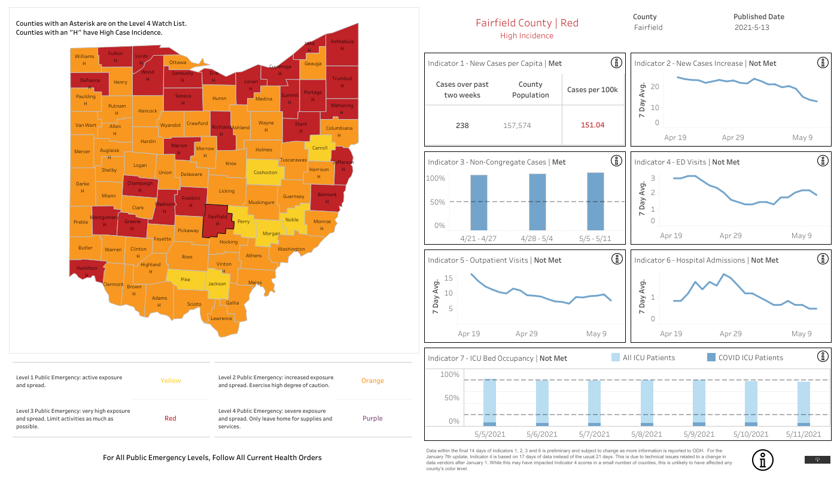

Operating Hours:

At this time, ELT is not recommending expanding operating hours back to pre-pandemic levels. With potential cuts to the PLF and an unsure outlook in the housing market, this is not the time to expand hours. The library feels it is in the best interest of being fiscally responsible to wait until the beginning of next year to reassess the financial outlook. The library understands there are community members who want Friday hours back at Sycamore Plaza Library, but there is a need to rebuild that location’s business before expanding hours.

Discussion was held about meeting in person for the next meeting.

Discussion was held about challenges to the library in comparison to other libraries in the area, and decisions about current operating hours.

New Business

2022 Budget Request

The proposed 2022 Budget Request is $2,433,940 General Fund, $300 Homework Help Center Fund and $40,000 for the Capital Projects Fund. The request estimates revenue for 2022 at $2,634,084 for the General Fund and $50 for the Capital Projects Fund.

**05-02-21 Resolution to approve the 2022 Budget Request of $2,433,940 General Fund, $300 Homework Help Center Fund and $40,000 for the Capital Projects Fund**

Mike Jones made a motion to approve the 2022 Budget Request of $2,433,940 General Fund, $300 Homework Help Center Fund and $40,000 for the Capital Projects Fund. Mary Herron seconded.

Roll Call: Berneice Ritter-yes, Todd Stanley-yes, Cristie Hammond-yes, Michelle Shirer-yes, Mike Jones-yes, Jennifer Hess-yes, Mary Herron-yes. Resolution passed.

For the good of the order

Adjournment

Cristie adjourned the meeting at 10:44 a.m.

Next Board Meeting:

Regular Board Meeting  
June 21, 2021 @ 7:00 p.m. at Main Library in addition to Zoom

____________________________________________

Cristie Hammond

President

____________________________________________

Mary Herron

Secretary