PICKERINGTON PUBLIC LIBRARY BOARD OF TRUSTEES MEETING  
August 16, 2021

The Board of Trustees of the Pickerington Public Library met in regular session on August 16, 2021 at 7:00 p.m. in the Pickerington Public Library at 201 Opportunity Way, Pickerington, OH 43147. Members present were Cristie Hammond, Mike Jones, Mary Herron, Todd Stanley and Berneice Ritter. Staff members present: Tony Howard, Library Director, Brenda Oliver, Fiscal Officer, Colleen Bauman, Community Engagement Manager and Norma Lockney, Deputy Fiscal Officer.

Call to Order

Meeting called to order by Cristie Hammond.

Roll Call

Excused Absence: Jennifer Hess

Unexcused Absence: Michelle Shirer

Secretary’s Report

Consent Agenda

1. July 19, 2021 Regular Board Meeting minutes
2. Staff Changes
   1. Rachael Beardsley – Customer Service Assistant – Main started August 9th at $11.17 an hour
3. Employee Dress and Personal Appearance Policy – Procedural Update

**08-01-21 Motion to approve the Consent Agenda**

Mary Herron made a motion to approve the Consent Agenda items. Berneice Ritter seconded.

Roll Call: Mike Jones-yes, Mary Herron-yes, Cristie Hammond-yes, Berneice Ritter-yes. Motion passed with no changes.

Public Participation

Friends of the Library Report

Todd Stanley entered the meeting at 7:03 p.m.

Finance Committee

Fiscal Officer’s Report

Checking balance - $1,623,568.17

General Fund Investments - $2,742,167.19

Capital Fund investments – Star Ohio - $238,675.78

July General Fund Revenue - $135,062.73

Revenue Highlights:

* PLF - $132,840.16
* Customer Fines - $367.79
* Coin Op - $842.55
* Interest - $173.94
* Misc. - $640 (Friends Yearly Contract Fees)
* Capital Projects interest income - $15.15
* Special Revenue - $0

Expenditure Highlights:

* Main Personnel - $101,279 (3 payrolls)
* Branch Personnel - $18,228 (3 payrolls)
* Main Operations - $31,585 (Quarterly CLC Dues)
* Branch Operations - $9,064
* Collection - $16,074
* Equipment and Furniture - $1,675 (New security cameras)

July General Fund Expenditures - $177,906

Brenda asked if there were any questions from the financial reports. There were none.

Financial Updates:

- Public Library Fund – State Revenues – The amount to be received for July PLF is $97,099.41, which is 12.69% higher the original estimate. The State biennial budget has been approved and the PLF has been set at 1.7%. The library received a revised PLF estimate for 2021 of $1,329,736 which is $167,901 higher than the original estimate.



Star Ohio’s daily interest rate – 0.08%

Star Ohio Plus daily interest rate – 0.08%

- Franklin County 2022 PLF – The Franklin County Budget Commission approved the Pickerington Public Library being included in the 2022 PLF Distribution. This decision was based on 1,481 residents living in the Franklin County portion of the PPL service area and agreement by all the libraries in Franklin County to include PPL, based on the current agreement which includes 90 residents living in the Delaware County District Library service area of Franklin County. The estimated 2022 PLF will be $43,814.10 from Franklin County.

- Fairfield County Budget Commission – Tony and Brenda attended the August 9th Fairfield County Budget Hearing. The Budget Commission approved the 2022 PLF Distribution based upon the 1-year agreement with the Fairfield County libraries. The estimated 2022 PLF for the Pickerington Public Library will be $1,297,060. We also received the estimate for 2022 levy receipts of $1,550,000. One of the topics of discussion was reserve balances. The County Auditor pointed out that the library currently has almost two years of reserve balance and the recommended amount is 25% of one year of operating budget. Brenda explained that the library is at the beginning of the new levy and has a 10-year forecast for utilizing these funds. She also mentioned that the library has $500,000 in capital improvements that need to be made in 2021 and 2022, which includes replacing portions of the parking lot, new carpet at main, one boiler and replacing the partition in the meeting room at main. The library will need to transfer $500,000 to the Capital Fund to cover these capital costs. Cristie recommended that the finance committee have a meeting to discuss the reserve balances. Mike Jones said he will send an email out to all board members once scheduled.

- 2022 Budget Revenue Estimates – The estimated total of 2022 PLF is $1,340,874.10 and levy $1,550,000 and $23,550 for other revenue. The current 2022 Revenue Estimate is $2,914,424.10, which is $80,838.10 higher than the forecasted revenue for 2022 on the 10-year forecast. This is the first estimate for 2022 and revised estimates are expected.

- American Rescue Plan Act (ARPA) Outreach Grant – The library has applied for a grant for $68,497 for a box truck outfitted for mobile library services (Pop up Library), book trucks and totes. This grant is 100% Federal, 0% matching funds.

Other Committee Reports

Director’s Report

Spring Strategic Focus – Read

Facilities:

Current projects:

- Main Library Roof project update - Roof exterior is complete. ACI has to schedule the final inspection. The interior roof still has a few issue areas that need addressed.

- Main Library Parking Lot Repairs - The process of planning the next phase of the parking lot repair project has begun. Overall the lot is in good shape, but there are a few sections in need of replacement. Frank will be managing this project with Tony providing administrative support. These repairs are part of the library’s 10-year plan. No new updates at this time.

- Security Panic Alarm issues at Sycamore Plaza - This project is complete. The panic buttons were replaced and a new router was installed.

Miscellaneous:

- Staff Member Highlight - Frank Moriconi – Frank is extremely dedicated to the success of the library. He works a varied schedule, often coming in before we open. It is not uncommon for Frank to split his work shifts throughout the day in order to stay on top of things. He researched many options to ensure the library is touch-free and safe and installed those options for staff and customers. Frank does a great job keeping the library facilities clean. He has kept tables, desks, counters and other surfaces clean and safe throughout and before the pandemic! He keeps up with trash cans, bathrooms, break rooms, dust, dirty floors and every other cleaning task while managing projects and conducting preventative maintenance. In addition to major project management like the roof project, Frank spends a lot of time on preventative maintenance (air conditioners, alarm systems, dying trees, hornets in electrical panels, burnt out light bulbs, etc.). Frank cares about his colleagues and works tirelessly to meet the needs of his colleagues and the library’s customers. For these reasons and more, Frank is being recognized before the Library Board of Trustees.

- Pop up Library Grant Submitted - The library submitted a grant request for a new Library Vehicle to provide outreach services in the community. Short of a Branch or standalone Kiosk, an outreach vehicle the best way to meet the levy commitment of finding ways to better serve the northwest portion of the service area. This vehicle will be operated by Sycamore Plaza staff. The objectives of the project are as follows:

* To provide dedicated service to the community outside of the physical library facilities.
* To increase the presence of the library in the northwest portion of the community where the community is underserved by the library and has the most need for library services due to socioeconomic challenges.
* The library will expand resources to the community with circulation of print and audiovisual formats increasing by 10% in year one (55,271 pop up library circs).
* The library will expand knowledge in the community by increasing usage of electronic resources by 15% in year one (a minimum increase of 3,031 uses).
* The library’s outreach to senior centers and assisted living facilities can restart by providing outside access on their properties to address concerns regarding resident and staff health safety.
* The library will increase access to library programs by increasing the amount of programs offered by 10% during year (49 programs offered from the pop up library).

This grant request was for $68,883.00. There will be some minor additional costs if the grant is awarded. If this grant is not received, the library will still consider moving forward with this project for 2022.

- Strategic Planning Update - Tony met with the Strategic Planning Consultant and worked to finalize the community focus group information. By the end of August, the consultant will have all of the information needed to synthesize her report. She expects to share information with the Board in September.

- Violet Township Community Development – Stakeholder Focus group - Tony participated in a stakeholder focus group for the Violet Township Development Planning process. He was able to share the perspective of the library’s needs with the consultants. The main discussion points were safe routes to libraries and a focus on approving more light industrial/manufacturing.

* Safe Routes to Libraries – Tony’s focus was on sidewalks and bike paths as this would benefit the community in getting to the library. Connecting neighborhoods were also talked about.
* Light industrial/manufacturing - One of the biggest challenges in this community is the perception that residents pay too much on their taxes. Compared to other communities in the region, Pickerington is far from the highest taxed community. The challenge the community faces is that almost all of the tax burden is on the residents. If the Township expanded their focus on light industrial/manufacturing land use instead of more residential growth, it would take some of the tax burden off of the residential property owners.

- OLC New Directors Workshop - Cristie and Tony presented on the topic of Board and Director Relationships to 16 new and aspiring Library Directors from around the State.

- Staff member interviewed and published in professional trade book - The book that Grace Walker was interviewed for, *Library Programming for Adults with Development Disabilities*, is now available! She has also gotten a couple more interview requests about the Kulture City sensory inclusion certification.

- OverDrive - The Digital Downloads Collaboration voted to add OverDrive Magazines to the library’s collection beginning in 2022. This will not add cost to the current budget. The plan is to keep Flipster, but just for magazines not accessible through OverDrive.

- Summer Reading - Summer Reading ended on Saturday with the Summer Reading Finale. A total of 362 customers attended the finale! Overall statistics for Summer Reading will be shared at the September meeting.

- Lions Club - The Lions Club loved the library presentation "Beyond the Book" by Jennifer Hrusch. Her visit highlighted the fact that many people in the community still do not know of all the services provided by the library. With the new service model of retain, regain and recover, the library will be focused on getting the word out there even more.

- Labor Day Parade - Library staff is scheduled to walk in the Lions Club Labor Day Parade. This is an annual event that the library supports.

Community Engagement Report

|  |  |  |  |  |  |
| --- | --- | --- | --- | --- | --- |
| February  SP Curbside: 78  Drive-up window: 443  Computer res: 137  Copy/Fax/Scan reservations: 15  Table Reservations: 459  Door Count: 3,702 (subtracting curbside at Sycamore)    Total circulation: 33,487 Wifi use: 710  Computer lab use: 302 users  **February ’21 Newsletter:** 32% open rate, 351 opens, sent to 715 people | March  Curbside: 69  Drive-up window: 466  Computer res: 140  Copy/Fax/Scan reservations: 11  Table Reservations: 654  Door Count: 6,656 (subtracting curbside at Sycamore)    Total circulation: 39,772 Wifi use: 1,090  Computer lab use: 430 users  COVID tests handed out: 543 *\*At-home COVID tests became available on Monday, March 8.*  **March ’21 Newsletter:**  31.3% open rate, 225 opens, sent to 723 people | April  Curbside: 58  Drive-up window: 442  Computer res:  44  Copy/Fax/Scan reservations: 7  Table Reservations: 348  Door Count: 6,120 (subtracting curbside at Sycamore)    Total circulation:  51,221 Wifi use: 1,174  Computer lab use: 359 users  COVID tests handed out: 256 (total all 799)  *\*Last month for reservation statistics. Stopped reservations system on April 20, after April 18 BOT.*  **April ’21 Newsletter:** 30.6% open rate, 220 opens, sent to 720 people  **April Events: 31 total events**  **Most attended hosted interactive events:**  ACT crash course: 32 Beyond Abilities Book Club: 22 and 20 STEAM Break: Kaleidoscope at Home Take 2: 13 | May  Curbside: 33  Drive-up window: 239  Door Count: 7,097    Total circulation: 38,000 Wifi use: 1,177  Computer lab use: 382 users  COVID tests handed out: 140  (total all 939)  *\*Reservations system no longer in place*  **May ’21 Newsletter:** 31.4% open rate, 228 open, sent to 725 people  **May Events: 26 total events**  **Most attended events:**  Scavenger hunt: shapes: 38 Feed the bees: 40 Scavenger-hunt Insects: 57 Beyond Abilities: 21 | June  Curbside: 11  Drive-up window: 189  Door Count: 11,570    Total circulation: 44,379 Wifi use: 1,284  Computer lab use: 521 users  COVID tests handed out: 49 (total all as of July 12 - 1,010)  **June ’21 Newsletter:** 31.7% open rate, 230 opens, sent to 725 people  **June Events: 49 total events**  **Most attended events:**  Facebook Live Chat: 343 Community Resource Expo: 280 Grab n’ Go: Butterfly Feeder: 99 Scavenger Hunt: Safari Animals: 83 Family Fun (4): 231 Popup Library at Sycamore Creek Elementary: 60 Animals we Love to Hate: 56 | July  Curbside: 11  Drive-up window: 176  Door Count: 9,589    Total circulation:  42,280  Wifi use: 1,358  Computer lab use: 521 users  COVID tests handed out: 118 (total all as of August 10 - 1,258)  **July ’21 Newsletter:** 28.3% open rate, 206 opens, sent to 732 people **July Events: 59 total events**  **Total attendance: 1614**  **Most attended events:**  Facebook Live Chat: 339 views  Scavenger Hunt (Scat) 117 M/50 S  9 Family Funs =388  Grab n Go –climbing animals: 70  Croc Talk (2) 76/45 |

Mike asked if there have been any discussions to do concerts.

Colleen shared a post from outdoor story time.

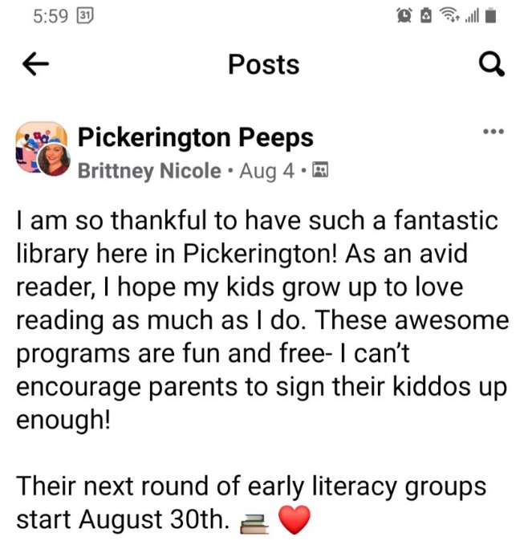

Summer Reading Finale – 2021 - Colleen showed some pictures and a post from one of the volunteers.

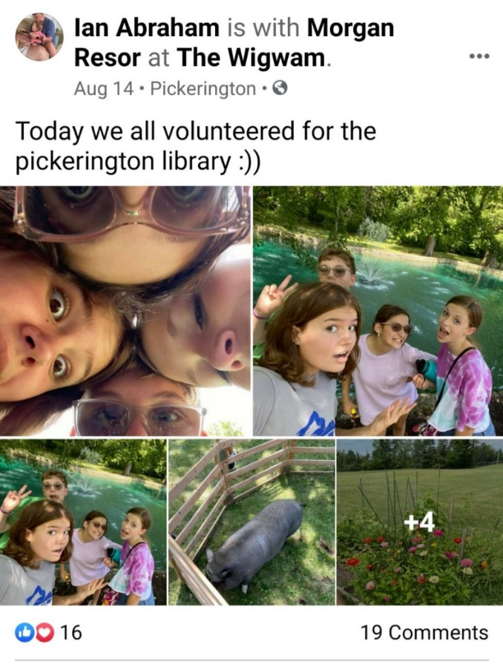

Old Business

Pandemic Operational Update

As stated in previous months, ELT is closely monitoring the progress of the pandemic. In June, the mask mandate was removed once State mandates were removed. Two weeks ago, the CDC moved Fairfield County into their defined substantial risk category for community transmission of the virus. Today, Fairfield County moved into the CDC’s high risk category. This means the county currently has 112.96 cases per 100,000 people. Keep in mind, the county only has a population of 157,574. For a closer look at all the data, please look at the CDC’s website. <https://covid.cdc.gov/covid-data-tracker/#county-view>

ELT has reviewed what steps the County, Township, City and School District are taking in response to this development. Additionally, the library is monitoring steps taken by other libraries. At this point, many libraries are not mandating masks for the public. The challenge is not having the support of the state for enforcement. Furthermore, most businesses throughout the county are not requiring masks for their customers.

After considering all information, ELT made the following changes effective August 3, 2021.

* Staff are required to wear masks while on the public service floor inside either location.
  + Masks will remain optional for staff while in staff only areas (i.e. staff workrooms, breakrooms, Tech Services, administrative and staff offices).
* Masks are strongly recommended for all library customers while inside the library.
* Masks are required for customers’ participation in any indoor class or event.

Colleen created a plan for communicating this change to the public. Tony informed staff then followed up with managers to ensure all staff understood the changes and why they were made.

Further information regarding other libraries.

- Masks - Most libraries in the CLC are requiring staff to wear masks. Some are requiring staff to wear masks everywhere on property and some only in public areas.

There are only a handful of the SERLS libraries that are requiring staff to wear masks. No SERLS Libraries are requiring customers to wear masks at this time

- Shutdown - No libraries in the CLC or SERLS are considering a shutdown at this time.

- Hours of operation - Many libraries who have not increased their hours back to pre-pandemic levels have decided to wait at least until the end of the year. Several libraries who already increased their hours are considering hour reductions.

- Vaccinations - Only one library system in Ohio has decided to make vaccinations mandatory for staff. Earlier this week, Athens Public Library Board voted to make COVID vaccinations mandatory. Staff can opt out but must submit to being tested for the COVID 19 virus every 3 days.

- Programming - Most libraries are planning both in person and virtual programs this fall. In person programming is all over the board. Some will only program outside and some will do both. Libraries are all over the place for programming.

ELT will continue to monitor the situation and make changes as necessary.

New Business

Bereavement Policy

As a follow up to last month’s personnel committee meeting and the July Board meeting, ELT has worked to update the Bereavement Policy. As with other policy updates, policies of other library systems were researched. For this policy, Midpoint Library, Columbus Metropolitan Library, Worthington Public Library, Marysville Public Library, Pickaway County District Library, and Bossard Memorial Public Library were looked at.

**08-02-21 Resolution to approve the changes to the Bereavement Policy**

Mike Jones made a motion to approve the changes to the Bereavement Policy. Mary Herron seconded.

Roll Call: Berneice Ritter-yes, Todd Stanley-yes, Cristie Hammond-yes, Mike Jones-yes, Mary Herron-yes. Resolution passed.

**Bereavement Leave**

**Board Policy: DATE REVIEWED: 11/9/2015**

**DATE APPROVED: 11/9/2015**

**EFFECTIVE DATE: 11/9/2015**

**REPLACING POLICY EFFECTIVE: 1/12/2015**

It is the policy of the Library to permit employees to be absent from work on an authorized, short-term basis for grieving and/or attendance at the funeral of a family member. In the event of the funeral of a current employee or Board member, the Library will close to the public in order for current employees to attend the funeral service.

**Administrative Procedure: DATE APPROVED: 08/16/2021**

**EFFECTIVE DATE: 08/16/2021**

**REPLACING PROCEDURE EFFECTIVE: 05/18/2020**

1. Bereavement leave allowances are as follows:
   1. Five (5) days for immediate family members
      1. Parent, step-parent
      2. Sibling, step-sibling
      3. Child, step-child, children of domestic partner, adopted and foster child
      4. Spouse or domestic partner
   2. Three (3) days for extended family members
      1. Grandparent, step-grandparent
      2. Parent of a spouse or domestic partner
      3. Sibling of a spouse or domestic partner
      4. Son or daughter in law
   3. One (1) day for further extended family members
      1. Aunt
      2. Uncle
      3. First Cousin
      4. Niece
      5. Nephew
2. To attend funerals of former Board members, retired employees, or volunteers, and members of their families, employees may use personal leave, vacation leave, or floating holiday leave, within the provisions of the library’s leave policy.
3. The library follows the Ohio Administrative Code in defining domestic partner.
   1. OAC Rule 3337-40-13 states:
      1. "Domestic partners" are two individuals of the same or opposite sex who:
         1. Share a regular and permanent residence; and
         2. Have a committed personal relationship for at least six months; and
         3. Can demonstrate financial interdependence; and
         4. Are not related by blood, not legally married, nor in a domestic partnership with anyone else.
4. Employees who had scheduled PTO during the bereavement leave may substitute bereavement leave for the scheduled PTO. Bereavement hours will not count toward overtime. Time will not be deducted from paid time off, floating holiday or vacation leave balances, but is considered separate for the days of leave. Additional time may be requested and charged to paid time off, vacation time, floating holiday or unpaid time off.
5. Full-time employees (36-40 hours per week) are paid for eight hours each day. Regular part-time staff (27.5-35.5 hours per week) will be paid for six hours and regular part-time staff (15-27 hours per week) will be paid for four hours leave. Part-time staff working less than 15 hours will not be paid for bereavement leave.
6. Employees should contact their immediate supervisor as soon as possible but no later than the beginning of the first day of absence due to bereavement leave. An employee must specify the relationship of the deceased and the number of days off. Proof of the death and relationship may be requested.
7. Prior approval from the Director or designee may be obtained for the actual time needed to attend the funeral of a friend. The time missed is to be made up during the same pay period if possible, otherwise PTO may be used.
8. Absence for bereavement will not be utilized in determining unscheduled absence/poor attendance records.
9. Absence for bereavement will be noted as such on time cards.

For the good of the order

Adjournment

Cristie adjourned the meeting at 8:05 p.m.

Next Board Meeting:

Regular Board Meeting  
September 20, 2021 @ 7:00 p.m. at Main Library

____________________________________________

Cristie Hammond

President

____________________________________________

Mary Herron

Secretary