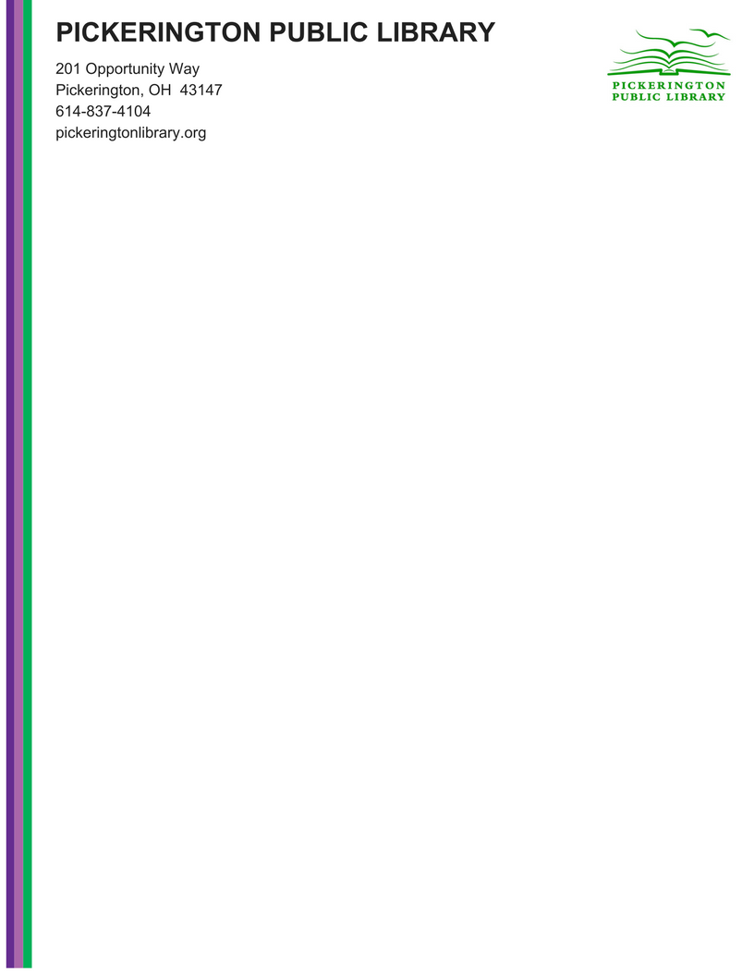

**Special Public Meeting**

**Notice**

**To:** Any interested members of the public

**From:** Tony Howard; Library Director

**Date:** 3/31/2022

**Subject:** Branch Lease Agreement

* **When**
  + Thursday, March 31, 2022
  + 5 pm
* **Where**
  + Main Library Large Conference Room

OR

* + Online at - <https://us02web.zoom.us/j/88693059388?pwd=RjBnbXdLdHVFb0V1Rllma1pTR0Fkdz09>
* **Agenda Topics**
  + Branch Lease Agreement