PICKERINGTON PUBLIC LIBRARY BOARD OF TRUSTEES MEETING
November 14, 2021

The Board of Trustees of the Pickerington Public Library met in regular session on November 14, 2021 at 1:00 p.m. in the Pickerington Senior Center, 150 Hereford Drive, Pickerington, OH 43147. Members present were Cristie Hammond, Mike Jones, Mary Herron, Jennifer Hess, and Todd Stanley. Staff members present: Tony Howard, Library Director, Brenda Oliver, Fiscal Officer, and Colleen Bauman, Community Engagement Manager. Also in attendance: Theresa Wessel, President of the Friends, Alyssa Gray, Student Trustee and Mikayla Wagner, Student Trustee.

Call to Order

Meeting called to order by Cristie Hammond.

Roll Call

Excused Absence: Michelle Shirer and Berneice Ritter

Secretary’s Report

Consent Agenda

- October 18, 2021 Regular Board Meeting minutes
- Donations
  - Donations of collectible memorabilia by Cherie Rida. Total estimated value - $527.00
    - Franklin Mint Presidential Hall of Fame 36 coin set valued at $55.00
    - Norman Rockwell’s “The Collector” Reprint on Canvas – 4 copies valued at $25.00 each – total value $100.00
    - Bicentennial coins (no precious metals) 3 at $16.00 – total estimates value $48.00
    - Bureau of Engraving and Printing vignette of the first U.S. Postage stamp. 5 values at $1.00 each – total value $5.00
    - Bureau of Engraving and Printing vignette of 1896 silver certificate – 5 copies at $7.00 each – total value $35.00
    - Bureau of Engraving and Printing vignette of 3 special (zeppelin) air mail stamps. 5 at $55.00 each – total value $275.00
    - Continental dollar coin colonial token with information – 1 value at $9.00
  - Charles Cokeley donated $10 in memory of Mary, a former library employee
  - Lease extension for Sycamore Plaza Library Branch
    - Original lease
    - Extension agreement

11-01-21 Motion to approve the Consent Agenda

Mary Herron made a motion to approve the Consent Agenda items. Todd Stanley seconded.

Roll Call: Mike Jones-yes, Mary Herron-yes, Cristie Hammond-yes, Todd Stanley-yes. Motion passed with no changes.

Public Participation

Friends of the Library Report

Theresa Wessel reported that they received $4,091.55 in sales and $640 in memberships from the booksale. There were 20 new members. The next meeting will be in December.

Jennifer Hess entered the meeting.

Finance Committee

Fiscal Officer’s Report

Brenda shared the October financials with the Board. Brenda asked if there were any questions from the financial reports. There were none.

Checking balance - $1,420,085.32
General Fund Investments - $3,142,762.59
Capital Fund investments – Star Ohio - $688,752.36
October General Fund Revenue - $139,143.99
Revenue Highlights:
- PLF - $132,840.16 (Includes overpayment of $24,743.30, will be deducted from November PLF)
- Customer Fines - $149.36
- Coin Op - $527.70
- Interest - $203.83
- Insurance Reimbursements - $5,183.01 (Initial Outreach Vehicle Repair)
- Capital Projects interest income - $44.67
- Special Revenue - $11,308 ($6,289 Federal & $5,019 transfer – GOO Grant)
Expenditure Highlights:
- Main Personnel - $83,858
- Branch Personnel - $14,785
- Main Operations - $29,762
- Branch Operations - $9,217
- Collection - $15,344
- Equipment and Furniture - $83
- Transfers – Out - $5,019
October General Fund Expenditures - $158,069

Other Committee Reports

Director’s Report

Spring Strategic Focus – Connect Community

Facilities:
Current projects:
- Picnic tables and benches - All missing pieces have arrived and the install is scheduled to be complete on the 18th of November.
- HVAC Maintenance Contract - On Monday November 15, the current HVAC Company, General Temperature Control, will be notified that the contracts will not be renewed. Currently the contracts end in February and March. While we have used this same company since the early 2000’s, quality of service has been subpar over the past couple of years. Additionally, when they quote a project, they often leave important parts of the project out. This has led to paying out more money after installation.

IT:
- Computer Equipment delays - The library is experiencing major delays in computer purchases from Dell. Cyril was told it is a supply chain issue where shipments are delayed at California ports.

Miscellaneous:
- Staff Member Highlight - Trudi Coakley: Trudi is a Reference Assistant at Main Library. She has worked for the library since September of 2010. Trudi does an excellent job of working with customers and adds value to tactical projects. Most days, you can find Trudi at the Information & Research desk at Main, but she also leads outreach services. Her positive impact in providing library services to assisted living facilities was evident when the library added bookdrops and bookshelves at some of the community’s assisted living facilities. The library heard from the residents that they loved having Trudi come to bring materials. They also expressed concerns that the library would “get rid” of Trudi because of adding the bookdrops and bookshelves. They were reassured them this was not the case. Trudi is being recognized before the Board for her positive attitude, excellent customer service and ability to build strong lasting relationships while providing outreach service.
- CLC - The CLC Governing Council approved their annual budget and there were a couple things to note.
- Transportation costs are going up by 9% - While this is a huge increase, CML’s service is still better than the state’s contractor. Some libraries are still experiencing several month turnarounds for materials.
- CLC is purchasing OCLC services - Not all CLC Libraries have experienced catalogers. This purchase will allow the consortium to have more consistency in materials’ records.
- Experience passes - Tony met with staff recently to discuss experience passes to create a consistent approach to how records are managed. This will ensure the customers have an easy time finding materials and staff can easily and accurately process new passes.
- Down with Dewey after 1 year - When the Down with Dewey project was started, the decision was made not to make any changes to any materials until one year had passed. This would help to keep and adjust to the new process. Now that there is a year out from completing the Children’s materials, staff is beginning to look at any issues from the past year. Recently rules were created to follow when processing series books to solve the associated issues. This reevaluation process will continue throughout the next six to eight months.
- Library IQ - The library entered into an agreement with Library IQ. The agreement to use Collection HQ ends at the end of this year. Both of these products are designed to help libraries manage collections by using data. CLC is looking at a consortium purchase for Library IQ, which would bring the cost down.

Programming:
- The Trunk or Treat event was a success. Over 240 customers participated.
Staff are going in person to teach early literacy classes at both Sycamore Creek Elementary school and Violet Elementary school.
- Staff attended a Romeo and Juliet event at Central High School. (Now that the library is allowed back into the schools, staff are working hard to strengthen the relationship).
- The Ghost Hunters event was held at Main Library! This event made the Columbus Dispatch (Kudos Colleen).

COVID 19 Operational Update:
Current Data shows that new cases in the county have remained fairly flat over the past three weeks for the number of new COVID-19 cases. The new case rate is 175.8 cases per 100,000 population. These new case numbers are similar to the numbers reported in late August. The county has 22 confirmed deaths from COVID-19 in October. Hospitalizations were down 28.57% over the previous month.
Booster shots have been made available to most Americans 18 years or older. So far, the County has given 9,778 booster shots to residents. Additionally, the shot has been made available to children 5 years old to 11 years old. Most appointments have already filled for the first round of vaccinations for this age group. The CDC said November 20, 2021 is the last day for this age group to receive their first dose in order to be fully vaccinated before Christmas.
Currently, 60.4% of the eligible Fairfield County population is fully vaccinated. Here is a breakdown by age group:
85.5% of county residents 65 years or older are vaccinated
66% of all county residents between the ages of 18-65 are fully vaccinated
63.8% of all county residents between the ages of 12-17 are fully vaccinated
According to the CDC, 78.8% of the vaccine eligible population of the United States have received their first dose.
In considering the data and understanding the community, the decision was made to remove the requirement for masks for staff while performing most of their daily workflows. Beginning Tuesday, November 9, 2021, masks will again be optional for staff as long as social distancing is an option. For class and event settings, masks for everyone involved will still be required. If there is an in-person meeting where social distancing is not possible, masks will be required.
Over the past year, many parents and caregivers have inquired as to when the toys will be made available for children to use. Tony’s response has been that they will be brought out once a vaccine is made available for children. Since that has happened, the library is planning to bring toys back out for customers to use beginning January 10, 2022. This will allow time for the first round of children to become fully vaccinated. It also coincides with the beginning of winter classes.

Community Engagement Report

Projects:
- Wayfinding project is moving along: Next for team – library audits and site visits.
- Website project: Team is compiling page information.
- Digital Resource Highlight: Hoopla
There were 584 Instant circs in October 2021 borrowed by 178 patrons. The average number of Instant circs was 3.28 circs per patron, with 34 individual(s) using all 7 Instant circs.

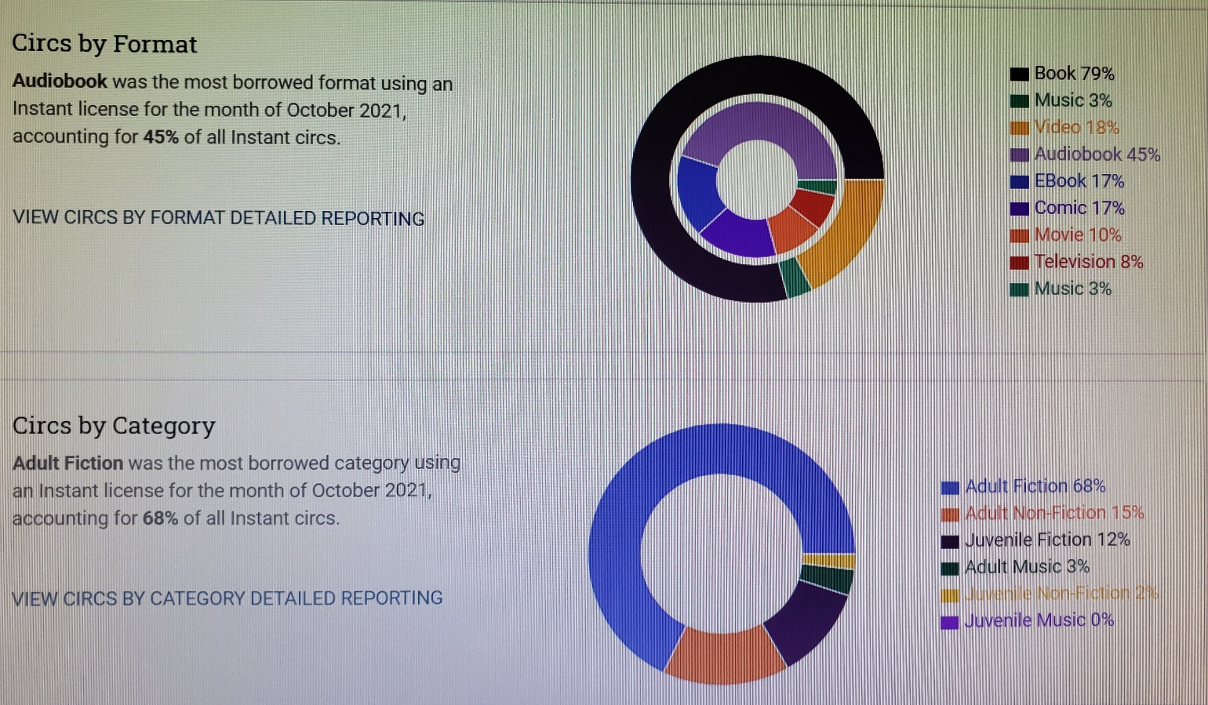
Social Media:
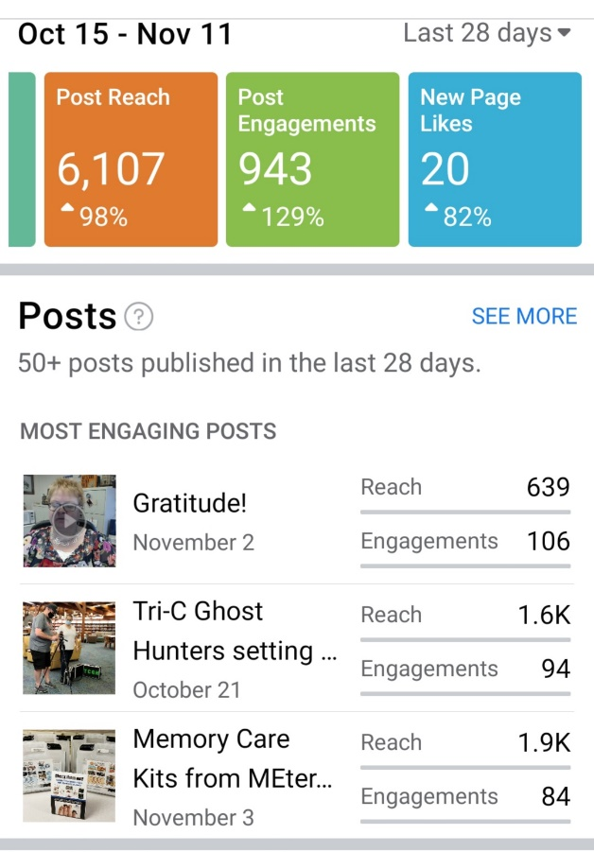
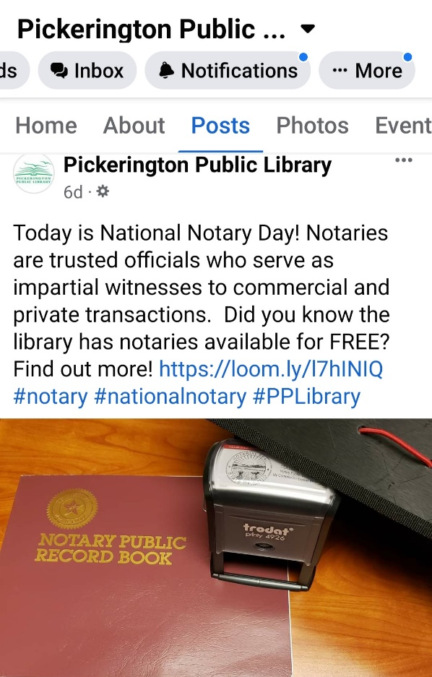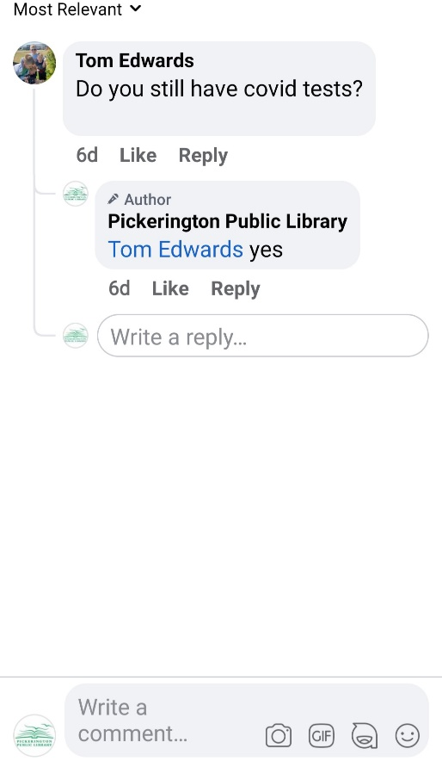
Upcoming events and initiatives (community, outreach):

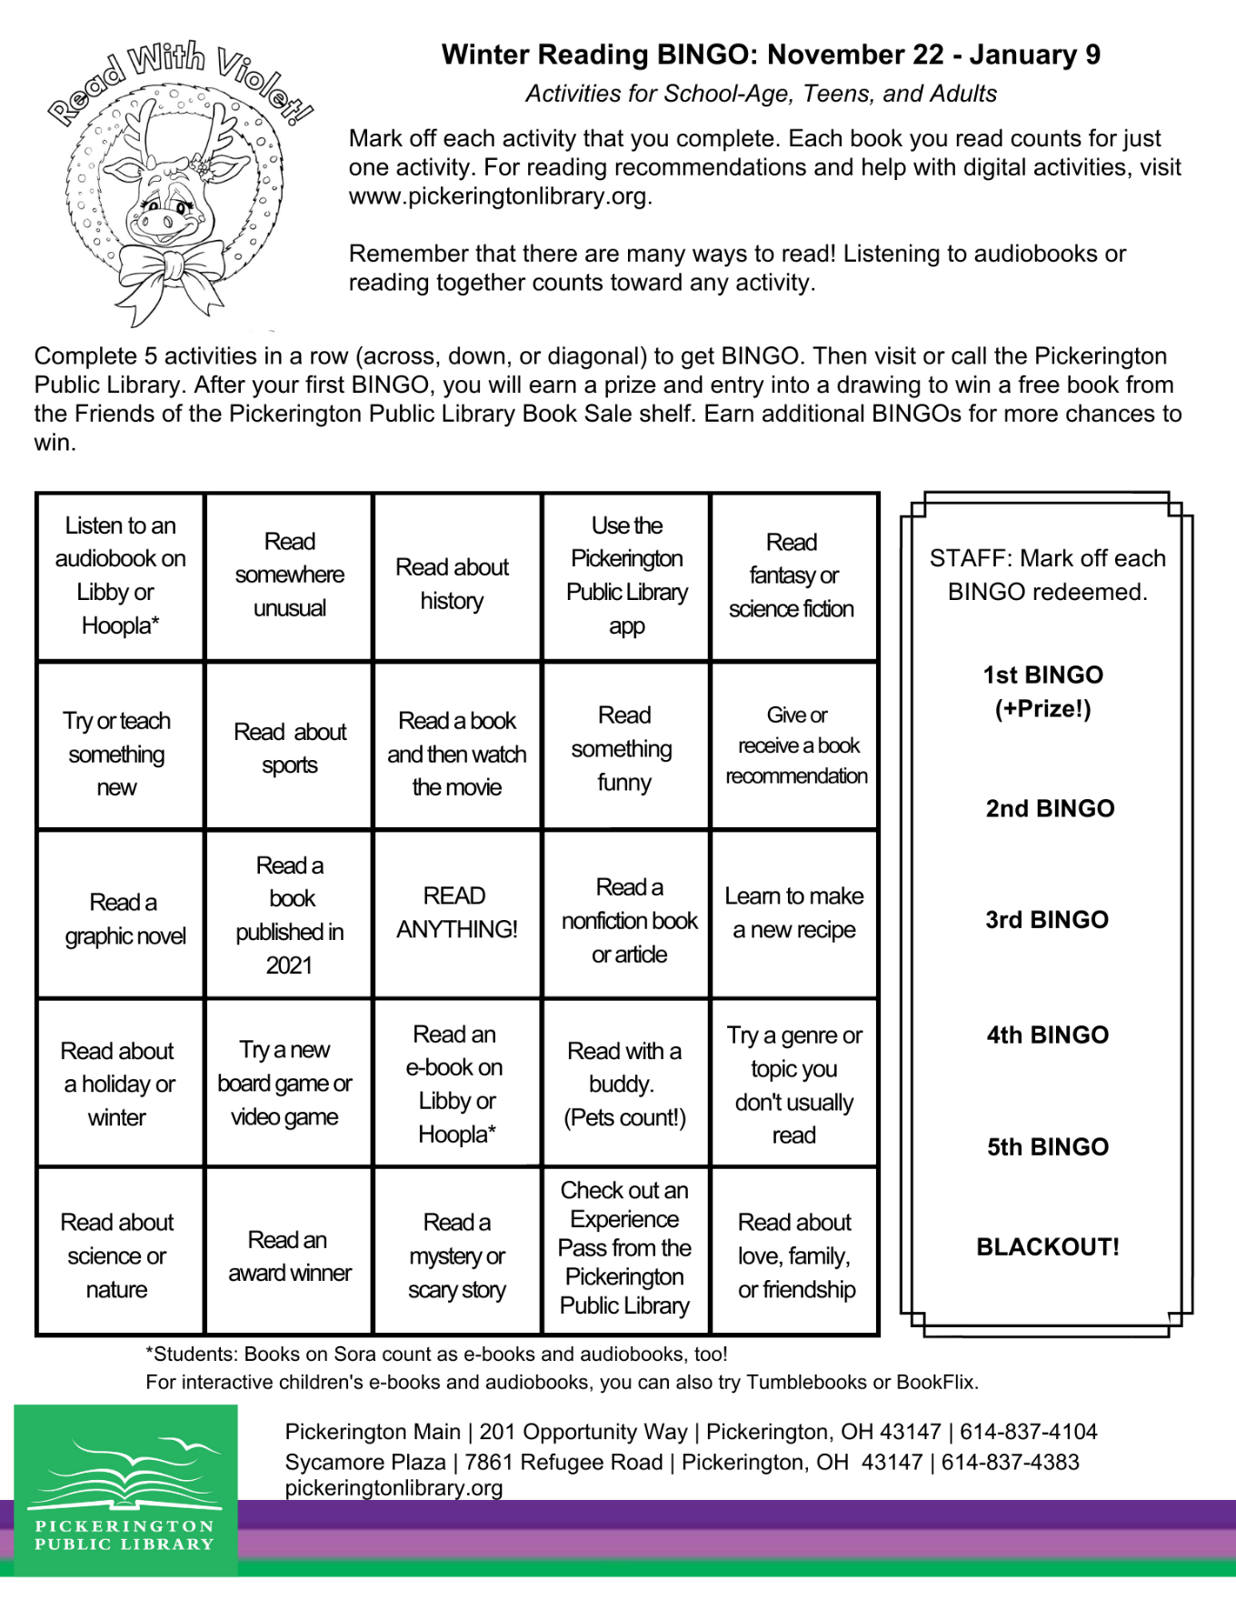

- Turkey Bouquet - Monday Makers – November 22 @ 6:00 p.m.
- Fairfield County Foundation fundraising initiative
Give Back This Year through the 32-Hour Give
32-Hours of Giving, November 30, 8:00 a.m. through December 1, 4:00 p.m.
- Santa Saturday - Saturday, December 4: 1:00 – 3:00 p.m., Pickerington Main -
Holiday joy abounds at Pickerington Main Library’s annual Santa Saturday event, welcoming Musician Joanie Calem to this year's festivities. There will also be fun crafts, photos with Violet the Cow and of course, a visit with Santa!
- American Red Cross Blood Drives - December 11 & February 12, 10:00 a.m. – 4:00 p.m., Pickerington Main - For more information and to schedule an appointment: 1-800-RED CROSS or visit RedCrossBlood.org sponsor code: PickeringtonLibrary

Old Business

New Business

Friends of the Pickerington Public Library Agreement

Every two years, the Library and Friends of the Pickerington Public Library renew their agreement. As ELT reviewed the agreement, they considered the pandemic situation as well as the need for the Friends to restock saleable merchandise. ELT does not feel it is appropriate to increase the fees beyond the merchandise goals outlined in the agreement. This renewal will go through the end of January 2023. Tony requested any feedback before a vote at the next meeting.

For the good of the order

Adjournment

Cristie adjourned the meeting at 1:11 p.m.

Next Board Meeting

Regular Board Meeting
December 20, 2021 @ 7:00 p.m. at Main Library

____________________________________________
Cristie Hammond
President

____________________________________________
Mary Herron
Secretary

