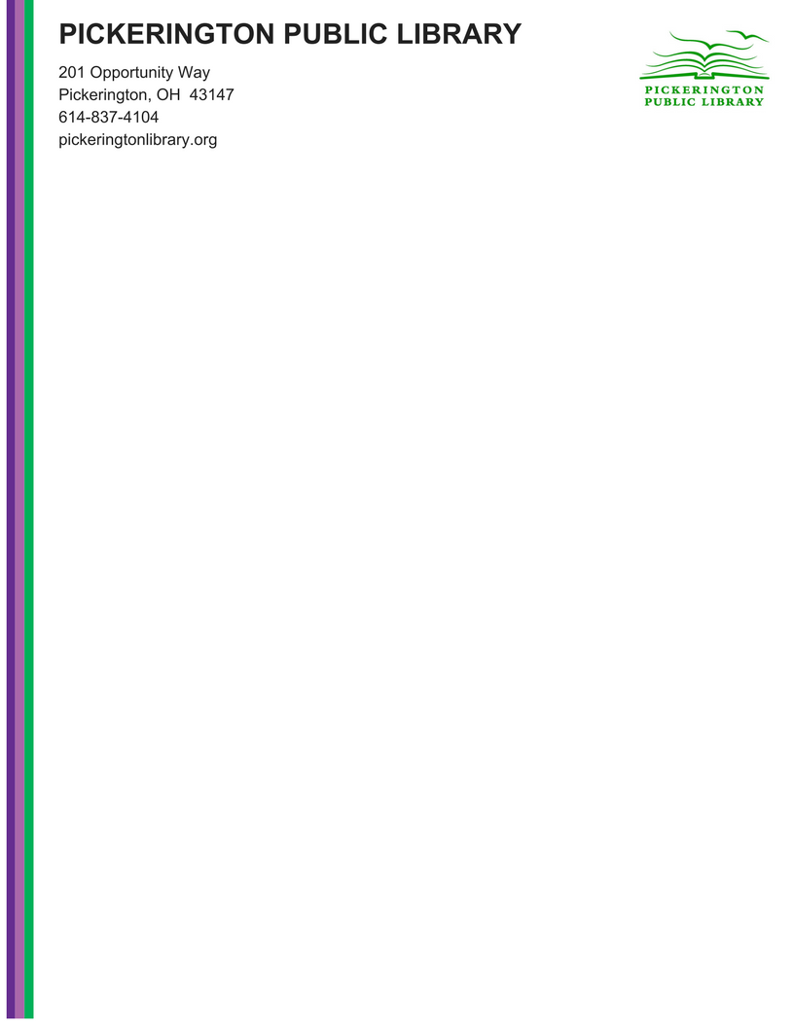

**Special Public Meeting**

**Notice**

**To:** Any interested members of the public

**From:** Tony Howard; Library Director

**Date:** 4/10/2022

**Subject:** Branch Lease Agreement

* **When**
  + Monday April 11, 2022
  + 5:30 pm
* **Where**
  + Online at - <https://us02web.zoom.us/j/82447424977?pwd=MlhKQmNmTnM5amFkWlVmL2FlQzZmZz09>
* **Agenda Topics**
  + Branch Lease Agreement