PICKERINGTON PUBLIC LIBRARY BOARD OF TRUSTEES MEETING
May 16, 2022

The Board of Trustees of the Pickerington Public Library met in regular session on May 16, 2022 at 7:02 p.m. in the Pickerington Public Library at 201 Opportunity Way, Pickerington, OH 43147. Members present: Cristie Hammond, Mike Jones, Mary Herron, Alissa Henry, Jennifer Hess, Berneice Ritter, and Todd Stanley.
Student Trustee Representatives present: Mikayla Wagner. Staff members present: Tony Howard, Library Director, Brenda Oliver, Fiscal Officer, and Norma Lockney, Deputy Fiscal Officer. Also in attendance: Theresa Wessel, President of the Friends of the Pickerington Public Library.

Call to Order

Meeting called to order by Cristie Hammond.

Roll Call

Excused Absence(s): Mikayla Wagner

Secretary’s Report

Consent Agenda

      - Minutes
        - April 11, 2022 Special Board meeting minutes
        - April 18, 2022 Regular Board Meeting minutes
      - Staff Changes
        - Leah Taynor – Promoted to Customer Service Leader at main – effective May 1, 2022 at $14.43 an hour
        - Moth Mauser – Started as Teen Librarian working out of both locations - effective May 3, 2022 at $19.17 an hour
      - Donations
        - Nutri Ninja Personal Blender Donated by the Howard Family for a Summer Reading Prize giveaway – Value $129.00
      - Administrative Procedure Changes to the Cardholder Policy

05-01-22 Motion to approve the Consent Agenda

Mike Jones made a motion to approve the Consent Agenda items. Mary Herron seconded.

Roll Call: Mike Jones-yes, Alissa Henry-yes, Mary Herron-yes, Cristie Hammond-yes, Todd Stanley-yes, Berneice Ritter-yes, Jennifer Hess-yes. Motion passed with no changes.

Public Participation

Friends of the Library Report

Theresa Wessel reported that the Friends have voted to buy sound absorbing panels for the branch expansion, $3,500. There will be a summer book sale on June 3 and 4 with mostly children’s books for sale. Any child who signs up for the Summer Reading Program will receive a coupon for a free book.

Finance Committee

Fiscal Officer’s Report

Brenda shared with the Board what the Finance Committee discussed. Brenda asked if there were any questions from the financial reports. There were none.

Other Committee Reports

Mary Herron reported that the Library Fund Advisory Committee will delay the scholarship this year to revise questions given to students. A restricted donation of $1,000 was given for children’s books. $9,500 is allotted to branch expansion improvements.

Director’s Report

Spring Strategic Focus – Fostering the Love for Reading

Facilities:
Current projects:
- Damage to the Gutter and Roof Repairs - Work is almost complete on this project. The contractor is waiting on the ice guards to arrive. Once they are installed, this project will be finished.
- Pavilion - Tony has not had a chance to meet with TRIAD Architects. He will work on this over the next few weeks. For summer, the library will use the tents. Ideally, there will be an agreement in early June and can commence work in early fall.
- Youth Services Staff Workroom/Barn - DesignGroup proposal is up for Board approval tonight.
  - Timeline pending approval
    - PO Issued on 5/17
    - Meeting 1 (5/24-5/27) Dream State
    - Meeting 2 (6/7 – 6/10) Redefine Design
    - Meeting 3 (6/21 – 6/24) 95% Contract Documents
    - Permitting and Bidding process to begin end of June or Early July
    - Notice to Proceed Early August
- Ravine - Met with Engineers and Yardmaster last week to begin the process of creating the plans for the ravine repair.

IT:
- Windstream notified the library that they will be ending service to the library in July. They cited costs and changing technology. Cyril is looking for a replacement vendor for the landlines. The challenge is that these are the library’s landlines and not a fiber connection. Expecting a substantial increase in costs with the switch.

Miscellaneous:
- Staff Member Highlight - Jessica Stokes has been a Customer Services Assistant for nine (9) months. During that time, she has positioned herself as an informal leader at Sycamore Plaza. She quickly learned the job and does an excellent job of building positive relationships with our customers. Jessica has great ideas and regularly shares them with her supervisor. She is friendly and helps foster a positive friendly atmosphere at the branch. For these reasons, Jessica is being recognized before the Library Board of Trustees.
- Storage Cleanout - The storage unit on Refugee Road was cleared out on May 11.
- Outreach Vehicle - The back door and lift of the outreach vehicle were accidently damaged during the storage cleanout. The lift chain caught on the door and caused the door to buckle. It also caused the lift to become misaligned. The lift was realigned and is completely functional again. The door has minor damage. The vehicle will need to be sent to an auto body shop for repairs or replacement. There is a final design for the vehicle. Tony shared some pictures.
- Branch Expansion
- Branch Floor Plan
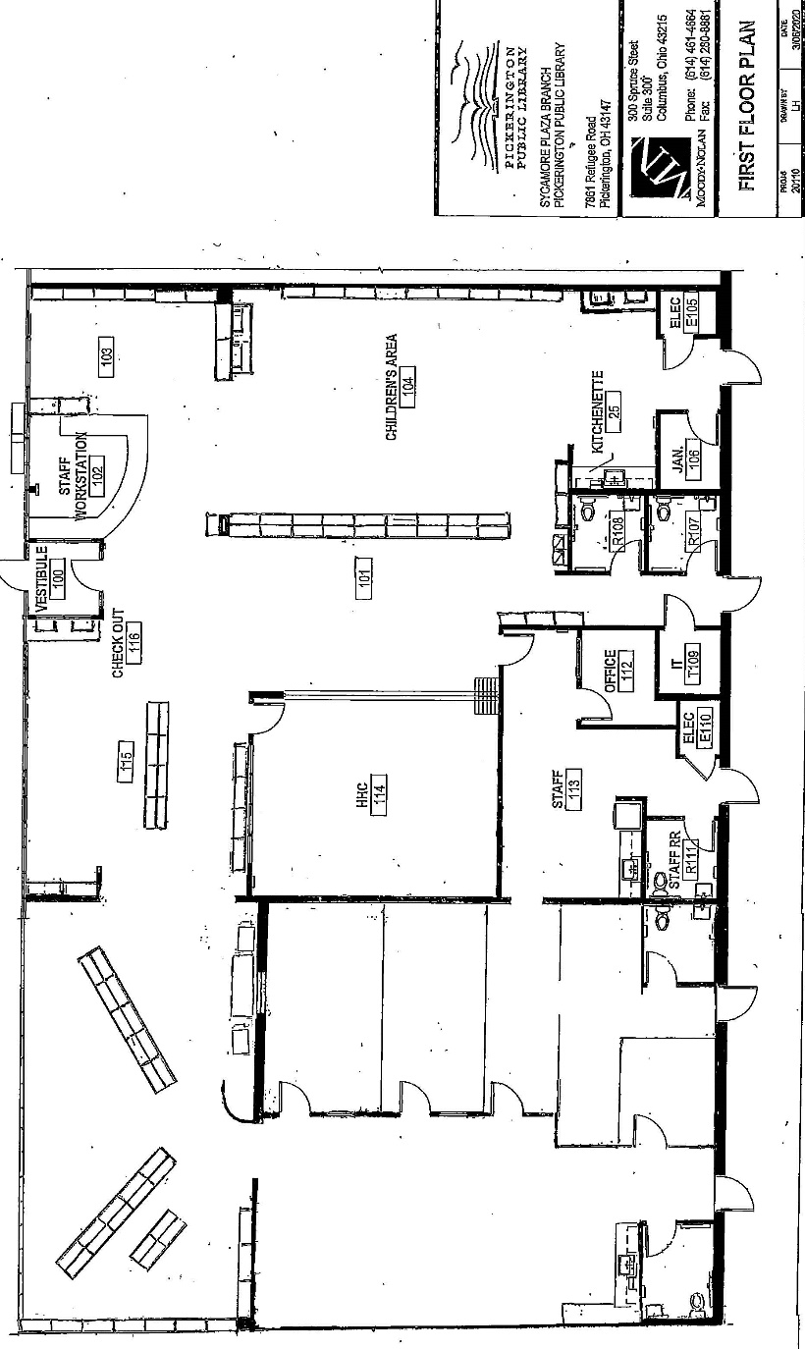

- Expected Expenses
  - Furniture
    - Meeting Room Furniture $2162.41
    - Shelving $16304.88
    - Study Room Tables $1519.95
    - Staff Standup Station $1475.01
    - Mobile Kitchen Island $850.41
  - Equipment
    - 3 Public Computers $3300
    - 1 staff Desktop $1500
    - Security equipment $7603
    - Hotplates for programming $500
  - Construction
    - General Construction $5805
    - Paint & Supplies $600
    - Data wiring $3000
    - Window Installation $5000
  - Total Estimated Expenditure $49,620.66
- Timeline for the Project
  - Construction begins June 6, 2022
  - Construction complete June 9
  - Window contractor still needs selected
  - Data wiring already complete
  - Security equipment installation expected the last week of May
  - Exempt Staff/BOT paint party between June 13 and 24
- Goal for opening - early July
- Summer Reading - May 21 through August 6 - Kickoff will be a low-key soft start. Most summer programming does not begin until June. The finale is planned at the Wigwam from 10:30 a.m. to 2:00 p.m. on Saturday, August 6. Prizes – there is a good assortment for the summer reading finale prizes. Tony shared pictures of some of the prizes.
- Comic Fest - Comic Fest was a huge success. There were 814 visits for the event.
- Staff Member – Community Recognition - Lauren Edmonds was one of the people honored at the Pickerington Education Association's Friends of Education Banquet. She was the nominee for PHSC for working with school library staff to get books into students' hands. Tony shared some pictures.

Community Engagement Report

Old Business

New Business

2023 Budget Request

The proposed 2023 Budget Request is $2,755,551 General Fund and $500 Homework Help Center Fund. The request estimates revenue for 2023 at $2,931,929 for the General Fund and $4,500 for the Capital Projects Fund.

Every May, the Board approves the Budget request for the following year.

05-02-22 Resolution to approve the 2023 Budget Request of $2,755,551 General Fund and $500 Homework Help Center Fund

Mike Jones made a motion to approve the resolution to approve the 2023 Budget Request of $2,755,551 General Fund and $500 Homework Help Center Fund. Jennifer Hess seconded.

Roll Call: Berneice Ritter-yes, Todd Stanley-yes, Cristie Hammond-yes, Alissa Henry-yes, Mike Jones-yes, Jennifer Hess-yes, Mary Herron-yes. Resolution passed.

2022 Permanent Budget Adjustment and Capital Fund Addition

Due to the expansion of Sycamore Plaza Library, the overall budget for 2022 has areas that need to be adjusted. In the proposed budget, furniture has increased to $40,000 in order to cover expenditures in that area. The equipment budget was left the same at $52,900. Additionally, a printing budget line item has been added for the branch to account for printing costs for the copiers.

The library also received notice through certified mail this past month from Windstream that they will no longer service the library. They cited evolving technology, changing economic conditions and current costs to provide service as reasons for this decision. Cyril has been seeking quotes to switch service, but the quotes are coming in a lot higher than expected. In order to make this switch, it is necessary to increase the appropriations for phones in the general fund.

During the storage cleanout, one of the back doors and the lift was damaged on the new outreach vehicle. Staff is working on pricing out repairs and checking to see what is covered under warranty. In case these repairs are not covered by the warranty, there is a request to increase the 2022 budget for vehicle maintenance and repairs.

The library has appropriated most of the Capital Projects Funds in the 2022 budget. In order to have adequate funds available for future capital projects, funds will need transferred into the Capital Fund.

The proposed 2022 Budget Adjustment Request is to increase the General Fund to $3,361,808.

Normally the annual Budget would not be adjusted after it is set. However, it was necessary due to changes brought on by the branch expansion and unexpected circumstances.

Funds need to be added to the Capital Fund balance for future capital projects.

05-03-22 Resolution to approve the amended 2022 permanent General Fund budget to $3,361,808

Berneice Ritter made a motion to approve the resolution to approve the amended 2022 permanent General Fund budget to $3,361,808. Mary Herron seconded.

Roll Call: Todd Stanley-yes, Mike Jones-yes, Cristie Hammond-yes, Alissa Henry-yes, Berneice Ritter-yes, Mary Herron-yes, Jennifer Hess-yes. Resolution passed.

05-04-22 Resolution to transfer $500,000 from the General Fund 1000-910-910-0000 Transfers - Out into the Capital Fund 4001-931-0000 Transfers - In

Berneice Ritter made a motion to approve the resolution to transfer $500,000 from the General Fund 1000-910-910-0000 Transfers - Out into the Capital Fund 4001-931-0000 Transfers - In. Mary Herron seconded.

Roll Call: Mary Herron-yes, Mike Jones-yes, Todd Stanley-yes, Jennifer Hess-yes, Cristie Hammond-yes, Alissa Henry-yes, Berneice Ritter-yes. Resolution passed.

DesignGroup Projects

After meeting with DesignGroup architects and engineers, it was recommended that several of the indoor projects at Main Library be combined in order to have better options and garner more interest from building contractors. When looking at all of the projects scheduled for the year, it was decided to ask DesignGroup for a quote combining the following five projects:
Youth Services Workroom Remodel
Barn Enclosure
Carpet Project for Main Library
Powered Blinds for the Atrium
Furniture Recommendations for Main Library
The overall quote came back for this design work at $48,000. This is about 14% of the overall cost of the five projects combined.

By combining these projects, the library will not only ensure a more competitive bid process, but it will free up staff time. Additionally, DesignGroup will provide support in the administrative and construction management of these projects.

All projects are budgeted projects for 2022 that would require some type of design guidance.

Pre-pandemic architectural and engineering fees would be approximately 10% to 12% of the overall cost of the project.

05-05-22 Resolution approving DesignGroup at $48,000 as the architect for the following combined projects: Youth Services Workroom Remodel, Barn Enclosure, Carpet Planning, Atrium Blinds, and Furniture Designs for the Atrium

Todd Stanley made a motion to approve the resolution approving DesignGroup at $48,000 as the architect for the following combined projects: Youth Services Workroom Remodel, Barn Enclosure, Carpet Planning, Atrium Blinds, and Furniture Designs for the Atrium. Jennifer Hess seconded.

Roll call: Jennifer Hess-yes, Berneice Ritter-yes, Todd Stanley-yes, Cristie Hammond-yes, Alissa Henry-yes, Mike Jones-yes, Mary Herron-yes. Resolution passed.

Collections Fund #2014

The Library Fund Advisory Committee recently met and approved the distribution of restricted funds in the amount of $1000 to the Pickerington Public Library. These funds are restricted specifically for the purchase of nonfiction children’s books.

In order to receive and spend these restricted funds, a special fund must be created within our budget.

The purpose of this fund will be for any grants or restricted donations for any type of collection materials as specified in the grant or restricted donation received.

Special funds are created anytime grants or restricted donations are awarded to the library.

05-06-22 Resolution to establish a collections fund #2014

Berneice Ritter made a motion to approve the resolution to establish a collections fund #2014. Todd Stanley seconded.

Roll call: Cristie Hammond-yes, Mary Herron-yes, Berneice Ritter-yes, Todd Stanley-yes, Alissa Henry-yes, Mike Jones-yes, Jennifer Hess-yes. Resolution passed.

For the good of the order

Cristie asked for dates to be set for committee meetings.

Adjournment

Cristie adjourned the meeting at 7:45 p.m.

Next Board Meeting:

Regular Board Meeting
June 27, 2022 @ 7:00 p.m. at Main Library

____________________________________________
Cristie Hammond
President

____________________________________________
Mary Herron
Secretary

